Report from Public Consultation on the Environmental Management Plan
for Contract 1B.3/2:
Stage II - The construction of docking-mooring infrastructure on Lower Odra River and on boundary sections of Odra River as well as new aids to navigation
(carried out as part of the Odra-Vistula Flood Management Project (OVFMP)

Draft of the Environmental Management Plan (EMP) for Contract 1B.3/2: Stage II - The construction of docking-mooring infrastructure on Lower Odra River and on boundary sections of Odra River as well as new aids to navigation was subject to public consultation conducted in accordance with the requirements of the World Bank's operational policy (OP 4.01). The purpose of the consultation was to enable natural persons, institutions, and all interested parties to become acquainted with the content of this document and to provide them with the opportunity to submit any comments, queries, and requests related to its content. Because of the state of epidemiological threat, the formula for conducting public consultations on the draft EMP document has changed. There was no open meeting for all interested parties and the consultation was conducted in the form of a webinar.
Once the draft EMP was prepared, the document was submitted to the World Bank for approval to begin the publishing procedure. After obtaining the approval of the World Bank to begin the draft EMP publishing procedure, the electronic version of the document with the notice of public consultation was published on the following websites:
- State Water Management Polish Waters, Regional Water Management Authority in Szczecin – (Fig. 1);
- Odra-Vistula Flood Management Project Coordination Unit – (Fig. 2);
- Szczecin City Hall – (Fig. 3);
- Municipal Office Chojna – (Fig. 4)
- Municipal Office Cedynia – (Fig. 5)
- Municipal Office Górzyca– (Fig. 6)
- Słubice City Hall – (Fig. 7)
- Cybinka City Hall – (Fig. 8)
- portal wszczecinie.pl – (Fig. 9)
- Odra-Vistula Flood Management Project – (Fig. 10)
Information on the possibility to review the content of the EMP draft and to submit requests and comments, along with detailed information (correspondence address, e-mail address, and phone number) was published in local press. The notice was published on 22.06.2020 in the local press to Gazeta Lubuska (Fig. 11) and on 22.06.2020 in Kurier Szczeciński (Fig. 12). The published Notice contains information about the revised formula for conducting public consultations due to the state of epidemiological threat in Poland, including indication of the website where the link to the webinar to be posted at least 10 days before the on-line meeting and the step-by-step instruction on how to join the online meeting conducted as part of concluding the public consultations of the EMP draft (along with the date, time, website where the link to the webinar will be posted, and the purpose of the meeting).
Information (Fig. 13) about the initiated EMP draft publishing procedure and the possibility to submit requests and comments was sent via email to the following persons, institutions, and organisations:
- Minister of Maritime Economy and Inland Waterways
- PGW WP National Water Management Authority
- Odra-Vistula Flood Management Project Coordination Unit
- PGW WP Regional Water Management Authority in Szczecin”
- Voivode of the Zachodniopomorskie Voivodeship, Office of the Zachodniopomorskie Voivodeship in Szczecin
- Voivode of the Lubuski Voivodeship, Office of the Lubuski Voivodeship in Gorzów Wielkopolski
- Szczecin Maritime Office
- Szczecin-Świnoujście Seaport Authority
- Marshal of the Zachodniopomorskie Voivodeship, Marshal's Office of the Zachodniopomorskie Voivodeship
- Marshal of the Lubuskie Voivodeship, Marshal's Office of the Lubuskie Voivodeship in Zielona Góra
- Regional Director for Environment Protection in Szczecin
- Deputy Regional Director for Environment Protection in Szczecin
- Regional Director for Environment Protection in Gorzów Wielkopolski
- Deputy Regional Director for Environment Protection in Gorzów Wielkopolski
- Voivodeship Inspector for Environment Protection in Szczecin
- Voivodeship Inspector for Environment Protection in Zielona Góra, Office in Gorzów Wlkp.
- Poviat Sanitary Inspector in Słubice
- Powiat Sanitary Inspector in Gryfino
- Voivodeship Sanitary Inspector in Szczecin
- Powiat Sanitary Inspector in Gorzów Wielkopolski
- Mayor of Szczecin Szczecin City Hall
- Mayor of Chojny
- Mayor of Cedynia
- Mayor of Mieszkowice
- Mayor of Słubice
- Head of the Górzyca Commune
- Head of the Boleszkowice Commune Municipal Office
- Poviat (county) Office in Gorzów
- Poviat (county) Office in Słubie
- Zachodniopomorskie Voivodeship Landscape Parks Unit
- National Park “Warta River Mouth” ("Ujście Warty")
- Polish Fisheries Union PFU District in Szczecin
- Polish Fisheries Union PFU District in Gorzów Wielkopolski
- Voluntary Firefighting, Water and Environmental Rescue Unit in Kostrzyn nad Odrą
- Voivodeship Headquarters of the State Fire Service in Szczecin
- Municipal Headquarters of the State Fire Service in Zielona Góra
- Municipal Headquarters of the State Fire Service in Słubice
- Municipal Headquarters of the State Fire Service in Gorzów Wielkopolski
- Regional Directorate of State Forests in Szczecin
- Forest Division Chojna
- Forest Division Gryfino
- Forest Division Mieszkowice
- Regional Directorate of State Forests in Zielona Góra
- Forest Division Dębno
- Forest Division Rzepin
- Inland Waterways Office in Szczecin
- Szczecin Metropolitan Area Association
- Road and City Transportation Authorities in Szczecin
- Ośrodek Inicjatyw Społecznych i Ekologicznych [Centre for Social and Ecological Initiatives] “Stary Zagon”
- Instytut Rozwoju Terytorialnego [Institute of Territorial Development]
- Stowarzyszenie Nadodrzańskie Klimaty [Association Odra Climate]
- Zachodniopomorskie Towarzystwo Przyrodnicze [Zachodniopomorskie Association of Naturalists]
- Koalicja Ratujmy Rzeki [Coalition Save the Rivers]
- Mrs. Ewa Leś
- Mr. Artur Furdyna
- Mrs. Iwona Krępic
- Liga Ochrony Przyrody [Nature Conservation League]
- Federacja Zielonych Gaja [Green Federation Gaja]
- Ogólnopolskie Towarzystwo Ochrony Ptaków [National Society for the Protection of Birds]
- Greenpeace Polska
- Stowarzyszenie Zielona Dolina Odry i Warty [Odra and Warta Green Valley Association]
- Polski Klub Ekologiczny Okręg Zachodniopomorski [Polish Ecological Club Zachodniopomorskie District]
- Polski Klub Ekologiczny Zarząd Główny [Polish Ecological Club Executive Board]
- Związek Stowarzyszeń Polska Zielona Sieć [Union of Associations Polish Green Network] Office in Szczecin"
- Stowarzyszenie Gmin Polskich Euroregionu Pomerania [Association of Polish Municipalities of the Euroregion Pomerania]
- Stowarzyszenie Ekologiczne Eko-Unia [Ecological Association Eko-Unia]
- Mr. Radosław Gawlik
- WWF Polska
- Mr. Paweł Nawrocki
- Klub Przyrodników [Naturalists' Club]
- Greenmind Foundation
- Mr. Jacek Engel
- Fundacja na rzecz Collegium Polonicum [Foundation for Collegium Polonicum]
- Stowarzyszenie Miłośników Jeziora Dąbie [Association of Friends of Lake Dąbie] "Ekodąb"
- Stowarzyszenie Rybaków i Przedsiębiorców z Dąbia [Association of Fishermen and Entrepreneurs from Dąbie]
- Towarzystwo Przyjaciół Rzek Iny i Gowienicy [Society of Friends of Ina and Gowienica Rivers]
- Inland Navigation Captain Czesław Szarek Association for the Development of Inland Navigation and Waterways "Rada Kapitanów Żeglugi Śródlądowej" ["Council of Inland Navigation Captains"]
- Łagowskie Stowarzyszenie Turystyki Pieszej i Rowerowej (Łagow Tourism Association)
- Szczecińska Organizacja Turystyczna [Szczecin Tourist Organisation]
- Stepnicka Organizacja Turystyczna „Nie tylko dla Orłów [Stepnica Tourist Organisation „Not only for Eagles”]
- Lubuska Regionalna Organizacja Turystyczna "LOTUR" (Lubusz Regional Tourist Organisation „LOTUR”)
- Zachodniopomorska Regionalna Organizacja Turystyczna [Regional Tourism Organisation in Zachodniopomorskie]
- Związek Portów i Przystani Jachtowych Lokalna Organizacja Turystyczna Zachodniopomorskiego Szlaku Żeglarskiego [Association of Yacht Ports and Harbours Local Tourist Organisation of the Zachodnipomorskie Sailing Route]
- Stowarzyszenie Odra dla Turystów (Association Odra for Tourists)
- Foundation „Dziupla Inicjatyw Przyrodniczych”
- Sport Angling Club „Orfa”
- Polish Angling Association unit no 2 in Słubice
- Polish Angling Association unit no 1 in Słubice
- Sport Angling Club „Szuwarek”
- Sektor 3 Słubice
- Szczecińskie Centrum Wspierania Organizacji Pozarządowych Sektor 3 [Szczecin NGO Support Centre Sector 3]
- Foundation "Zielona strzała" Kostrzyn
- Water Sports Club in Kostrzyn
- Kostrzyn Friends Association
- Angling Association of Myślibórz
- Oddział Polskiego Towarzystwa Turystyczno-Krajoznawczego Zakład Dolna Odra [Polish Tourist and Sightseeing Association Unit Dolna Odra Plant]
- Polskie Towarzystwo Turystyczno-Krajoznawcze Regionalny Oddział Szczeciński im. S. Kaczmarka Szczecin [Polish Tourist and Sightseeing Association Unit named after S. Kaczmarek in Szczecin]
- Stowarzyszenie na rzecz Miast i Gmin Nadodrzańskich [Association for Cities and Municipalities on the river Odra]
In order to ensure the widest possible access to information on the EMP draft due to the epidemiological threat in Poland, it was decided that the electronic version of the documentation would be posted and accessible to all interested parties during the period from 22.06.2020 to 13.07.2020 (i.e. 16 working days) on the following websites:
- State Water Management Polish Waters the Regional Water Management Authority in Szczecin, at www.szczecin.wody.gov.pl;
- Odra-Vistula Flood Management Project Coordination Unit, at www.odrapcu2019.odrapcu.pl;
- Szczecin City Hall, at www.szczecin.pl;
- Municipal Office Chojna, at www.chojna.pl;
- Municipal Office Cedynia, at www.cedynia.pl;
- Municipal Office Górzyca, at www.gmina.gorzyca.pl;
- Słubice City Hall, at www.slubice.pl;
- Cybinka City Hall, at www.cybinka.pl;
- Odra-Vistula Flood Management Project, at www.bs.rzgw.szczecin.pl.
Information on the possibility to review the content of the EMP draft was also posted on social media site (Facebook) of portal “wSzczecinie”(Fig. 14).
Consultation meeting
After the end of the EMP draft publishing period (electronic version of the documentation was available to all interested parties from 22.06.2020 to 13.07.2020), an open online meeting was organised in the form of a webinar for all interested parties. The meeting was organised on 13.07.2019 and took place via the Microsoft Teams programme. In order to take part in the webinar, one had to go to http://bs.rzgw.szczecin.pl/aktualnosci/, where a link to the webinar was posted in the entry on the consultation meeting for the draft Environmental Management Plan for Task 1B.3/2. As indicated in the notice, the meeting started at 5 p.m. Representatives of the PIU joined the online meeting (attendance list - Fig. 15). For the purpose of the meeting, a multimedia presentation was prepared containing information on the principles of development and functioning of the EMP during the implementation of investments co-financed by the World Bank and detailed information on the draft EMP for Contract 1B.3/2: Stage II - The construction of docking-mooring infrastructure on Lower Odra River and on boundary sections of Odra River as well as new aids to navigation. The meeting ended at 7 p.m. The webinar was chaired by the Consultant (Fig. 16) at the headquarters of Sweco Consulting.
COMMENTS SUBMITTED DURING THE PUBLISHING PERIOD
No comments on the content of the EMP or its annexes were submitted in the course of the publishing procedure.
Therefore, the public consultation process was deemed completed – the Consultant proceeded to prepare the Report from Public Consultation on the EMP for Task 1B.3/2.

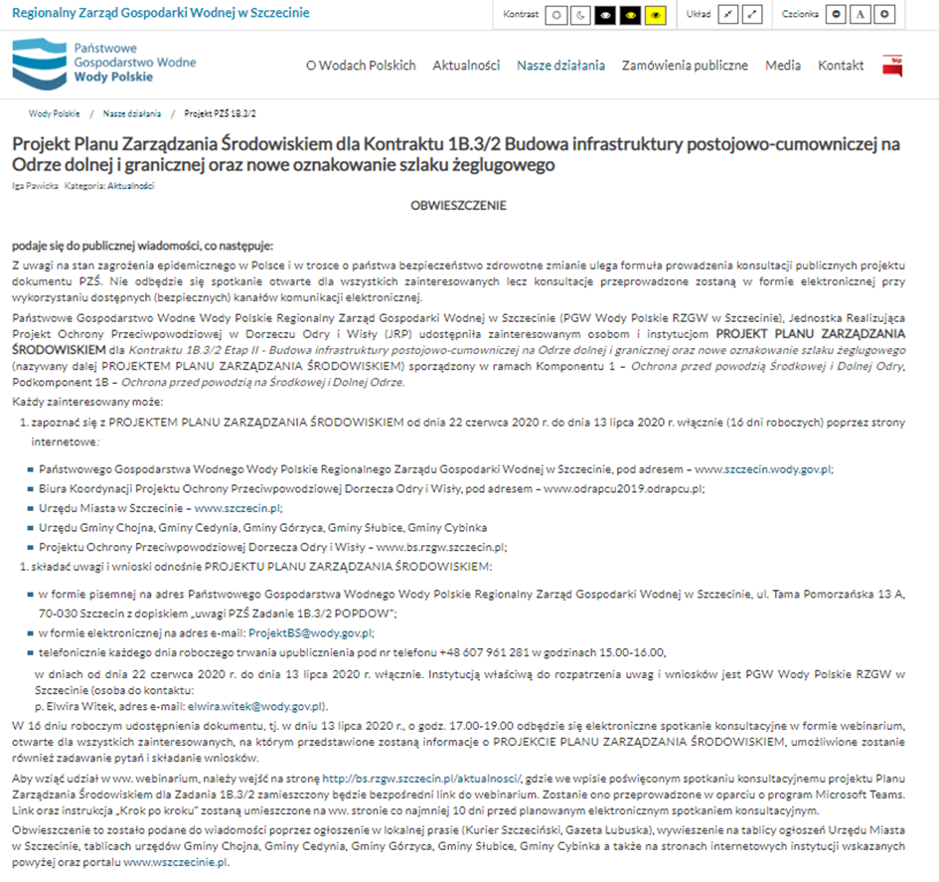
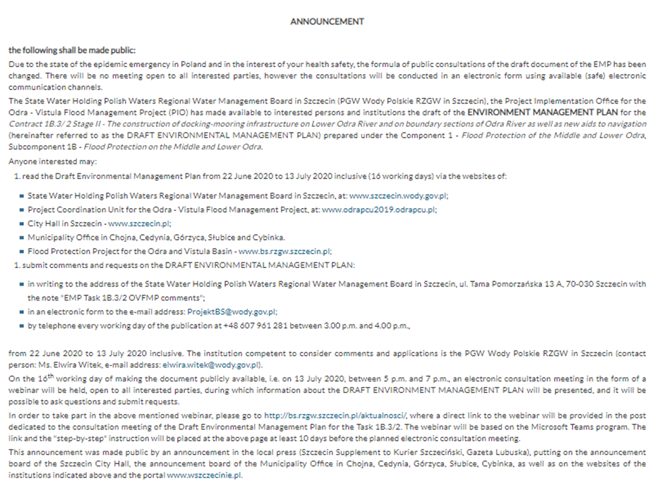

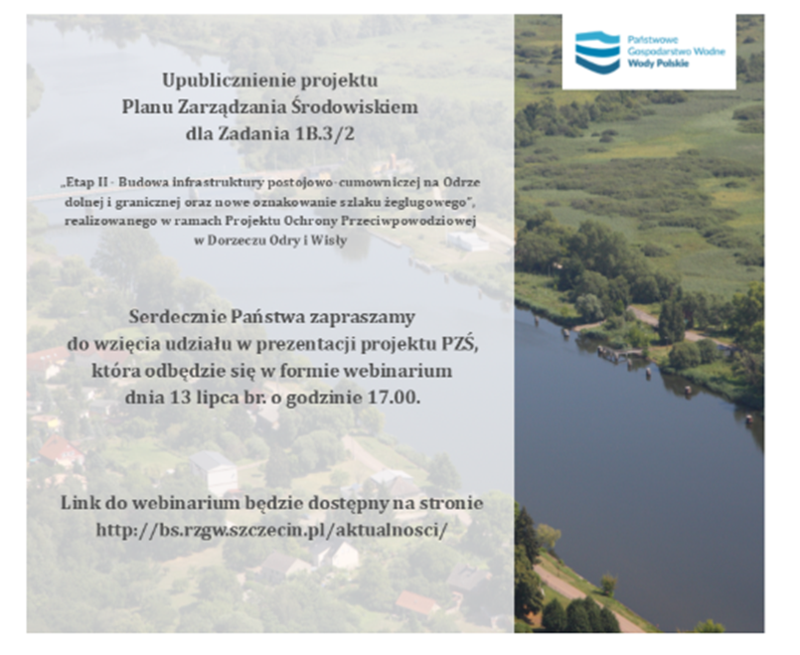
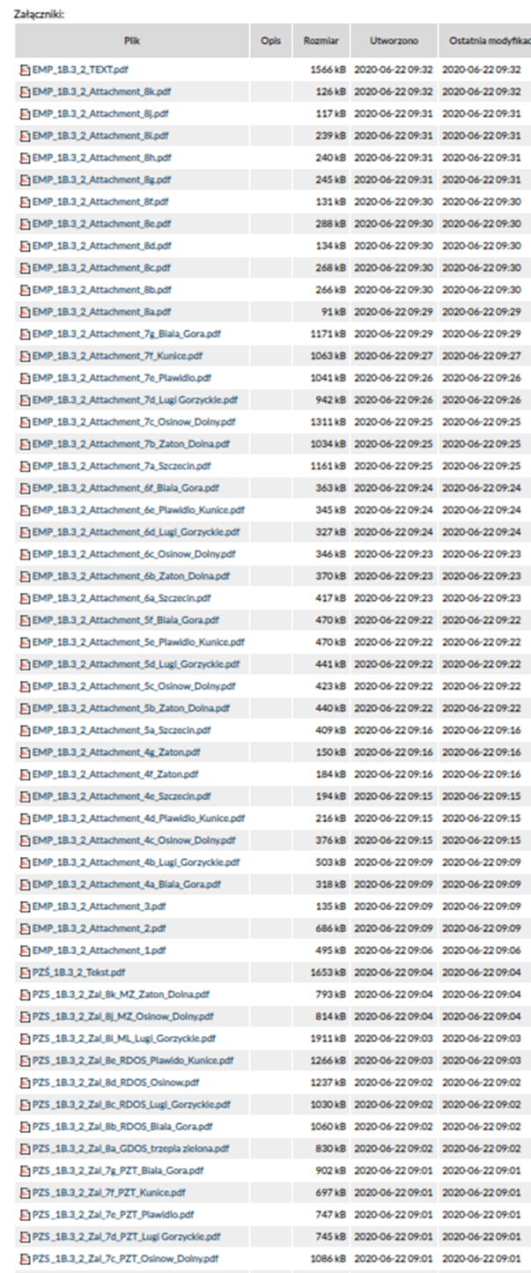
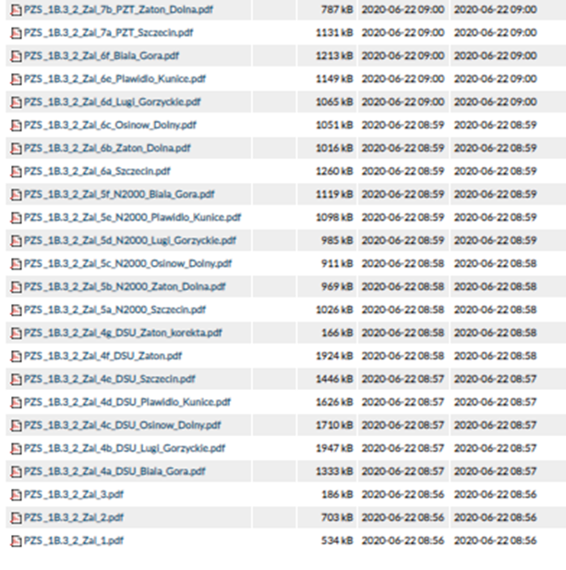
Fig. 1 Notice on PGW WP RZGW Szczecin website
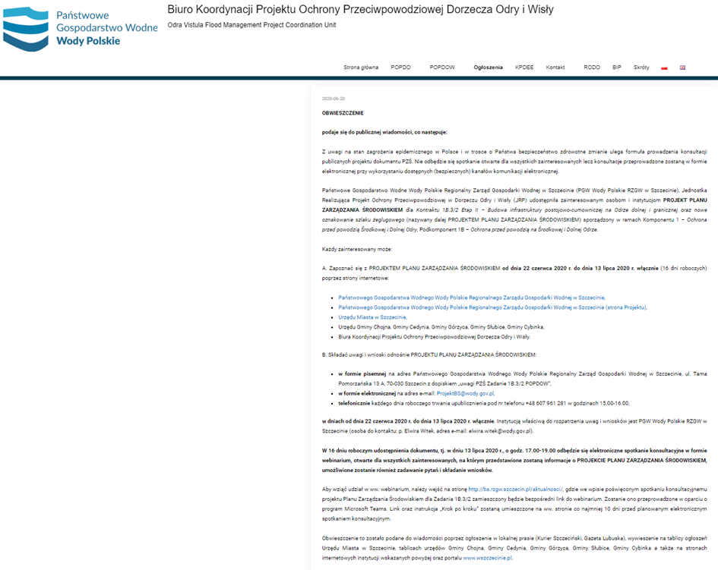
Fig. 2 Content of the draft document on the OVFM PCU website
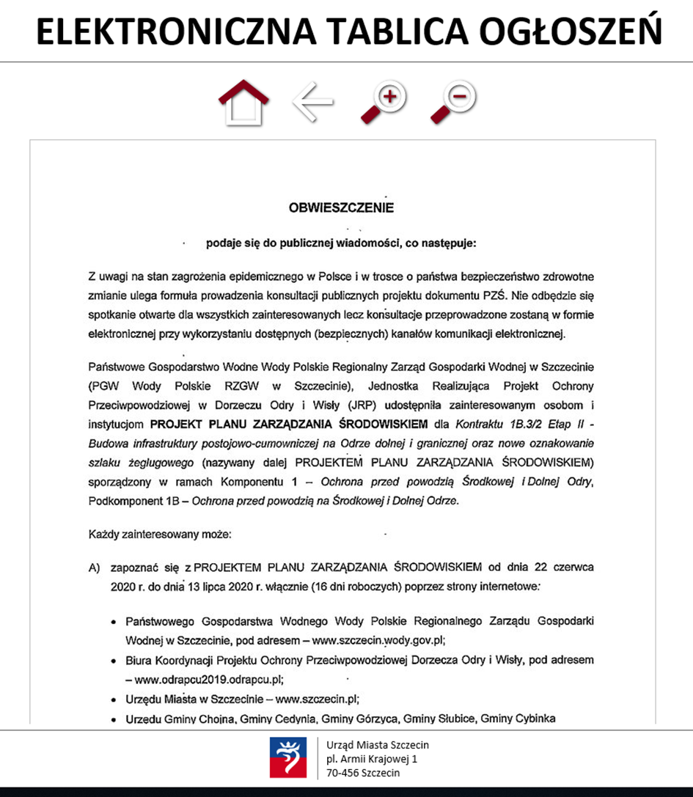
Fig. 3 Notice on the website of the Szczecin City Hall

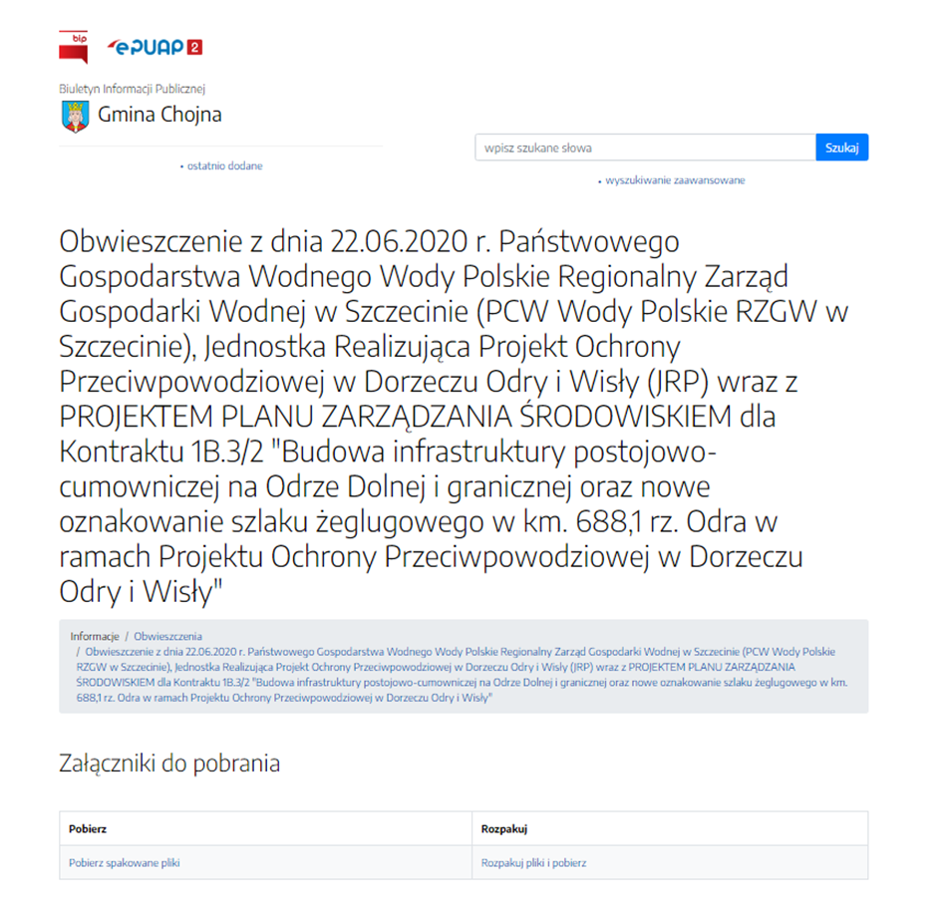
Fig. 4 Notice on the website of the Chojna Municipal Office
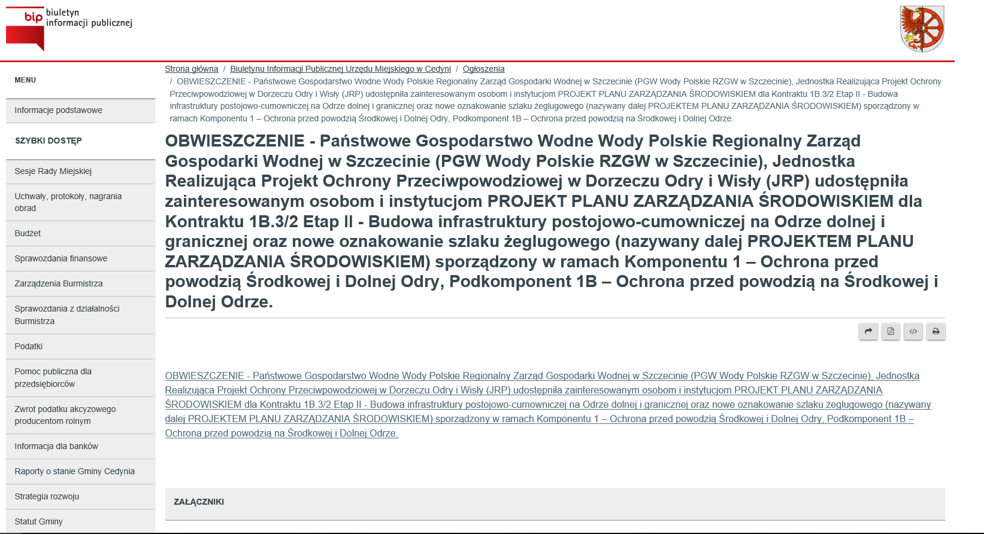
Fig. 5 Notice on the website of the Cedynia Municipal Office
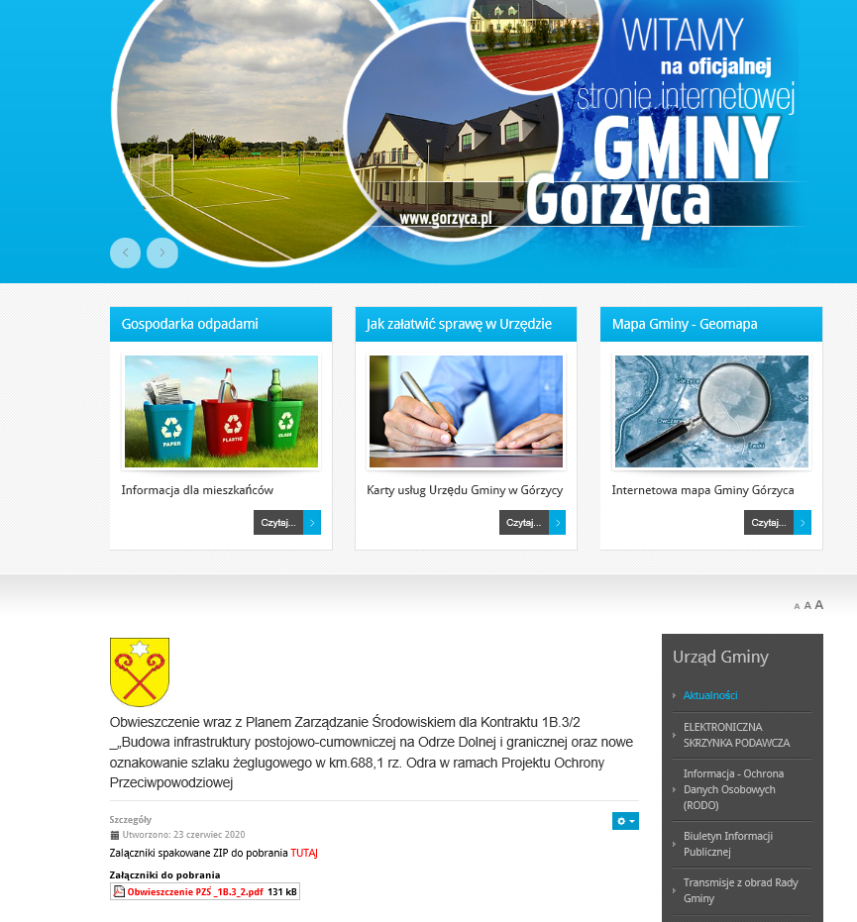
Fig. 6 Notice on the website of the Górzyca Municipal Office
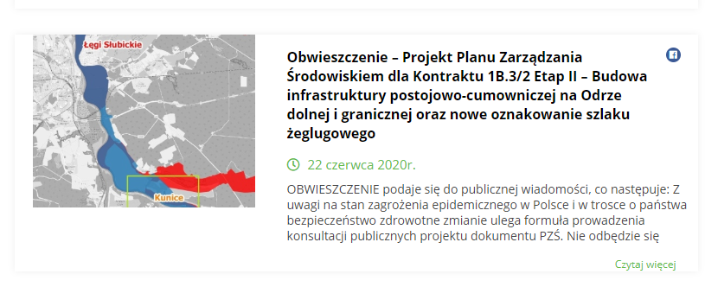
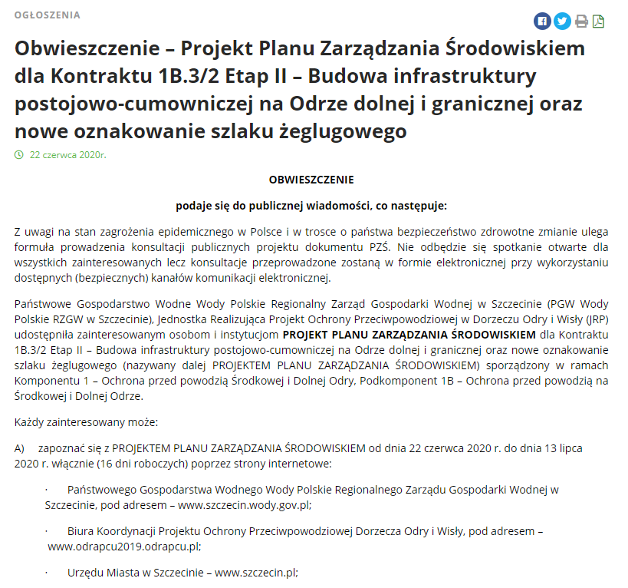
Fig. 7 Notice on the website of the Słubice City Hall
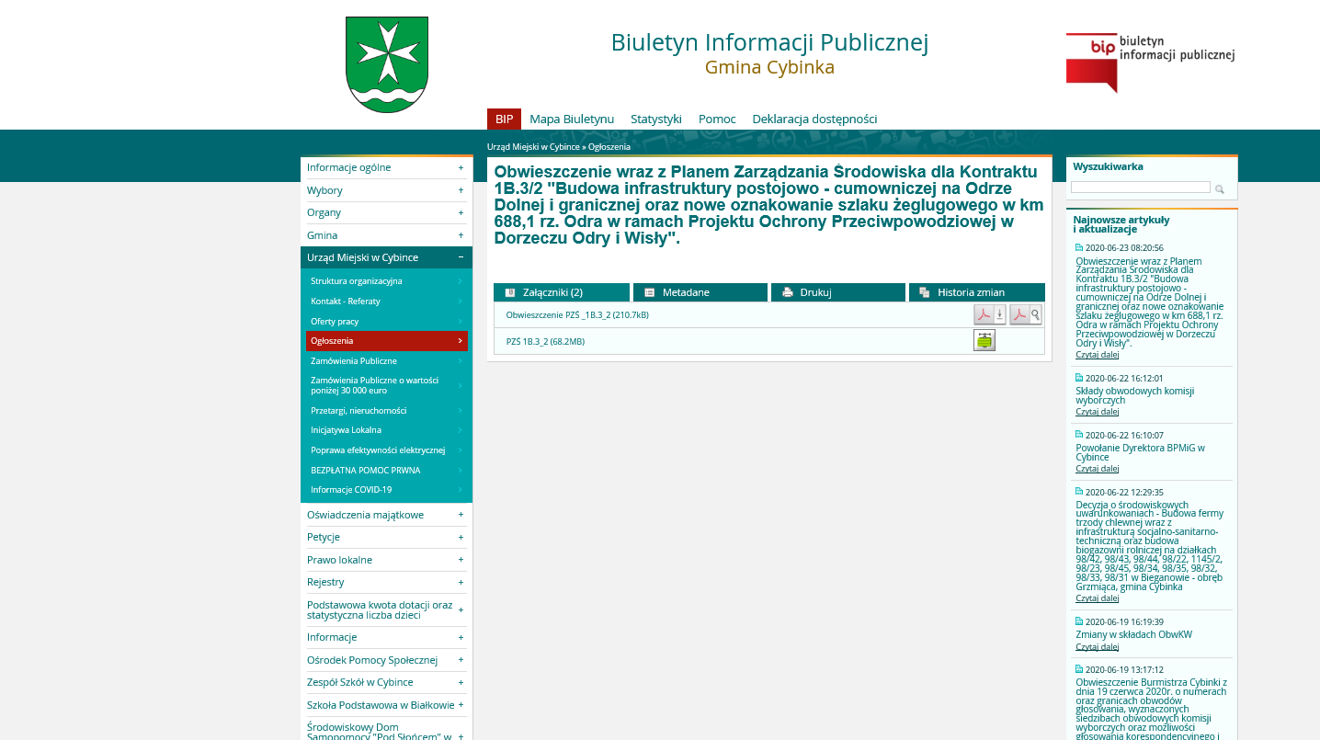
Fig. 8 Notice on the website of the Cybinka City Hall
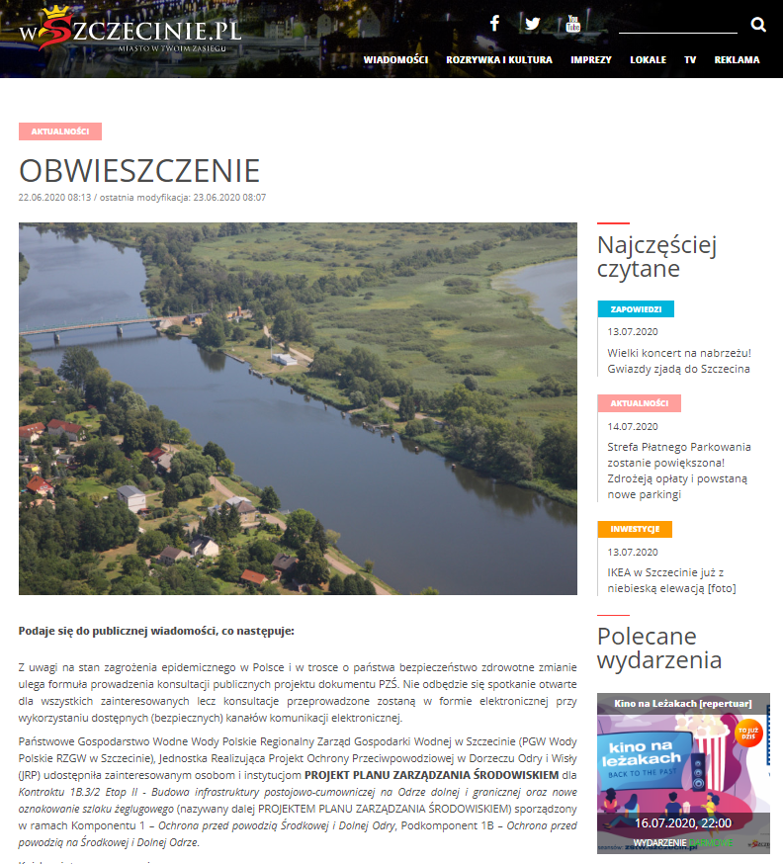
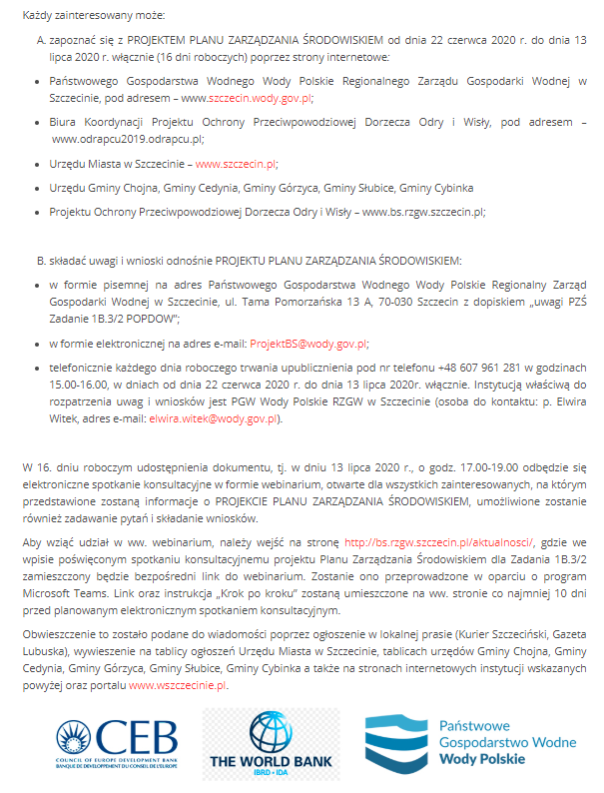
Fig.9 Notice on the wszczecinie.pl website
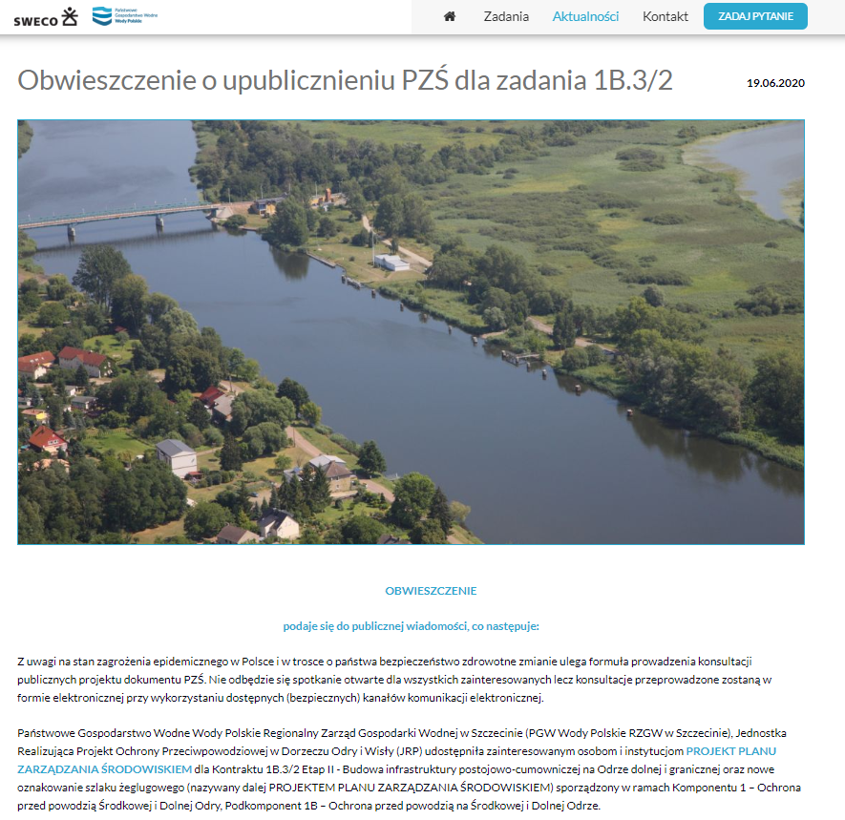
Fig. 10 Notice on the Project website – bs.rzgw.szczecin.pl
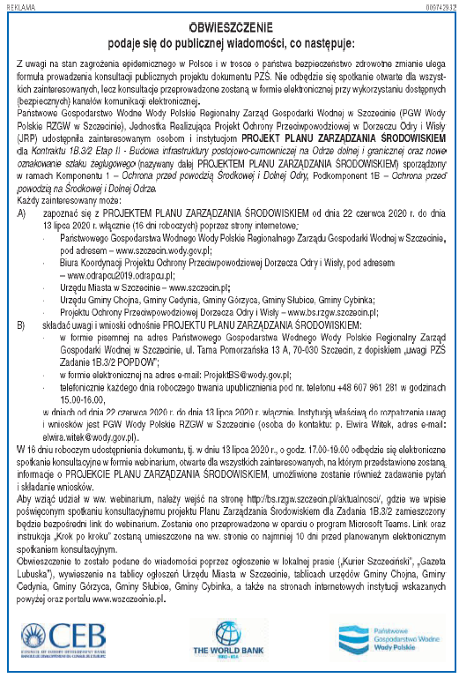
Fig. 11 Notice in Gazeta Lubuska dated 22.06.2020
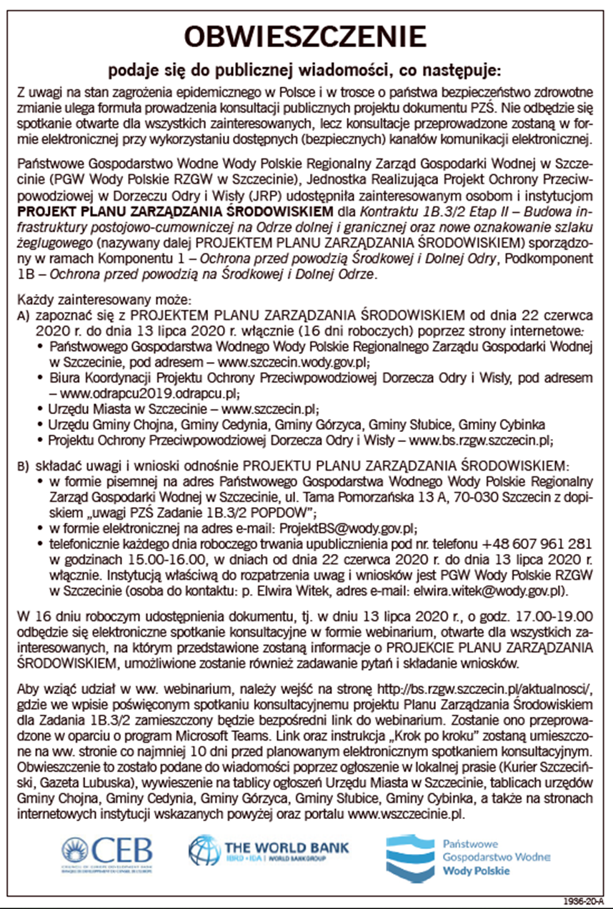
Fig. 12 Notice in Kurier Szczeciński dated 22.06.2020
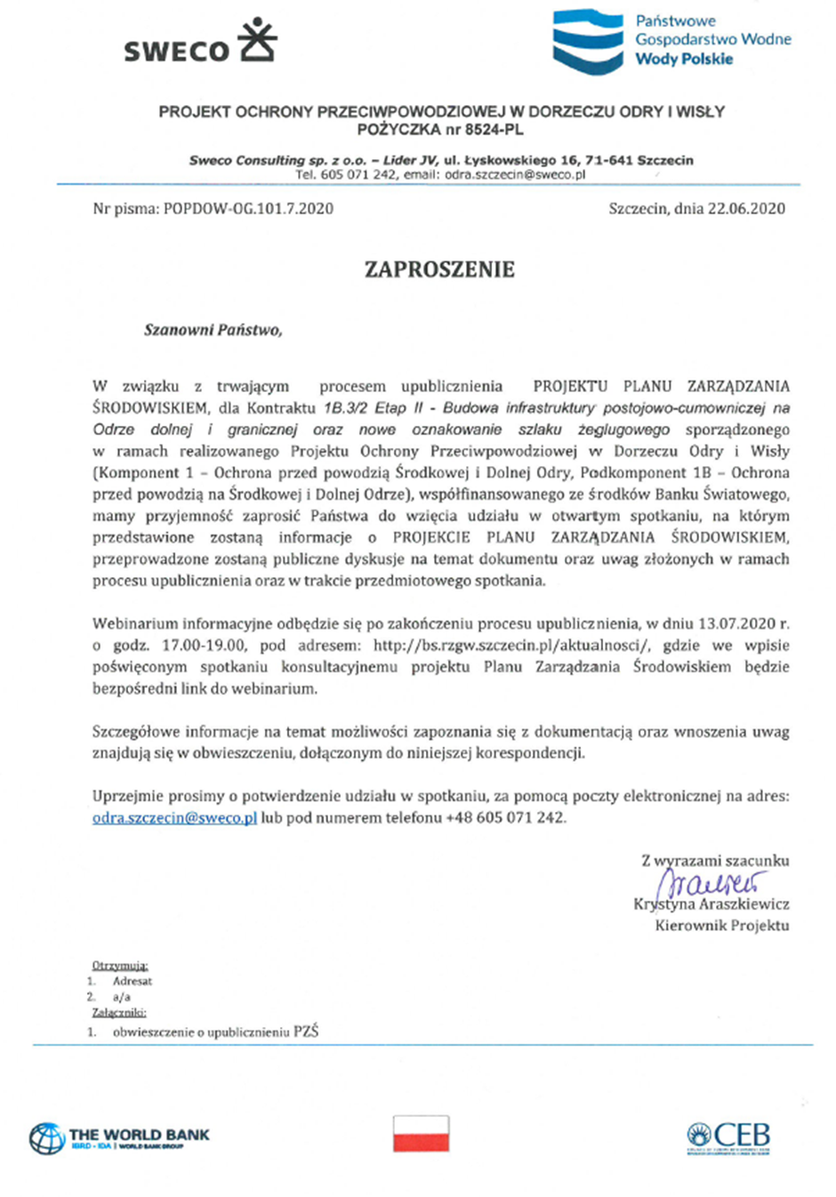

Fig. 13 Invitation to the meeting sent to representatives of local governments, private individuals, and NGOs
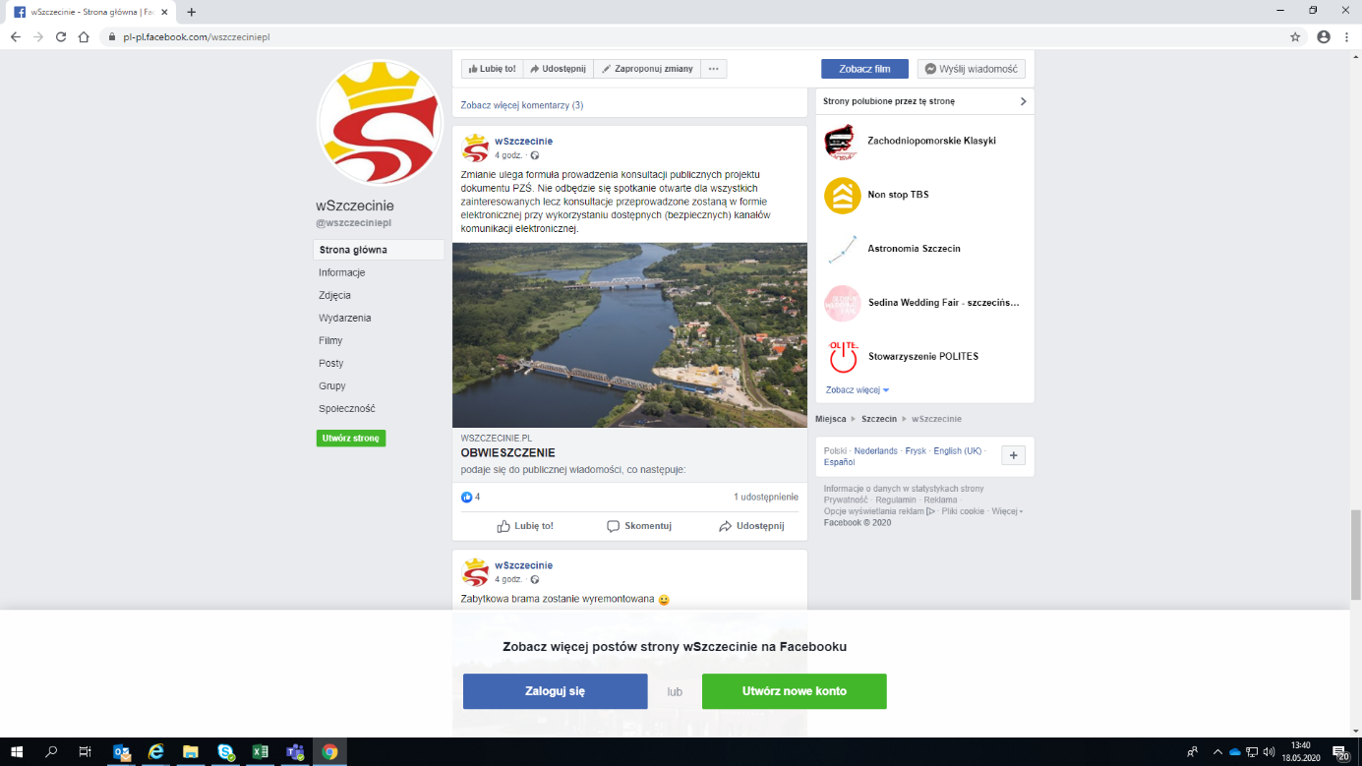

Fig. 14 Information about the webinar posted on the social media profile of portal wszczecinie.pl

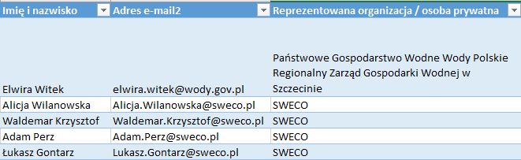

Fig. 15 Attendance list from the webinar conducted as part of the public consultation on the EMP draft on 13.07.2020

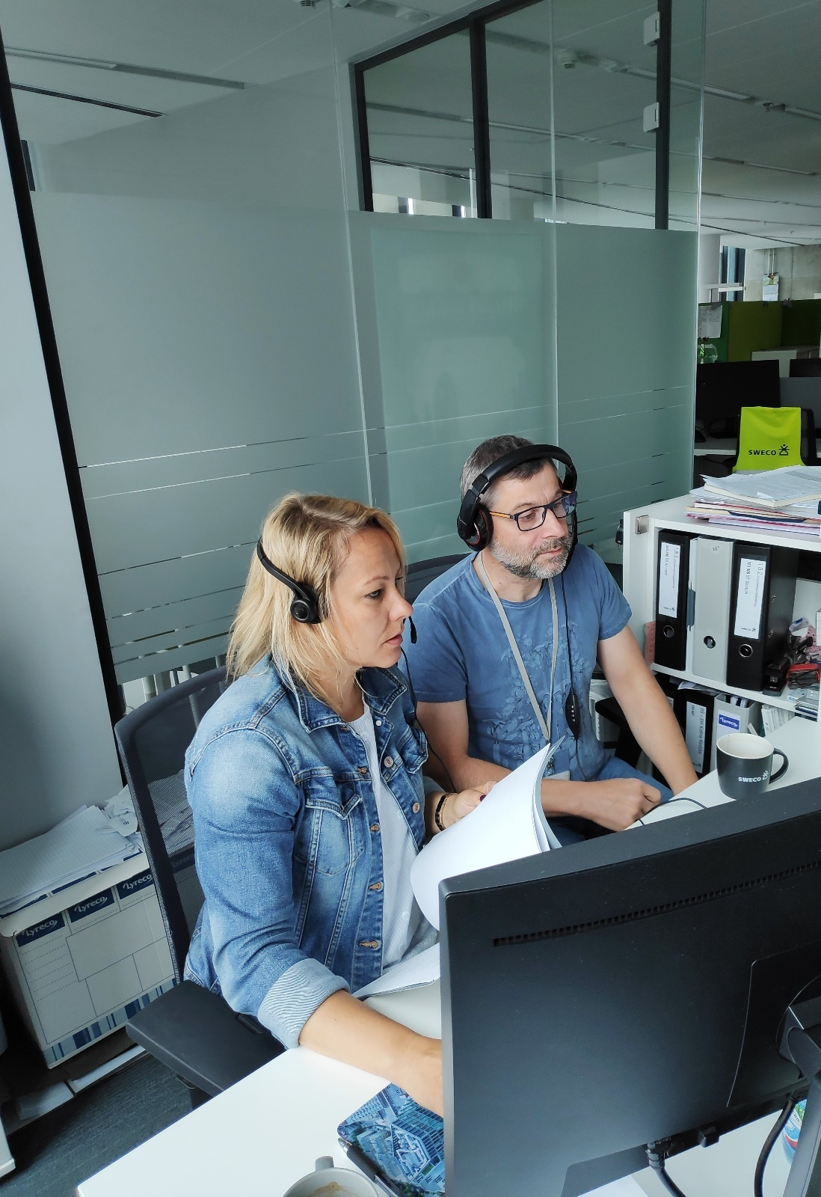

Fig. 16 Photos from the webinar held on 13.07.2020 at Sweco Consulting headquarters

