Based on article 140 paragraph 2 point 1, paragraph 3, article 122 paragraph 1 point 1, article 135 point 2, article 138 paragraph 1 of the Act of 18.07.2001 - Water law (Journal of Laws of 2012, item 145 as amended) and article 104 of the Act of 14.06.1960 - Code of Administrative Proceedings (Journal of Laws of 2000 No. 98, item 1071, as amended), having examined the request of the Maritime Office in Szczecin
I declare
- Stating the termination of the decision of the Mayor of the City of Szczecin of 25.02.2003 reference no.: WGKiOŚ. V.GK-6210/71-1/02/03 authorizing the Maritime Office in Szczecin to collect water from the West Oder River to desilt the Świnoujście - Szczecin fairway at km 51.0 to km 67.7 and authorizing the discharge of post-desilting waters from the "Dębina” discharge area to the West Oder River at km 60.5 of the Świnoujście - Szczecin fairway.
- Granting the Maritime Office in Szczecin a permit required by the Water Law Act for a special use of waters - collection of surface water from the West Oder River at km 60.0 of the Świnoujście - Szczecin fairway in order to desilt the Świnoujście - Szczecin fairway (on the section from km 51.0 to km 67.7), under the following conditions:
- amount of water collected:
Qmax.h = 200 m³/h
Q_{avr}. = 1.200 m³/d
Qmax.y. = 120.000 m³/year
- water collection conditions:
- the accumulation on the sections should not exceed the 0.2 m ordinate below the ordinates of the levee crown,
- during desilting, the spillway structures - the monk outlets, should be closed.
- Granting the Maritime Office in Szczecin a permit required by the Water Law Act for a special use of waters - introduction of post-desilting waters from the "Dębina" discharge area in Szczecin into soil, under the following conditions:
- amount of post-desilting waters:
Qmax.h = 216 m³/h
Q_{avr}. = 2.160 m³/d
Qmax.y. = 216.000 m³/year
- post-desilting water receiver: soil - drainage trench located on plots no. 910/3 and 912/3
Marshal Office
of the West Pomeranian Voivodeship
Szczecin, March 8, 2013
DECISION
W0S.II.7322.4.4.2013.MU

area Nad Odrą 25 Szczecin flowing into the West Oder River at km 60.5 of the fairway Świnoujście - Szczecin
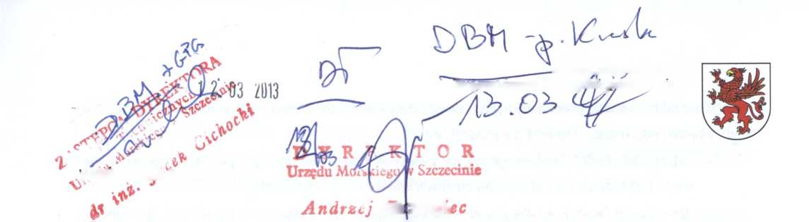

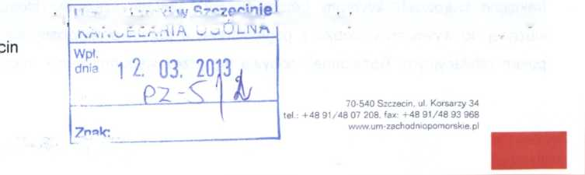

- introduction of post-desilting waters - using 7 steel monk outlets with a diameter of 508 mm
- conditions for discharging the post-desilting waters:
- the retention of post-desilting waters in the discharge area section once it has been completely filled cannot last less than twenty-four hours following the completion of desilting works,
- drainage of water from the discharge area section must be done gradually, i.e. by one stoplog on the monk outlet’s stand at a time,
- a maximum of two monk outlets furthest from the outlet of the desilting pipe in the area can be opened a the same time,
- carrying out tests of the West Oder River waters - following each instance of desilting works
- in the case of general suspension, at two control points: about 100 m below and above the outlet of the drainage trench to the river.
- Establish the period of validity of the water permit as 10 years from the date of signature of this Decision.
- Require the Maritime Office in Szczecin to:
- maintain the facility in proper technical and operational condition,
- systematically monitor the soil taken from the fairway for any possible pollution,
- update permits required by the Water Law Act in the event of changes in the conditions of water collection and discharge of post-desilting waters.
- Make the Maritime Office in Szczecin responsible for any damage resulting from the implementation of this Decision.
- The water sampling frame and this decision should be permanently kept in the Maritime Office in Szczecin and should be available to inspection bodies.
- The permit required by the Water Law Act does not give rise to the rights to real estate and water facilities necessary for its implementation, and does not infringe the property rights and rights of third parties relating to this real estate and equipment.
- The permit required by the Water Law Act may be withdrawn or limited without compensation if the unit changes the purpose and scope of water use or the conditions for exercising the rights set out in this Decision.

Justification
The "Dębina" discharge area is located on the island of Dębina in Szczecin on plots number: 910/3 (part), 910/4, 912/3 (part), 912/4 within the registration area Nad Odrą 25 Szczecin, which is the property of the State Treasury State Forests. These lands are managed by the Trzebież Forest District on behalf of the State Treasury. Plots No. 910/4 and 912/4, area Nad Odrą 25 Szczecin are located within the borders of the seaport in Szczecin.
Dredging works on the fairway consists in removing spoil in the form of a mixture of water and soil, in a ratio of 1:2 in the case of organic soil and up to 1:10 in the case of heavy gravel fractions, from the bottom. The removed spoil is pumped to a hopper vessel (a dump barge, watercraft used to transport spoil from dredgers), and then brought to the unloading site in front of the discharge area. The unloading consists of pumping the soil-water mixture out of the hopper vessel’s cargo hold, and then pumping it through the pipeline to the discharge area. In the discharge area, draining off takes place - a separation (sedimentation) of the water from the ground without any technological changes and its discharge through spillway structures (monk outlets) to the ditch - drainer and further to the basin from which it was collected (the West Oder).
The "Dębina" discharge area is located partly within the borders of the seaport in Szczecin. Ports or marinas as defined in the Act of 20.12.1996 on ports and marinas (Journal of Laws of 2002 No. 110, item 967, as amended), including port infrastructure used for loading and unloading, connected to the mainland or located off the shoreline, for handling vessels with a load capacity of not less than 1350 tonnes, in accordance with § 2 paragraph 1 point 34 of the Regulation of the Council of Ministers of 9.11.2010 on projects which may significantly affect the environment (Journal of Laws No. 213, item 1397) - are projects that can always significantly affect the environment.
Therefore, the authority competent to issue this decision, pursuant to art. 140 paragraph 2 point 1, item 3 of the Water Law Act, is the Marshal of the West Pomeranian Voivodeship.
The Maritime Office in Szczecin had the decision of the Mayor of the City of Szczecin of 25.02.2003 reference no.: WGKiOŚ.V.GK-6210/71-1/02/03 allowing the Maritime Office in Szczecin to collect water from the West Oder River to desilt the Świnoujście - Szczecin fairway at km 51.0 to km 67.7 and permitting the discharge of post-desilting waters from the "Dębina" discharge area to the West Oder River at km 60.5 of the Świnoujście - Szczecin fairway. Because the decision was valid until 1.03.2013, the Maritime Office in Szczecin requested to terminate the above decision of the Mayor of the City of Szczecin and issue a new water law decision.
In accordance with art. 135 point 2, the permit required by the Water Law Act shall expire if the unit waives the rights set out in that permit. In connection with the above, pursuant to the provision of art. 138 paragraph 1 the termination of the decision of the Mayor of the City of Szczecin of 25.02.2003 was stated, reference no.: WGKiOŚ.V.GK-6210 / 71-1/02/03.
The request for the water law decision was supplemented with the following attachments:
- “The water sampling frame for collecting surface waters from the West Oder River and for introducing post-desilting waters from the “Dębina” discharge area in Szczecin” - developed by mgr inż. Paweł Molenda (November 2012),
- intent description written in non-technical language.
During the water-law proceedings, the authority fulfilled the statutory obligation under art. 127 paragraph 6 of the Water Law Act and made public information about the proceedings initiated in the case. The parties to the water law procedure were notified about the initiation of the procedure by a notification of 15.02.2013, reference no.: WOŚ.II.7322.4.1.2013.MU. In accordance with art. 10 § 1 of the Code of Administrative Proceedings, the parties were informed about the materials collected in the case. Within the prescribed period of 7 days, the parties to the proceedings did not raise any objections to the case, and the conducted proceedings showed that there were no obstacles to issue the permit requested, to the extent and under the conditions specified in the decision.
Based on an analysis of the results of bottom sediment testing of 2.07.2012 made by the Polish Geological Institute The National Research Institute in Warsaw it was found that the spoil from the bottom of the Świnoujście - Szczecin fairway is not dangerous.
In accordance with art. 136 paragraph 1 point of the Water Law Act, a permit required by the Water Law Act may be withdrawn or limited without compensation if the unit changes its purpose and scope or the conditions for exercising the rights set out in this Decision.
In accordance with the provisions of art. 37 paragraph 3 of the Act of 21.03.1991 on maritime areas of the Republic of Poland and maritime administration (Journal of Laws of 2003 No. 153, item 1502, as amended), the draft permit required by the Water Law Act was agreed by the decision of the Director of the Maritime Office in Szczecin of 6.03.2013 reference no.: GPG-l-5010-Port Szcz-2/5/13.
Given the above, the decision was as in the conclusion.
The Party has the right to submit an appeal against this decision to the President of the National Water Management Authority through the Marshal of the West Pomeranian Voivodeship within 14 days from the date of its receipt.
70-207 Szczecin, pl. Batorego 4 Attachment: 1 sampling frame
- State Forests Trzebież Forest Division 72-004 Trzebież, Zalesie 1
- Regional Water Management Authority
70-030 Szczecin, ul. Tama Pomorzańska 13A
- a/a
For attention of:
1. Mayor of the City of Szczecin
70-465 Szczecin, pl. Armii Krajowej 1
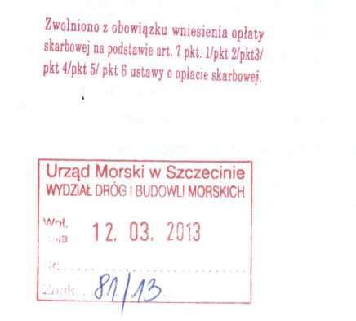

Copies to:
The Maritime Office in Szczecin

