Report on the public disclosure procedure for the draft Environmental Management Plan for Contract 1B.3/1 Stage I:
Mooring base for icebreakers
implemented as part of the Odra-Vistula Flood Management Project (OVFMP)

The Environmental Management Plan draft (EMP) for Contract 1B.3/1 Stage I: Mooring base for icebreakers was subject to public consultations conducted in accordance with the requirements of the World Bank's operational policy (OP 4.01). The purpose of the consultations was to enable individuals, institutions and all interested parties to become acquainted with the content of this document and to provide them with the opportunity to submit any comments, questions and requests regarding this content.
Once the EMP draft was prepared, the document was forwarded to the World Bank in order to obtain the approval to make the draft public. Once the World Bank approved the commencement of the procedure to make the EMP draft public, the electronic version of the document and the announcement on public consultations were posted on the following websites:
- The State Water Holding Polish Waters (PGW PW) Regional Water Management Board in Szczecin (RZGW in Szczecin) website - (Fig. 1);
- The Co-ordination Office of the Odra-Vistula Flood Management Project website - (Fig. 2);
- The Szczecin City Hall website - (Fig. 3);
- wszczecinie.pl – (Fig. 4)
- the Project website - bs.rzgw.szczecin.pl - (Fig. 5)
Information about the chance to get acquainted with the content of the EMP draft and to submit requests and comments, as well as contact details (e-mail address, addresses of places where the paper version of the document is available to be read, opening hours) was published in the local press. The Announcement was published on 07.08.2019 in Kurier Szczeciński (Fig. 7) and in the local Gazeta Wyborcza supplement (Fig. 6). The Announcement also contained information on the place and date of the consultation meeting being part of the summary of public consultations of the EMP draft (the date, time, address and purpose of the meeting).
In order to ensure the widest possible access to information on the EMP draft, it was decided that the paper version of the documentation would be made available to all interested persons in the period from 07.08.2019 to 29.08.2019 (i.e. 16 working days) at the following offices:
- The State Water Holding Polish Waters Regional Water Management Board in Szczecin, ul. Tama Pomorzańska 13A, 70-030 Szczecin;
- The Implementing Unit of the Flood Protection Project for the Oder and Vistula Basin (OPDOW PIU), PGW Polish Waters RZGW in Szczecin, ul. Teofila Firlika 19,
71-637 Szczecin;
- Department of Environmental Protection in the Szczecin City Hall, Plac Armii Krajowej 1, 70-456 Szczecin
Due to a technical error in the content of the announcement on the PGW WP RZGW website in Szczecin and on the http://bs.rzgw.szczecin.pl website, i.e. an incomplete e-mail address for submitting comments, the period for making documentation available and submitting comments was extended to 06.09.2019. This information was sent on 29.08.2019 in the form of announcements in Kurier Szczeciński (Fig. 8) and on the websites of Szczecin City Hall (Fig. 9), wszczecinie.pl (Fig. 10) and bs.rzgw.szczecin.pl (Fig. 11).

Public consultation meeting
After the end of the public disclosure period (paper and electronic version of the documentation was available to all interested parties from 07/08/2019 to 29/08/2019 inclusive) an open meeting was organized for interested persons, organizations and institutions (Fig. 12 - 13). The meeting was organized on 30/08/2019 in room no 302 at the Faculty of Civil Engineering and Architecture of the West Pomeranian University of Technology Szczecin (al. Piastów 50, 71-899 Szczecin) at 17.00-19.00. A total of 7 people attended the meeting, all of whom were representatives of the PIU and the Technical Support Consultant. For the needs of the meeting, a multimedia presentation was prepared containing information on the rules for the development and operation of the EMP during the implementation of investments co-financed by the World Bank and detailed information on the EMP project for Contract for works 1B.3/1 Stage I – Mooring base for icebreakers and content of draft EMP, including self-correction for the “Dębina” silting field.

Comments submitted during the publication period
During the period of publication no persons wanted to read the paper version of the document in the places indicated. During this period, the following questions and comments to the content of the EMP draft were received by electronic mail - they were submitted by one natural person. Comments below:
- In the "ENVIRONMENT MANAGEMENT PLAN” document (with a WORKING VERSION subtitle in the margin) http://szczecin.wody.gov.pl/ attachments / article / 603/1% 20PZ% C5% 9A_1B.3_TEKST.pdf ["base for icebreakers”] there is no information about monuments located in the investment area. Heavy equipment, construction machinery, transport of materials will take place on roads near which monuments entered in the voivodship and commune register of monuments are located. Ground vibrations can lead to their deterioration. The document does not mention that such monuments are located in this area, especially on ul. Karpia, where there are, among others, a tenement house and a church.
Even if the opinion of the authors of the study is that the transport of materials and equipment will not pose a threat to the local monuments: the document should directly state the existence of specific monuments and that there are no threats to them - or state that these threats exist, list them and indicate preventive measures.
Ignoring this issue or treating it only in general terms without reference to specific historic buildings may lead to their deterioration, if only because, e.g., construction manager, investor, supervisory authorities, or drivers transporting machinery and materials will not be informed that there are historic objects to which they should pay special attention on their route, drive at a lower speed, with less load, etc. The document made available to the residents does not indicate the permissible routes and maximum speeds and loads. Meanwhile, the said tenement house and the church in ul. Karpia are barely 1.5 meters from the road, and the road itself is paved, which means that the monuments will be exposed to greater vibrations. Please find attached the map http://geoportal.szczecin.pl:9090/gpt4/ ?permalink=21217566
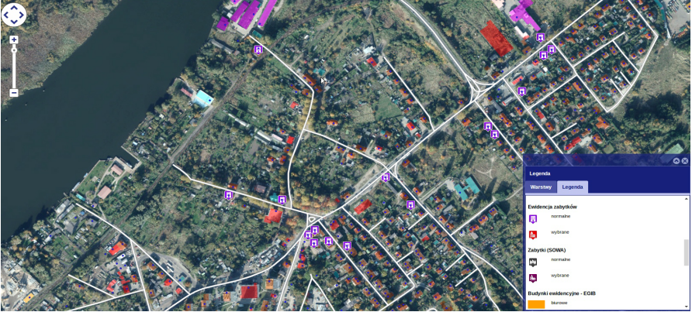
2) Another issue concerns preventing the residents and anglers from accessing Regalica. In Podjuchy, the residents’ access to Regalica is already very limited. In fact, the only peaceful and the closest place of access was the area for which the investment has been planned. Other nearby places of access are, for instance, under the railway bridge and under the road and railway bridges (both are unsightly and noisy places, and the second location is very difficult to access - access basically only by car).
Therefore, it would be reasonable for residents to have access to the quays as it is today - via the road that is an extension of ul. Karpia leading to Regalica, where there is still a bench and space for anglers.

Answers to comments
Ad. 1. The issue related to the need to limit the potential impact of transport on buildings (including historic buildings) at the Task implementation stage is included in Annex 1 to the EMP in the conditions specified for transport service of the Task implementation area. In particular, a requirement was imposed on the Contractor to develop, agree with road operators and carry out a traffic organization project (conditions in items 4-7). In item 10: the Contractor was obliged to comply with the statutory axle load limitations when transporting materials and equipment to and from the Task implementation area. One could also indicate item 9, which indicates the Contractor's material liability for damages to structures and buildings, including cultural objects and the obligation to repair any damages at their own expense. In connection with the above, in item 12 the Contractor was obliged to prepare photographic documentation of the entire Task implementation area and access roads, with particular regard to the technical condition of roads and buildings located near the roads to be used for transporting building materials.
The indicated mitigation measures, which are part of the mitigation package specified for the protection of material goods, should effectively protect historic buildings located by the construction site access roads.
In connection with the submitted comment, the provisions in the descriptive part of the EMP were extended to include the following:
- information about the historic buildings in the vicinity of access roads in the investment area, in particular buildings entered in the register of monuments in ul. Karpia
- indication that the mitigation measures specified for the protection of material goods also apply to historic buildings.
These provisions, in accordance with the suggestion contained in the comment submitted, should raise the Contractor’s awareness of the need to protect cultural property during planning and execution of transport operations.

Ad. 2. The described areas will be placed within the fenced area constituting the base for icebreakers. For security reasons and due to the need to protect public property, it is not possible to provide unauthorized access to the icebreaker base, including mooring and repair quays. There are no areas on the bank of Regalica that could be developed by the Investor and made available for the abovementioned purposes and where the safety of persons therein could be ensured. The photos of the area are included in Fig. 14 and 15.
The Environmental Management Plan covers issues of compliance with the World Bank's Operational Policies and Procedures in the field of environmental protection. The issues presented in the comment fall outside the scope of the Environmental Management Plan.
However, issues related to the process of property acquisition for the purposes of the Task, including issues related to restricting access to recreational and leisure areas, are subject to the requirements set out in the Operational Policy OP 4.12 (OP 4.12 Involuntary Resettlement - World Bank Operational Policy containing the main principles and procedures underlying the Bank's approach to involuntary resettlement related to investment projects). The document developed in accordance with the Operational Policy OP 4.12 is the Land Acquisition and Resettlement Action Plan (LA&RAP).
In connection with the above, this comment was forwarded to the team developing the Land Acquisition and Resettlement Action Plan and it will be considered when preparing this document. The Land Acquisition and Resettlement Action Plan will be subject to public disclosure and consultation.
No other comments or questions regarding environmental conditions and the content of the EMP and the description of mitigation and monitoring activities were reported during the document publication period. The comments received by the OVFMP PIU were analysed, an appropriate explanation was prepared on their basis, including references to individual entries in the content of the EMP draft. Relevant written responses were given to the comments submitted.
Due to the above, the public consultation process was considered complete. Then, the Consultant proceeded to prepare a Report on public consultation on the EMP draft for Task 1B.3/1).
The nature of the comments did not necessitate significant changes to the provisions of the EMP. However, due to the submitted comment regarding the potential hazards that the transport of materials on public roads may cause for buildings entered in the register of monuments, the entries in the descriptive part of the EMP regarding the location of buildings entered in the register of monuments in the vicinity of access roads in the investment area, in particular in Karpia Street, were extended. Additionally, it was clearly indicated in the EMP that mitigation measures specified for the protection of material goods also apply to historic buildings. These provisions, in accordance with the suggestion contained in the comment submitted, should raise the Contractor’s awareness of the need to protect cultural property during planning and execution of transport operations.
In addition, as a result of a revision of the document draft, some minor editing corrections were made as well as correction of item 118 of Annex 2 to the EMP and in particular additions due to the need to add records about the possibility of depositing spoil in the “Dębina” silting field. The decision on environmental conditions (see Annex 4 to the EMP) indicated that dredging spoil may be deposited in silting fields operated by the Maritime Office in Szczecin (UMS), including the “Mańków” and “Dębina” silting fields. The availability of discharge areas depends on their current use as part of the investments carried out by the Maritime Office in Szczecin. At the stage of preparing the document draft, UMS declared the possibility to desilt the spoil in the “Mańków” silting field - such a provision was applied in the EMP draft. Currently, due to the dredging works planned by UMS on the Szczecin - Świnoujście fairway, UMS predicts restrictions on the use of the “Mańków” field by third parties and also indicates the use of the "Dębina" silting field for the Task. In connection with the above, it was necessary to supplement the provisions of the EMP draft and include the "Dębina silting field.

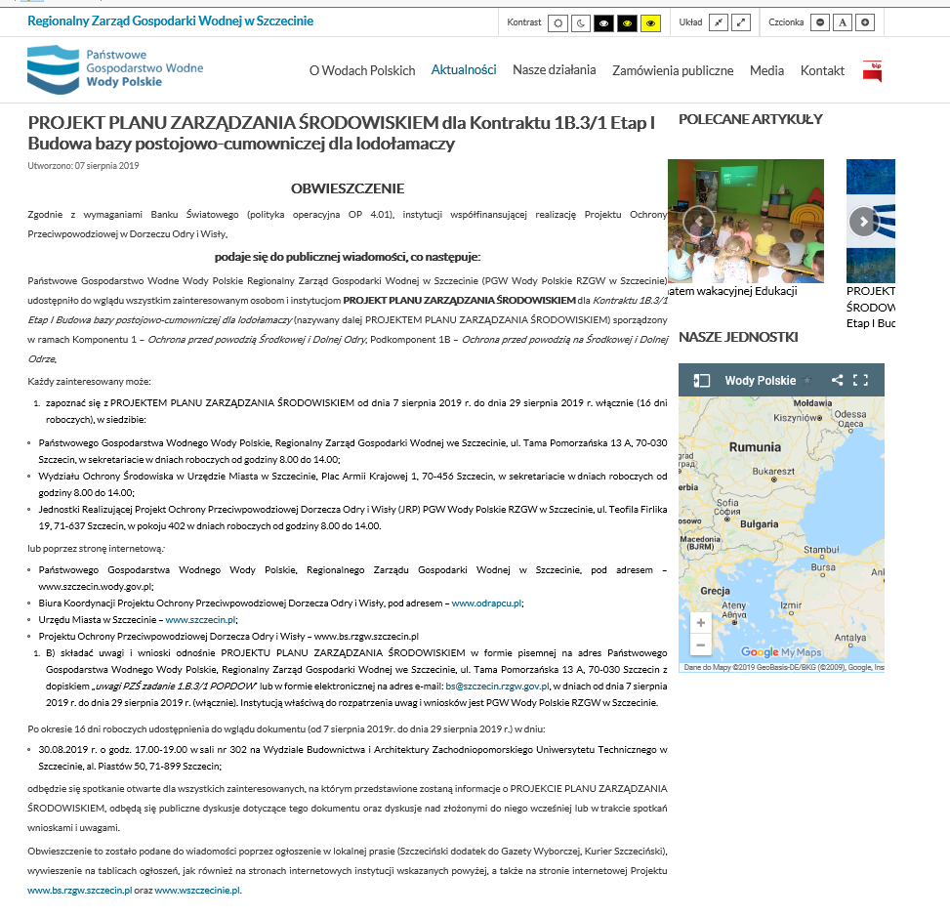
Fig. 1 Announcement on the PGW WP RZGW website in Szczecin
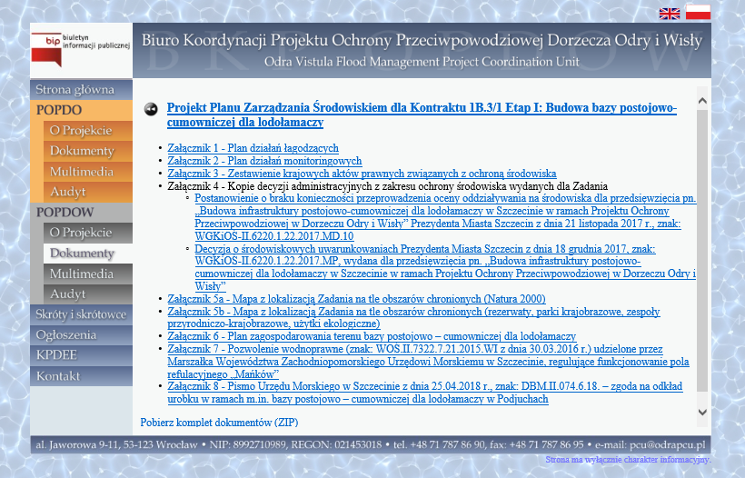
Fig. 2 Content of the document draft on the BKP OPDOW website
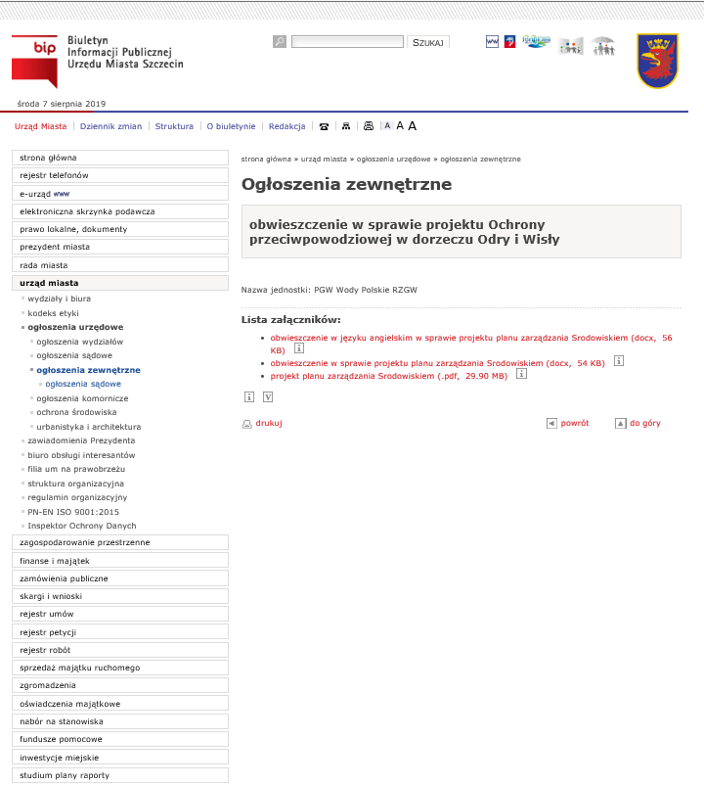
Fig. 3 Announcement on the Szczecin City Hall website
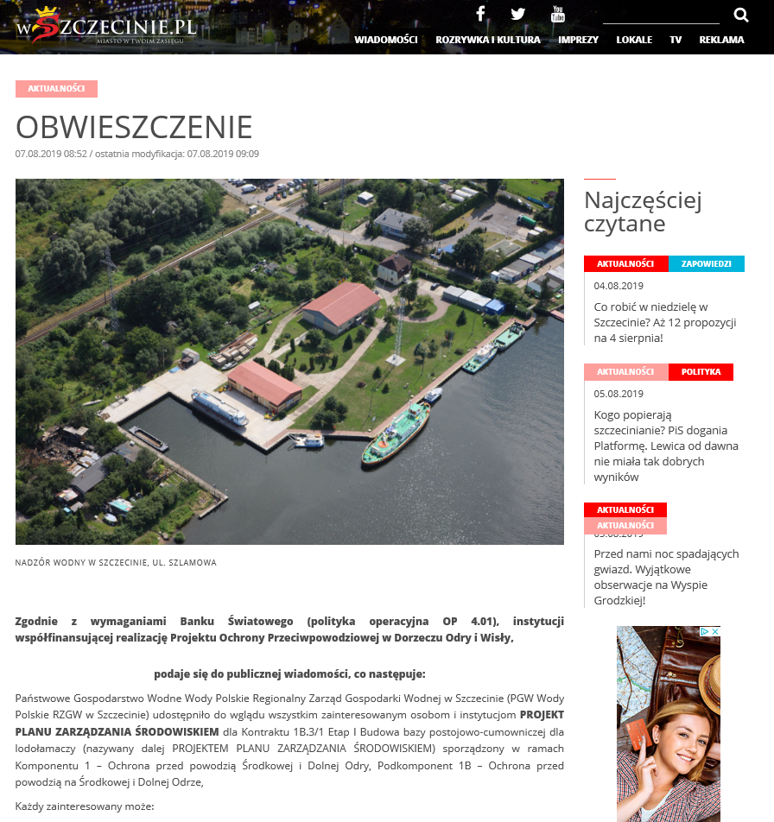
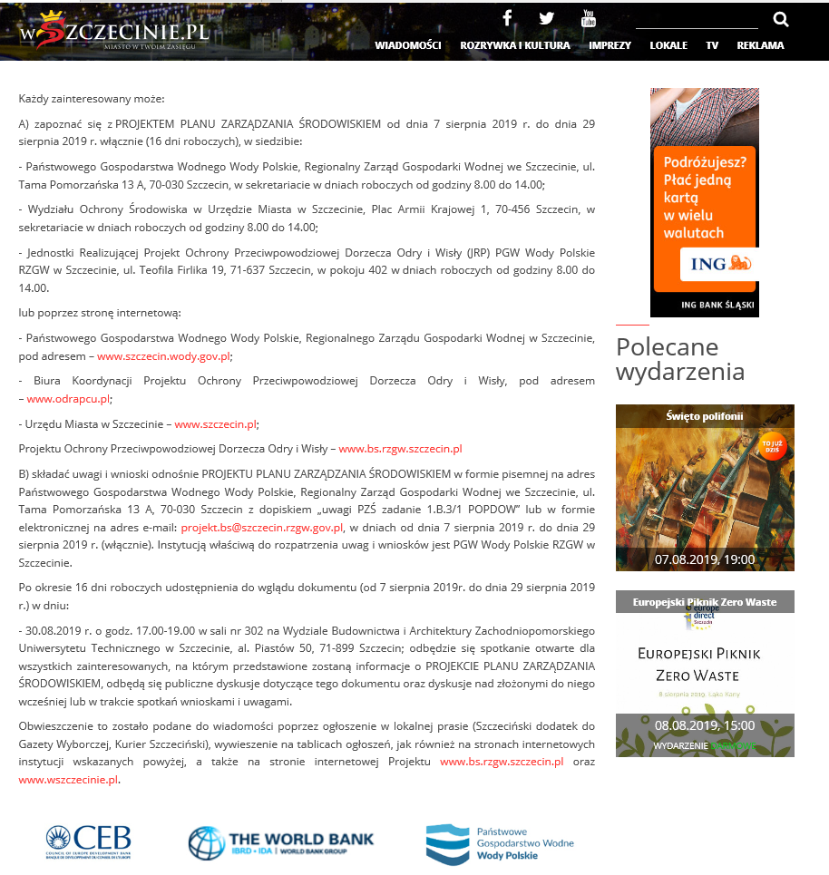
Fig. 4 Announcement on the wszczecinie.pl website
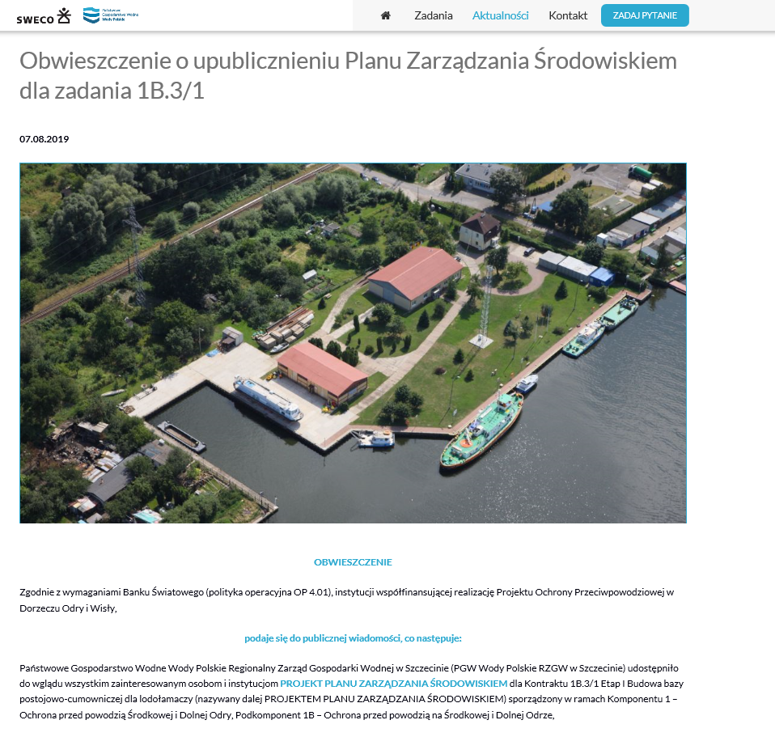
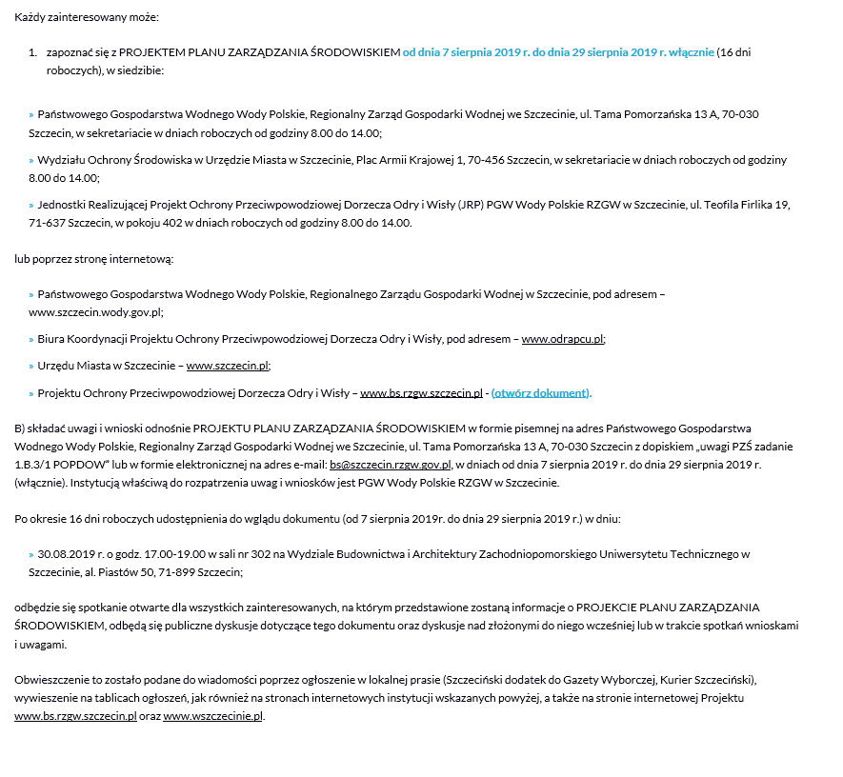
Fig. 5 Announcement on the Project website - bs.rzgw.szczecin.pl
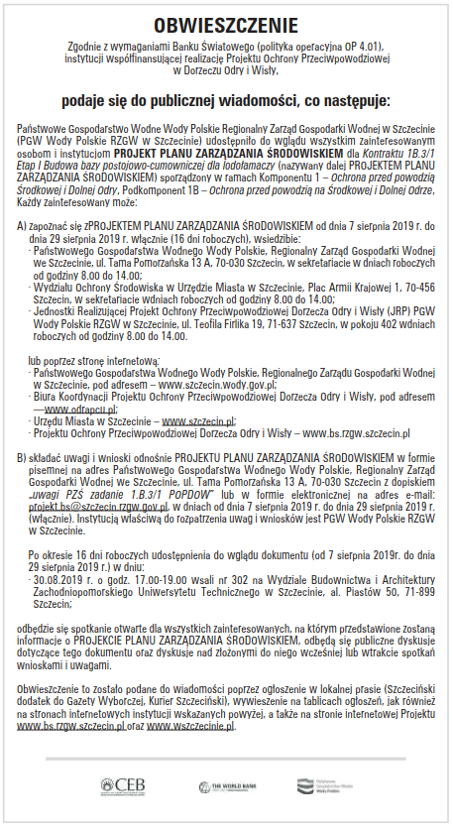
Fig. 6 Announcement in the supplement to Gazeta Wyborcza of 07.08.2019
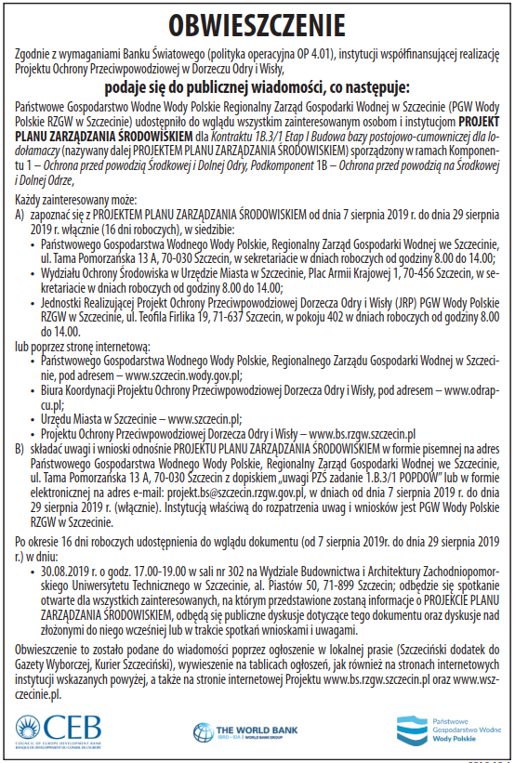
Fig. 7 Announcement in Kurier Szczeciński of 07.08.2019
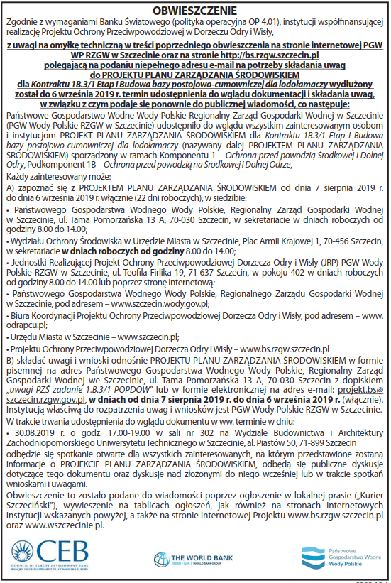
Fig. 8 Second announcement in Kurier Szczeciński of 29.08.2019.
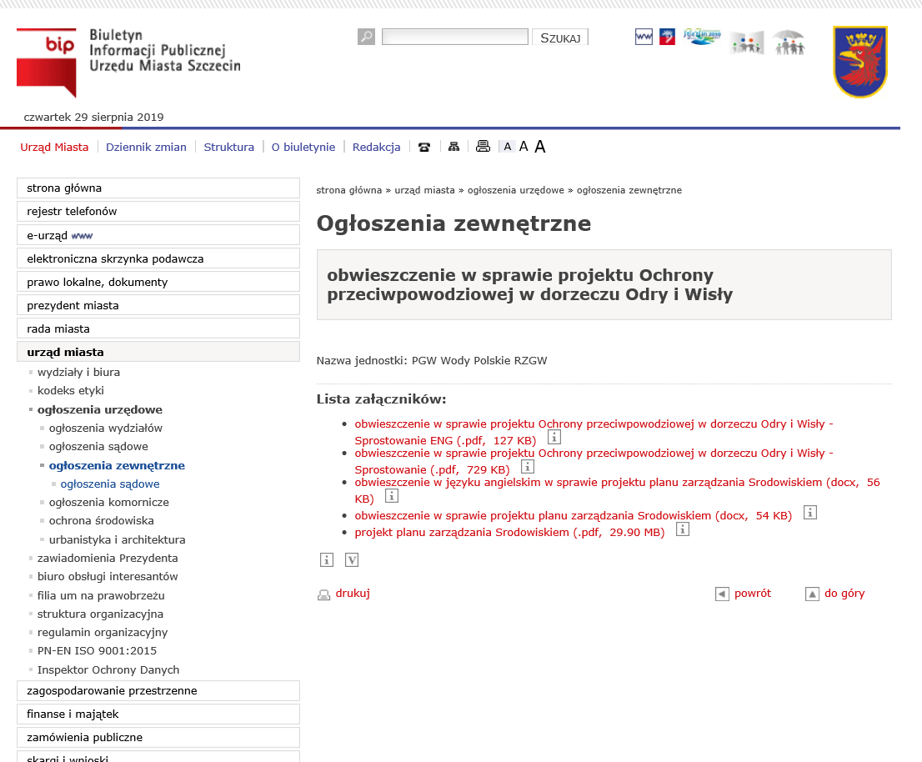
Fig. 9 Correction on the Szczecin City Hall website
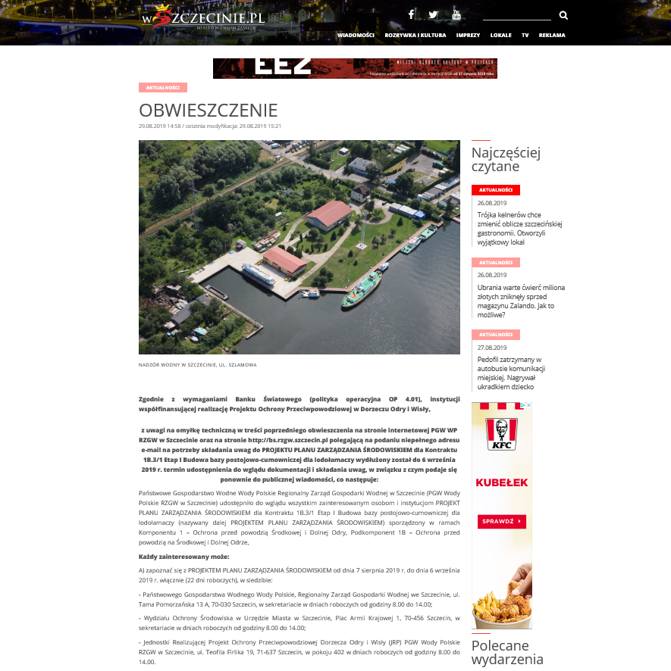
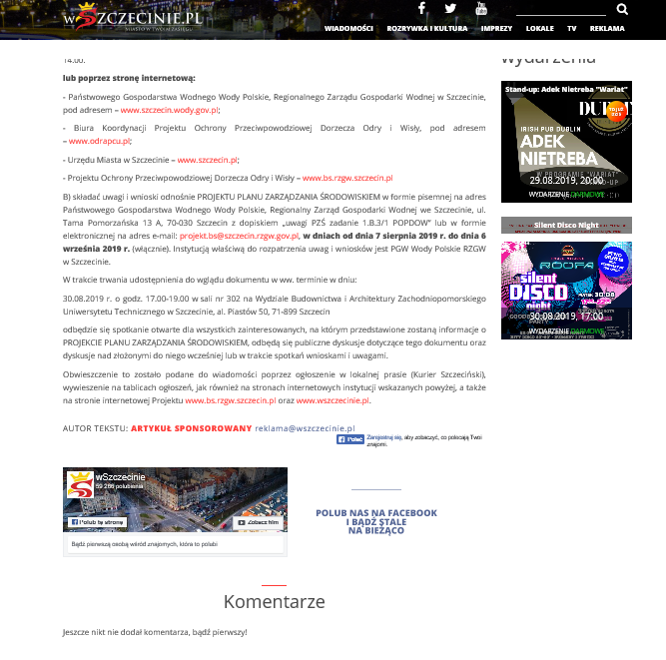
Fig. 10 Correction on the wszczecinie.pl website
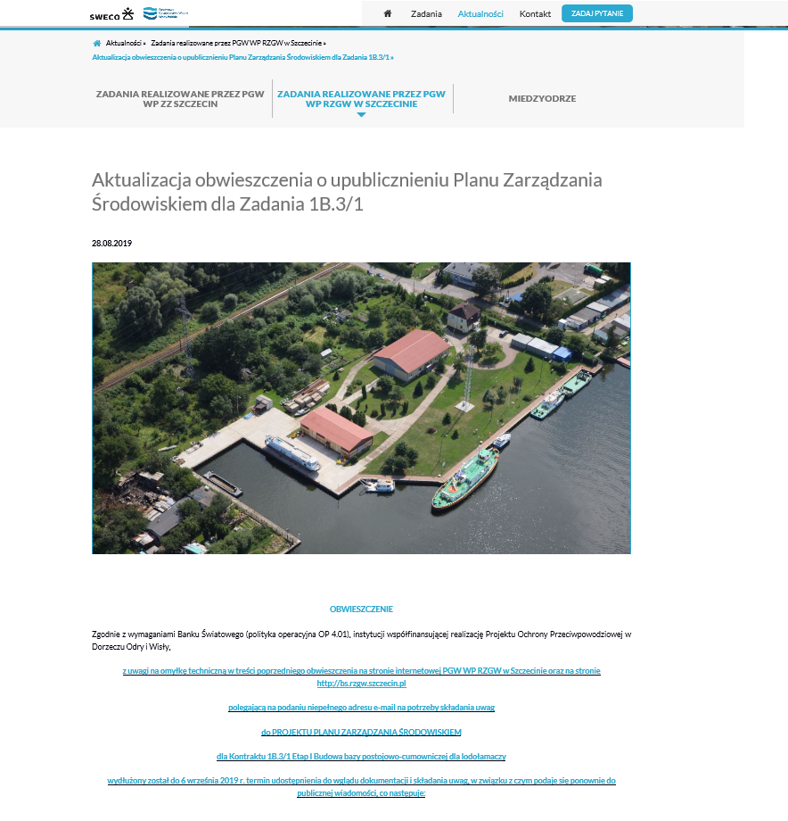
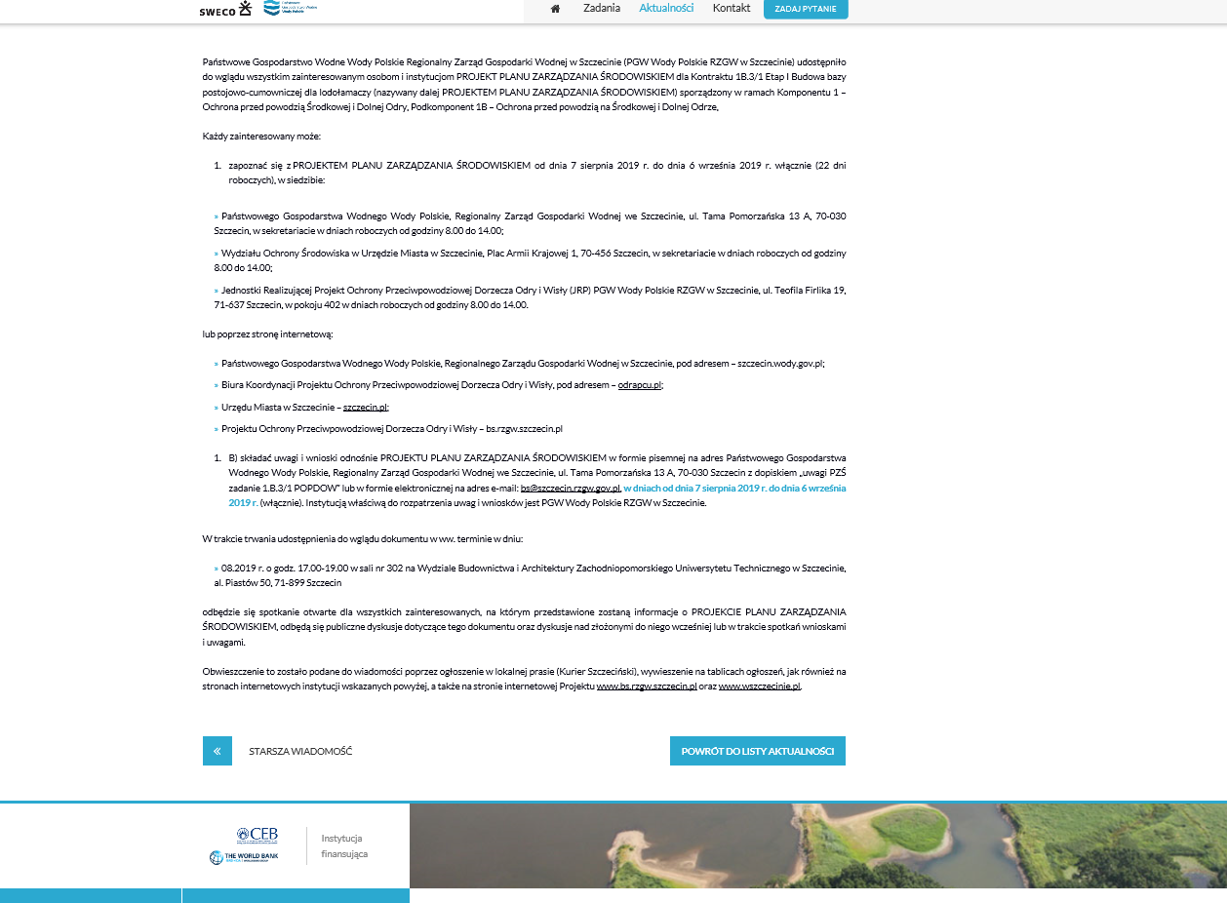
Fig. 11 Correction on the Project website - bs.rzgw.szczecin.pl

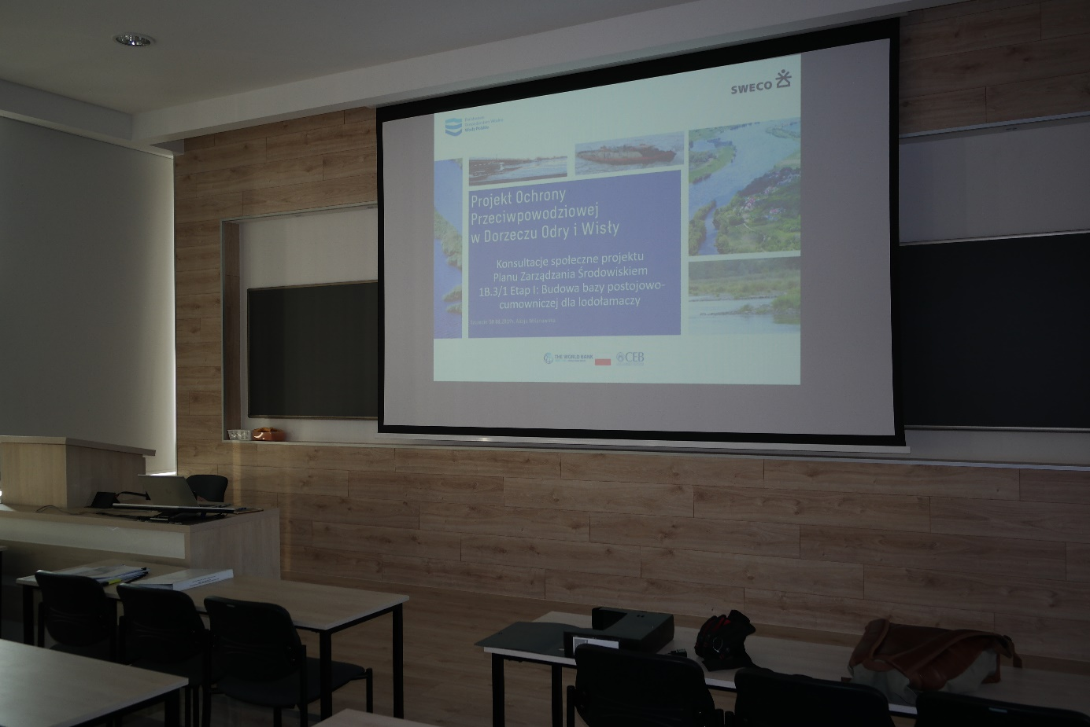
Fig. 12 Public consultation on the EMP draft at the Faculty of Civil Engineering and Architecture of the West Pomeranian Technical University in Szczecin on August 30, 2019
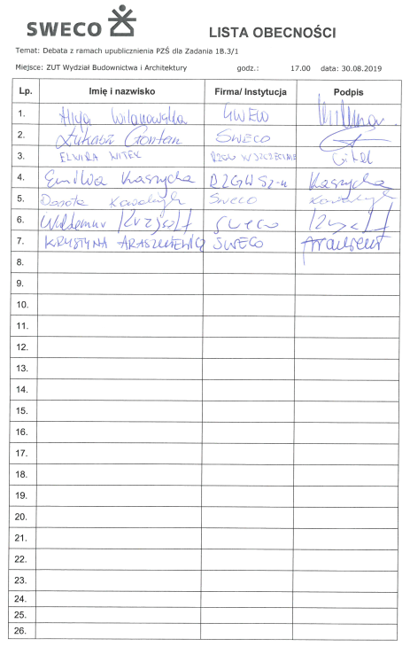
Fig. 13 List of attendance at the public consultation on the EMP draft meeting on 30.08.2019

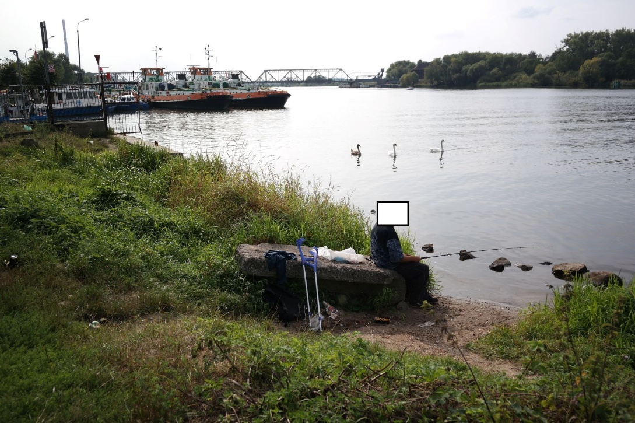
Fig. 14 The place used by anglers described in the comment

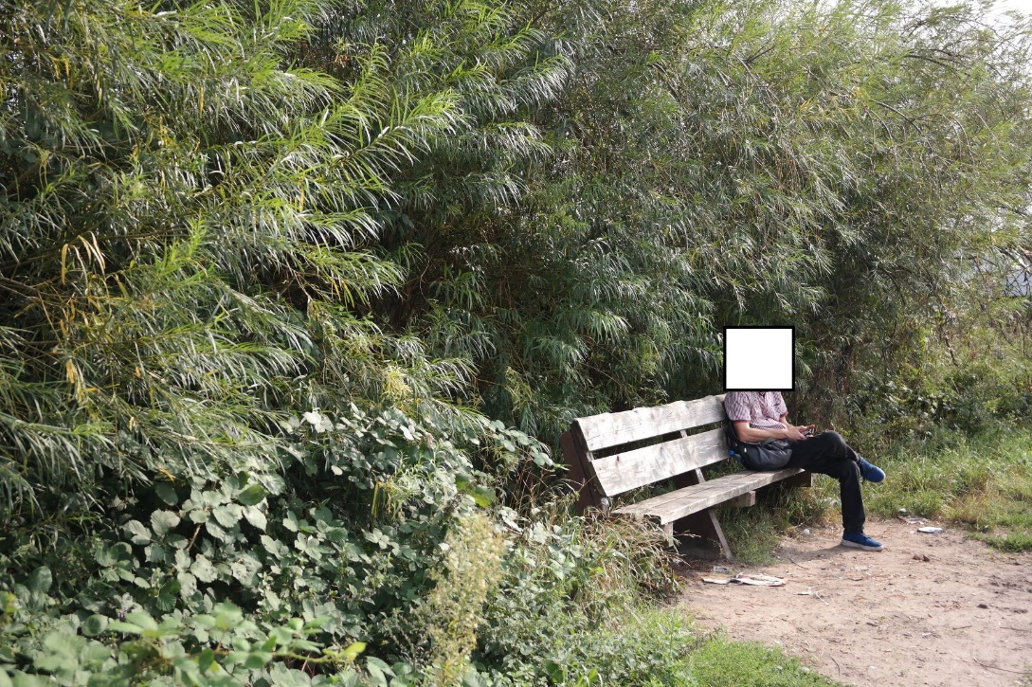
Fig. 15 The bench described in the comment

