State Water Holding Polish Waters
Regional Water Management Board in Szczecin

Environmental Management Plan
ODRA - VISTULA FLOOD MANAGEMENT PROJECT – 8524 PL
Environmental Category B – pursuant to the OP 4.01 WB

Component 1:
Flood Protection of the Middle and Lower Odra

Subcomponent 1B:
Flood Protection in the Middle and Lower Odra

Contract 1B.5/1:
Reconstruction of bridge to ensure a minimum clearance - Railway bridge km 733,7 Regalica River in Szczecin

Issue | Date | Author | Checked by | Customer's Approval
I | July 2020 | Alicja Wilanowska | Dorota Kowalczyk
 |  | Waldemar Krzysztof

ODRA -VISTULA FLOOD MANAGEMENT PROJECT
co-financed by:
World Bank, Loan Agreement No. 8524 PL
The Council of Europe Development Bank, Framework Loan Agreement No. LD 1866
The European Union Cohesion Fund (Operational Programme Infrastructure and Environment 2014-2020)
State Budget

Environmental Management Plan
Component: 1- Flood Protection of the Middle and Lower Odra
Subcomponent: 1B- Flood Protection in the Middle and Lower Odra
Contract: 1.B.5/1 Reconstruction of bridge to ensure a minimum clearance - Railway bridge km 733,7 Regalica River in Szczecin

Project Implementing Unit:
State Water Holding Polish Waters
Regional Water Management Board in Szczecin

Authors of the Study:
Project Implementation Unit for the Odra - Vistula Flood Management Project
at the State Water Holding Polish Waters Regional Water Management Board

Technical Support Consultant of the Regional Water Management Authority in Szczecin
for the Odra - Vistula Flood Management Project -
Joint Venture: SWECO Consulting Sp. z o. o., SWECO Nederland B.V., Sweco Engineering Sp. z o. o., Ekocentrum – Wrocławski Ośrodek Usług Ekologicznych Sp. z o. o.

Szczecin, July 2020

TABLE OF CONTENTS
Summary 9
1. Introduction 15
1.1. Odra - Vistula Flood Management Project (OVFMP) 15
1.2. Flood Protection of the Middle and Lower Odra River (Component 1 OVFMP) 16
2. Task Description 1.B.5/1 17
2.1. Task location 17
2.2. Task Characteristics 17
3. Institutional, legal and administrative conditions 29
3.1. Institutions involved in the implementation of the Task 29
3.2. Acts of national law in force in the field of the environment 29
3.3. EIA procedure in Poland 29
3.4. World Bank Guidelines 29
3.5. Current status of the EIA procedures for the Task 30
3.6. Grievance redress mechanisms 31
4. Description of environmental elements in the Task area 32
4.1. Land surface and landscape 32
4.2. Climate 32
4.3. Sanitary condition of the air 32
4.4. GEOLOGICAL STRUCTURE 35
4.5. Soil and land 35
4.6. Surface water 35
4.7. Underground water 38
4.8. Acoustic climate 39
4.9. Wildlife 40
4.10. Material and cultural goods 46
5. Summary of the Environmental Impact Assessment 47
5.1. Land surface and landscape 47
5.2. Climate 47
5.3. Sanitary condition of the air 48
5.4. Surface water 48
5.5. Underground water 49
5.6. Wildlife 49
5.7. Acoustic climate 57
5.8. Population and material goods 58
5.9. Cultural monuments 58
5.10. Human health and safety 58
5.11. Extraordinary risks (crisis and emergency situations) 59
5.12. CUMULATIVE AND CROSS-BORDER IMPACTS 60
6. Description of mitigation measures 62
6.1. Land surface and landscape 62
6.2. Climate 63
6.3. Condition of the air 63
6.4. Soil and land 64
6.5. Surface water and underground water 65
6.6. Acoustic climate 66
6.7. Wildlife and protected areas 66
6.8. Cultural landscape and monuments 70
6.9. Material goods 71
6.10. Human health and safety 72
6.11. Exceptional environmental hazards 74
6.12. Waste and waste water 76
6.13. Requirements for the implementation of action plans at the construction stage 78
6.14. Specific requirements in the scope of the World Bank’s ES policies (environmental and social aspects, including the risk of sexual abuse, mistreatment for sexual exploitation and sexual harassment) 81
6.15. activities at the operation stage 83
7. Description of monitoring actions 84
7.1. Environmental monitoring during the execution of works 84
7.2. Environmental monitoring in the operation period 84
8. Public consultations 85
8.1. Public consultations on the Environmental and Social Management Framework Plan for the OVFMP (2015) 85
8.2. Public consultations at the stage of environmental procedures for the Task 85
8.3. Public EMP consultations 86
9. ORGANISATIONAL STRUCTURE for THE IMPLEMENTATION OF THE EMP 101
9.1. Project Coordination Unit for the Odra - Vistula Flood Management Project (PCU OVFMP) 101
9.2. Project Implementing Unit (PIU) and Project Implementation Office (PIO) 101
9.3. Consultant / Engineer 102
9.4. Contractor 103
10. time schedule FOR THE IMPLEMENTATION OF THE EMP AND REPORTING PROCEDURES 105
11. List of source materials 108
12. List of Attachments 109

List of basic definitions and abbreviations used in the EMP
Name | Description
IBRD / WB | International Bank for Construction and Development / World Bank
PCU / PCU OVFMP | Project Coordination Unit / Coordination Unit for the Odra-Vistula Flood Management Project
WB | World Bank Procedure (Bank Procedure)
Environmental decision / ED | Decision on environmental conditions
Epidemic | The occurrence of a significantly higher number of infections or infectious diseases in a given area than in the previous period or the occurrence of infections or infectious diseases not yet occurring.
Species decision | Decision authorising activities subject to prohibitions applicable to protected animal, plant or fungi species
ESMF | Environmental and Social Management Framework (Environmental and Social Management Framework) for the OVFMP
ES | The Environmental and Social World Bank Policy - ES, concerning environmental and social issues (i.e. in the scope of the environmental protection, health and safety at work and of the community, gender equality, protection of minors, particularly vulnerable people (including the disabled), sexual harassment, sexual violence, awareness and prevention of HIV / AIDS).
Investor /  Employer /  PIU | State Water Holding Polish Waters in Warsaw represented by the Director of the Regional Water Management Board in Szczecin / Project Implementing Unit for the Odra - Vistula Flood Management Project
BSW | Body of Surface Water
BUW | Body of Underground Water
PIU | Project Implementation Office for the OVFMP in the State Water Holding Polish Waters Regional Water Management Board in Szczecin
Consultant /  Engineer /  Contract Engineer | Company or legal entity providing the Investor with the service of Technical Support Consultant within the OVFM Project
Contract /  Contract for Works  / Task | Contract / Contract for Works / Task 1.B.5/1 Reconstruction of bridge to ensure a minimum clearance - Railway bridge km 733,7 Regalica River in Szczecin
LSDP | Local Spatial Development Plan
OOŚ (Eng. EIA) | Environmental Impact Assessment
OP | World Bank’s Operational Policy (Operational Policy)
PAD | Project Appraisal Document (Project Appraisal Document) for the OVFMP
HSP Plan | Health and Safety Protection Plan
PKP [PSR] | Polish State Railways
SEM | State Environmental Monitoring
OP Infrastructure and Environment | Operational Programme Infrastructure and Environment
POM | Project Operations Manual (Project Operations Manual) for the OVFMP
PFAOREAR | Plan for Acquisition of Real Estates and Resettlement
Project / OVFMP / OVFM Project | Odra - Vistula Flood Management Project
EMP | Environmental Management Plan
EIA Report | Report on the Environmental Impact of the Project: Partial dismantling and construction of a new bridge at km 733.7 of the Regalica River in the course of the railway line 273 together with accompanying infrastructure”, carried out under the Odra - Vistula Flood Management Project "Task 1B.5 Reconstruction of bridges to ensure minimum clearance" April 2019 with additions
RDOŚ (RDFEP) | Regional Directorate for Environmental Protection
ORBWMP | Odra River Basin Waters Management Plan (Regulation of the Council of Ministers of 18 October 2016 on the Odra River Basin Waters Management Plan)
State Water Holding Polish Waters | State Water Holding Polish Waters
SDF | Standard Data Form: The Standard Data Form (SDF) is a uniform template for describing a Natura 2000 area throughout the European Union. It is approved by the decision of the European Commission and compulsory for use in all Member States
Natural habitats | The concept of natural habitats used in the text refers to the definition of natural habitats and the listing of their types in the Council Directive 92/43/EEC of 21 May 1992 on the conservation of natural habitats and of wild fauna and flora (Journal of Laws EU L 206, 22.07.1992, as amended).  (The Polish nomenclature of natural habitats is set out in the Ordinance of the Minister of the Environment of 13 April 2010 on natural habitats and species of Community interest and criteria for the selection of areas eligible for recognition or designation as Natura 2000 sites (consolidated text in Journal of Laws of 2014, item 1713), the Ordinance specifies, inter alia, the types of natural habitats of Community interest, which require protection in the form of designation of Natura 2000 sites, with the indication of priority natural habitat types).
State of risk of epidemic emergency | Legal situation introduced in a given area in connection with the risk of epidemic occurrence in order to undertake the preventive actions specified in the Act of 5 December 2008 on preventing and combating infections and infectious diseases in humans (Journal of Laws of 2019, item 1239 as amended)
State of risk of epidemic emergency | Legal situation introduced in a given area in connection with the risk of epidemic occurrence in order to undertake the preventive actions specified in the Act of 5 December 2008 on preventing and combating infections and infectious diseases in humans (Journal of Laws of 2019, item 1239 as amended)
EU | European Union
Contractor /  Contractor for Task /  Contractor for Part of Contract | A company or a legal person executing the Contract under the name of: Task 1.B.5/1. - Reconstruction of bridge to ensure a minimum clearance - Railway bridge km 733,7 Regalica River in Szczecin
VMC | Voivodeship Monument Conservator
EHS Guidelines | World Bank Guidelines on Environment, Health and Safety (EHS), General EHS Guidelines (The Environmental, Health, and Safety (EHS) Guidelines, General EHS Guildelines).
Road Operator | An organisational unit executing the duty of managing public roads pursuant to the Public Roads Act or the duty of managing non-public roads.

List of abbreviated names of legal acts used in EMP
The names of legal acts cited in this EMP are provided in a shortened version. The full names of the various acts are given in the list below.
Name used in the text | Full name (including publication address)
Birds Directive/BD | Directive 2009/147/EC of the European Parliament and of the Council of 30 November 2009 on the conservation of wild birds (Journal of Laws EU L 20/7 of 26.01.2010 as amended).
Habitats Directive/HD | Directive 92/43/EEC of the Council of 21 May 1992 on the conservation of natural habitats and of wild fauna and flora.  (Journal of Laws EU L 206 of 22.07.1992, as amended)
Water Framework Directive (WFD) | Directive 2000/60/EC of the European Parliament and of the Council of 23 October 2000 establishing a framework for Community action in the field of water policy (Journal of Laws L 327 of 22.12.2000, as amended).
EIA Regulation | Regulation of the Council of Ministers of 9 November 2010 on projects likely to have a significant impact on the environment (consolidated text: Journal of Laws of 2016, item 71)  The above mentioned Regulation has been repealed by the Regulation of the Council of Ministers of 10 September 2019 on projects, which may significantly affect the environment (Journal of Laws of 2019 item 1839). However, the provisions in force before the entry into force of the repealing Regulation applied to this Task.
EIA Act | Act of 3 October 2008 on publishing information about the environment and its conservation, public participation in environmental protection and on environmental impact assessments (consolidated text: Journal of Laws of 2020, item 283, as amended)
Act  on public roads | Act of 21 March 1985 on Public Roads  (consolidated text: Journal of Laws of 2020, item 470, as amended)
Nature Conservation Act | Nature Conservation Act of 16 April 2004  (consolidated text: Journal of Laws of 2020, 55)
Waste Act | Act of 14 December 2012 on Waste  (consolidated text: Journal of Laws of 2019, 701, as amended)
Construction Law Act | Act of 7 July 1994 Construction Law  (consolidated text: Journal of Laws of 2019, 1186, as amended)
Environmental Protection Law Act | Act of 27 April 2001. Environmental Protection Law  (consolidated text: Journal of Laws of 2019, 1396, as amended)
Water Law Act | Act of 20 July 2017 Water Law (consolidated text: Journal of Laws of 2020, item 310, as amended)
Act on Railway Transport | Act of 28 March 2003 on Railway Transport (consolidated text: Journal of Laws of 2019, 710, as amended)

Summary
This Environmental Management Plan (EMP) relates to the Task 1B.5/1 – Reconstruction of bridge to ensure a minimum clearance - Railway bridge km 733,7 Regalica River in Szczecin.
This EMP provides, inter alia, the following information:
- brief description of the OVFMP and its Component 1, which includes the Task in question (Section 1.1 and 1.2);
- description of the Task being subject of this EMP (Section 2);
- characteristics of institutional, legal and administrative conditions for the implementation of the Task, including the current status of the EIA procedures for the Task (Section 3);
- description of individual elements of the environment in the Task surrounding (Section 4);
- summary of the environmental impact assessment for the Task (Section 5);
- description of the mitigation measures to eliminate or reduce potential negative impact of the Task on the environment (Section 6), together with a tabular breakdown of these measures (Attachment 1);
- description of the environmental monitoring activities applicable to the Task (Section 7), with a tabular breakdown of these activities (Attachment 2);
- description of the public consultation process carried out at individual stages of developing environmental documentation for the Task (Section 8);
- description of the organisational structure for the implementation of the EMP (Section 9);
- time schedule for the implementation of the EMP and description of reporting procedures (Section 10);
- list of reference materials cited in the EMP (Section 11);
- list of Attachments to the EMP (Section 12);
- copies of administrative decisions on environmental protection issued for the Task (Attachment 4),

Task characteristics
The task concerns the reconstruction of the bridge in km 733.7 of the Regalica River within the course of the railway line No. 273. The Project Implementing Unit (PIU) for the task is the State Water Holding Polish Waters, Regional Water Management Board in Szczecin.

Scope of the Task
The task consists in the construction of a bridge under the new railway system (moved in the vertical projection from the existing one by several dozen metres down the Regalica River) and partial demolition of the existing facility - 3 spans, while keeping the drawbridge span entered in the register of monuments. The location of the facility will be changed, i.e. in the existing condition in km 349.120, in the designed condition in km 349.152 (location in the designed hectometre) of the railway line No. 273 of Wrocław Główny - Szczecin Główny.
The reconstruction of the bridge results in the necessity to adjust, within the framework of the Task, the railway infrastructure and the existing utilities within the access roads to the facility, including the reconstruction of the track system and selected elements of the Szczecin Podjuchy railway station.
The construction of the new bridge will ensure proper clearance for effective icebreaking action using icebreakers. The existing bridge stops the ice flow at key moments of the action, cutting the icebreakers stationed below the bridge from the icebreaking action area on the Odra River and stopping the ice float on the pillars.
The task includes the protection of the preserved historic drawbridge span - according to the indications of the Voivodeship Monument Conservator.

Institutional, legal and administrative conditions
The Task, with regards to its characteristics, predicted potential impacts on the environment and location in relation to protected areas is implemented in accordance with relevant national environmental legislation and relevant World Bank policies.

Status of administrative procedures for EIA
The Regional Director of Environmental Protection in Szczecin carried out an environmental impact assessment for the Task. The proceedings were concluded by issuing a decision on environmental conditions No. 1/2020 of 10.01.2020 r., Reference No.: WONS-OŚ.420.20.2018.KK.38.
The decision on environmental conditions is included in the Attachment 4a to the EMP.

Condition of environmental elements in the Task area
As the result of works related to the identification of the environmental and cultural values it was found that the area of Task implementation and its surroundings are characterised, among other things, by the following environmental conditions:
- the area of the Task implementation is located within the catchment area of the Odra River body of surface water (BSW) from the Western Odra River to the Parnica River with the code RW6000211971 and within the catchment area of the body of underground water (BUW) No. 4 with the code PLGW60004
- in the area of task implementation, the occurrence of protected vascular plant sites was found, such as: water caltrop (Trapa natans), broad-leaved helleborine (Epipactis helleborine) and dwarf everlast (Helichrysum arenarium). Two protected natural habitats were found in the area of the investment: willow, poplar, alder and ash riparian forests (Salicetum albo-fragilis, Populetum albae, 91E0) and acidophilus oak forests (Quercetera robori-petraeae, 9190).
- 65 bird species have been recorded in the Task area, including 4 species listed in the Annex I of the Birds Directive, and on the bridge itself probably a breeding white wagtail (Motacilla alba) and common wood pigeon (Columba palumbus) were observed. In the entire bridge facility there were no bats' hiding places or potential living places found, including wintering ones. The minimum probability of presence of single bat hiding places during the season of activity of these mammals (male / mating hiding places) concerns a room after the shelter planned to be demolished in the abutment on the east bank of the river. In the waters of the Regalica River, due to suitable habitats in the close vicinity of the Task area, protected species of fish and lampreys can be expected with high probability: asp (Aspius aspius), spined loach (Cobitis taenia), northern whitefin gudgeon (Romanogobio albipinnatus) and European bitterling (Rhodeus sericeus) and during the spawning trips, European river lamprey (Lampetra fluviatilis) and Atlantic salmon (Salmo salar).
- the task implementation area is located within the boundaries of the following protected areas: the Lower Odra Valley Natura 2000 area PLB320003, the Lower Odra Valley Natura 2000 area PLH320037, the buffer zone of the Szczecinski Park Krajobrazowy "Puszcza Bukowa" [Szczecin Landscape Park “Beech Forest”];
- in accordance with the Decision No. L.dz.DZ-4140/47/O/K/2008/2009 on entry into the register of monuments, the drawn span of the railway bridge over the Regalica River, which is a movable part of the bridge, is under the monument conservation protection. The Task includes leaving and securing the historic drawn span (drawbridge).

Summary of findings on the Environmental Impact Assessment
As part of the EIA proceedings, measures were identified to minimise the technical assumptions of the Task while limiting negative effects on the environment, including protected species and habitats, the nature of which will be short-term - mostly limited to the construction period and reversible.

Land surface and landscape
The Task consists in dismantling the current bridge and building a new one in the same location (with a slight relocation). The permanent occupation of the area of the site therefore concerns the area already occupied for the reconstructed objects (bridge and access sections within the railway area). Temporary occupation of the area concerns the site and the construction backup facilities. The area of land used for the needs of the construction site and the construction backup facilities will be restored to the condition from before the construction. The investment does not generate significant impacts on the land surface.
As the result of the Task implementation, completely new elements in the landscape will not be created. Therefore, no changes in the landscape are expected to occur apart from the general improvement of the aesthetics of the new facilities in comparison to the current state. The historic drawbridge span will be maintained and secured.

Climate
The implementation of the Task has no impact on the climate condition.

Atmospheric air
The emission of dust and gas pollutants will occur primarily at the stage of the Task implementation. In the operation phase, after completion of the construction works, no significant changes in the emission of pollutants into the air are expected to occur in comparison with the state before the bridge was reconstructed.

Surface water
The impact on the environmental objectives set for the body of surface water (BSW) in the Odra River Basin Waters Management Plan (ORBWMP) was assessed as insignificant, limited to the construction period. Impacts on populations of aquatic organisms at the implementation stage will be effectively minimised to eliminate medium-term impacts on aquatic organisms populations.

Underground water
The Task implementation will not cause the inflow of pollutants to the groundwater, and thus it will not have a negative impact on the chemical condition of the body of underground water and on the environmental objectives concerning the quantitative status of groundwater.

Acoustic climate
During the implementation of the Task, the generated noise emissions will be of a local nature, limited to the area of executed works. Nevertheless, bearing in mind the vicinity of areas subject to acoustic protection, the investment process must be properly planned and organised, therefore technical and organisational measures to minimise noise emissions will be taken into account during implementation.

Wildlife
A moderate impact on fish fauna is expected to occur during the Task implementation stage. In particular, during the works carried out in the river bed, the concentration of suspended matter and biogenic substances in the water will increase periodically, which as a consequence will lead to the increase in its turbidity and a decrease in its transparency but this will not result in presence of anaerobic conditions. However, the small area of the works carried out in relation to the width of the river and the volume of flow in Regalica will result in the rapid dispersion of the suspended matter, without negative effects on the environment. Impacts associated with works in the river bed causing an increase in the suspended matter can be effectively minimised.
Implementation of the Task on a relatively small scale will not have a significant negative impact on the identified bird species in the bridge area. The Task implementation area is located in the surroundings of vast areas much more valuable for bird life. Application of time constraints in tree removal should effectively minimise impacts to insignificant levels.
It is not expected that the construction and operation of the new bridge over Regalica will have a significant negative impact on other protected animal species identified in the bridge area.
In the area of the investment, the presence of patches of protected natural habitats and the sites of protected plant species were found. The sites of their occurrence will need to be secured for the duration of the Task implementation and the introduction of mitigation measures in case of the need to deplete habitats or populations of species.
The task implementation area is located within the boundaries of the Natura 2000 areas. In order to assess the impact on the Natura 2000 areas, an analysis of the project was carried out in terms of interference with the natural environment. The implementation of the Task, which consists in the reconstruction of the existing railway infrastructure, will not adversely affect the processes conditioning the maintenance of the desired natural structure of the Międzyodrze area, in particular it will not change the extent and duration of floods, will not cause fragmentation of habitats or isolation of the population. Within the framework of the EIA proceedings the mitigation measures were determined, which may enable to achieve the technical assumptions of the Task while limiting to the acceptable level the negative effects on the environment, including protected species and habitats, the nature of which will be short-term and reversible.

Cultural monuments and material goods
As a part of the bridge demolition works, the drawbridge span has been planned to be preserved and protected. Taking into account the scope of the construction works, the manner of carrying out the works and the fact that the drawbridge's part under the monument conservation protection will be properly secured, no negative impact of the project on this monumental object is expected. As the result of demolition works, the historic span of the bridge will be renovated and properly secured and prepared to be made available to tourists.
The contractor is obliged to implement preventive measures in case of negative impacts that may appear at the stage of execution of works (and are currently impossible to determine). In particular, it is possible to discover objects during the earthworks or other construction works, which are supposed to be a monument.
The task concerns construction works within the railway area, mostly outside the vicinity of other building development. However, at the implementation stage it will be necessary to implement mitigation measures to protect buildings and facilities (including those listed in the municipal register of monuments) in the vicinity of the construction site and access roads against unintentional damage.

Human health and safety
The implementation of the Task does not generate significant risks to human health and safety. They may occur in case of accidents, catastrophes and other random events (e.g. pollution leakage, fire, finding unexploded ordnance and shells, flooding). Increased safety risks will be associated with the execution of works on water and in the bank area.

Mitigation and monitoring measures
Sections 6 and 7 and Attachments 1 and 2 of the EMP describe and present in a tabular form a set of mitigation and monitoring actions to eliminate or reduce the negative environmental impacts of the Task and ensure effective implementation of the terms of the EMP. These measures include the conditions set out in the issued administrative decisions on environmental protection as well as additional conditions formulated during the phase of works on the EMP.

Public consultations
Section 8 of the EMP presents a report on public consultations carried out as a part of the procedures related to the environmental impact assessment of the planned Task, including the following:
• public consultation on the document entitled Environmental and Social Management Framework Plan (ESMF) for the OVFMP Project (2015);
• public consultations at the stage of issuing environmental decisions (2019) – for the Task, an environmental impact assessment procedure was carried out – under which public participation in the procedure was ensured in accordance with the rules set out in the Environmental Protection Act;
• public consultations of this Environmental Management Plan (May – June 2020).

Introduction
This Environmental Management Plan (EMP) relates to the Task 1.B.5/1 – Reconstruction of bridge to ensure a minimum clearance - Railway bridge km 733,7 Regalica River in Szczecin, which is a part of the Subcomponent 1B under the Odra - Vistula Flood Management Project (OVFMP) and implemented as the Contract 1B.5/1.
With reference to the environmental screening described in the Environmental and Social Management Framework Plan for the OVFM Project, the Task was not included in the Odra River Basin Master Plan (2014) as an investment likely to put at risk the achievement of environmental objectives for uniform water bodies. The Task has been included in the Flood Risk Management Plan for the Odra River Basin area under No. 123 (List of strategic actions for the Odra River basin area).

Odra - Vistula Flood Management Project (OVFMP)
The objective of the Odra - Vistula Flood Management Project (OVFMP) is the increasing the level of flood protection for the population living in the selected areas of the Odra River and upper Vistula River basins and institutional strengthening of the government administration in terms of providing more effective protection against summer and winter floods and violent floods.
The Project consists of the following components:
Component 1 – Flood Protection of the Middle and Lower Odra River, including:
Subcomponent 1A - Flood Protection of areas in Zachodniopomorskie Province;
Subcomponent 1B – Flood Protection on the Middle and Lower Odra;
Subcomponent 1C – Flood Protection of Słubice City.
Component 2 – Component 3 – Flood Protection of Nysa Klodzka Valley, including:
Subcomponent 2A – Active protection;
Subcomponent 2B – Passive protection.
Component 3 – Flood Protection of the Upper Vistula River, including:
Subcomponent 3A – Flood Protection of Upper Vistula Towns and Cracow
Subcomponent 3B – Flood Protection of Sandomierz and Tarnobrzeg.
Subcomponent 3C – Passive and active protection in the Raba Sub-basin;
Subcomponent 3D – Passive and Active Protection in San basin;
Component 4 - Institutional strengthening and enhanced forecasting
Component 5 - Project Management and Studies
Detailed information and additional documents concerning the OVFMP Project are available on the website of the Project Coordination Unit for the Odra – Vistula Flood Management Project (http://odrapcu2019.odrapcu.pl) and on the website of the World Bank (http://documents.worldbank.org/curated/en/docsearch/projects/P147460).

Flood Protection of the Middle and Lower Odra River
(Component 1 OVFMP)
Component 1 OVFMP “Flood Protection of the Middle and Lower Odra” aims at flood protection by strengthening protection against summer and winter floods in localities along the Odra River.
Under the Component 1, three Subcomponents are implemented:
Subcomponent 1A – Flood Protection of areas in Zachodniopomorskie Province;
Subcomponent 1B – Flood Protection on the Middle and Lower Odra;
Subcomponent 1C – Flood Protection of Słubice City.

Sub-Component 1B consists of the following tasks:
- 1B.1/1 (a). Reconstruction of the Odra River control infrastructure - adjusting to the III class of waterway, on the section from the village of Ścinawa to the estuary of the Nysa Łużycka River – Stage II.
- 1B.1/1 (b). Reconstruction of the road bridge in Krosno Odrzańskie with access roads.
- 1B.2. Modernization works on boundary sections of Odra River to provide Good Condition for Ice – breaking.
- 1 B.3/1 Stage I - Construction of a mooring base for icebreakers,
- 1B.3/2 Stage II - The construction of docking - mooring infrastructure on the Lower Odra River and on boundary sections of Odra River as well as new aids to navigation.
- 1B.4/1. Improving flood water -flow during winter from Dąbie Lake.
- 1B.4/2. Dredging of the Klucz-Ustowo ditch.
- 1B.5/1. Reconstruction of bridge to ensure a minimum clearance - Railway bridge km 733.7 Regalica River in Szczecin.
- 1B.5/2. Reconstruction of bridge to ensure a minimum clearance - Road bridge km 2.45 Warta River, Kostrzyn nad Odrą.
- 1B.5/3. Reconstruction of bridge to ensure a minimum clearance - Railway bridge at km 615.1 of the Odra River in Kostrzyn nad Odrą.
- 1B.6. Flood protection of Nowa Sól and Below Krosno Odrzańskie:
- 1B.6/1. Nowa Sól stages I and II,
- 1B.6/2. Wężyska - Chlebowo.
- 1B.7. WFS Widawa – the rebuilding of the flood management system of the communes and municipalities Czernica, Długołeka, Wisznia Mała and Wrocław.

Task Description 1.B.5/1
The Task, which is the subject of this EMP includes the reconstruction of the railway bridge located within the railway line No. 273 Wrocław Główny - Szczecin Główny, in km 349.120 (Szczecin Podjuchy station), over the Regalica River bed (in km 733.7 of the river). The Project Implementing Unit (PIU) for the Task is the State Water Holding Polish Waters, Regional Water Management Board in Szczecin.
In connection with the implementation of the Task, an appropriate Agreement was concluded between the State Water Holding Polish Waters - Regional Water Management Board in Szczecin and PKP Polskie Linie Kolejowe Spółka Akcyjna (PKP PLK S.A.). According to the Agreement, the scope of work has been divided into:
- Construction works related to the construction of a railway bridge - works from km 348.320 of the 273 line and the 428 line, which include: a) construction of pillars and bridgeheads for a double-track facility, b) construction of a single-track bridge over the Regalica River, c) construction and equipping of a signal tower facility, hereinafter referred to as the "Bridge Works.
- Construction works related to the reconstruction of railway infrastructure - works up to km 348.320 of the 273 line in the scope of reconstruction of track system of the Szczecin-Podjuchy station, which includes: a) construction of bridge span elements for the second track of the 273 line, b) construction of the second track from the bridge over the Regalica River to the Szczecin Port Centralny station, c) works in track No. 30, hereinafter referred to as the "Infrastructure Works".
The costs of the Bridge Works will be incurred as a part of the OVFMP and the costs of the Infrastructure Works will be borne by PKP PLK S.A.

Task location
This Task in question includes the dismantling and construction of a railway bridge in the railway line No. 273 Wrocław Główny - Szczecin Główny, in km 349.120 (Szczecin Podjuchy station), over the Regalica River bed (in km 733.7 of the river). The new railway bridge will be built in a new trace; therefore, the Task includes the reconstruction of the railway infrastructure and the existing utilities within the access roads to the facility.
The Task implementation area is located on the territory of the city with the rights of the Szczecin County in the West Pomeranian Voivodeship.

Task Characteristics
The implementation of this investment is planned within the framework of the Odra - Vistula Flood Management Project (OVFMP).
The scope of the project includes in particular the ‘reconstruction’ of the railway bridge consisting in the dismantling of three fixed spans of the existing railway bridge crossing a waterway with supports and the construction of a new railway bridge in a new trace, together with the reconstruction of the railway infrastructure and the existing utilities within the access roads to the facility.
The Task consists in the construction of a bridge for a new track system (the bridge is moved in the vertical projection from the existing one by several dozen metres down the Regalica River) and partial demolition of the existing bridge - 3 spans with the preservation of the drawn span entered into the register of monuments. The location of the facility will be changed, i.e. in the existing condition in km 349.120, in the designed condition in km 349.152 (location in the designed hectometre) of the railway line No. 273 of Wrocław Główny - Szczecin Główny.
In the designed condition, the bridge is located in a changed location in relation to the existing facility due to technological conditions, including among other things: maintaining continuity of traffic for as long as possible on the railway line in question and preservation of the historic drawbridge span.
The construction of the new facility will provide a clearance of 6.20 m, which ensures the effective operation of icebreakers in winter, and at the same time this clearance corresponds to the current clearance of the drawn part of the existing facility. The existing bridge stops the ice flow in key moments of the action, cutting the icebreakers stationed below the bridge from the icebreaking area on the Odra River and stops the ice float on the pillars.
The purpose of the new facility will not change in relation to the existing one - the bridge will be a crossing of railway line 273 over the Regalica River in its km 733.7.

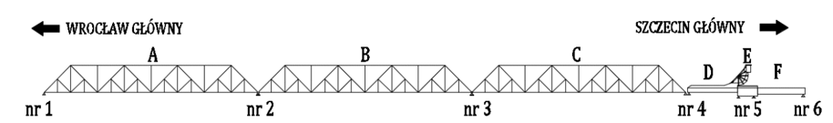
Partial dismantling and construction of a railway bridge

Figure 1. Drawing of the existing bridge with the designation of the supports (pillars and bridgeheads) and spans
The bridgehead No. 1, intended for demolition, is founded on wooden and concrete piles, while the pillars in the current are founded indirectly on a layer of rubble mound reinforced with wooden piles. The demolition is planned together with part of the indirect foundation up to the level of the riverbed bottom in the cover of sheet pile walls. In connection with the dismantling of the bridge, it is planned to dismantle two existing railway culverts in km 347+147 and km 347+408 of the line 273 (former passages to the Wiskord plant and a culvert for drainage of the tracks) and ultimately to build the culvert in km approx. 347+408 in the form of a reinforced concrete frame for drainage in the place of the dismantled existing culvert.
The construction of the new bridge on the Regalica River includes in particular: the construction of two massive bridgeheads, common for both railway tracks, indirectly located on large diameter bored piles with execution of bases with the injection method, i.e. reinforcing them by introducing cement grout under the previously made piles; construction of two massive, edge-wrapped pillars (protection against flow of ice float), indirectly placed on large-diameter bored piles with execution of bases with the injection method, construction of three-span continuous truss load bearing structures, separate for each track, with a roadway closed in the form of an orthotropic plate, i.e. a steel plate reinforced with transverse and longitudinal ribs. A contactless track is planned to be built on the bridge structure and on the access roads to the structure. The construction standards for the surface will be defined as for class 0 tracks. The traction poles will be mounted to steel supports, formed on spans. It is planned to build tracks No. 1, No. 2 in the new course on the newly built bridge.
The three-span structure of the bridge will be supported on two end supports (bridgeheads P1, P2) and two intermediate supports (pillars F1, F2). These supports will be common for the spans in both tracks. The theoretical spans will be 81.0 m + 114.05 m + 81.0 m, with the facility length of 277.90 m.

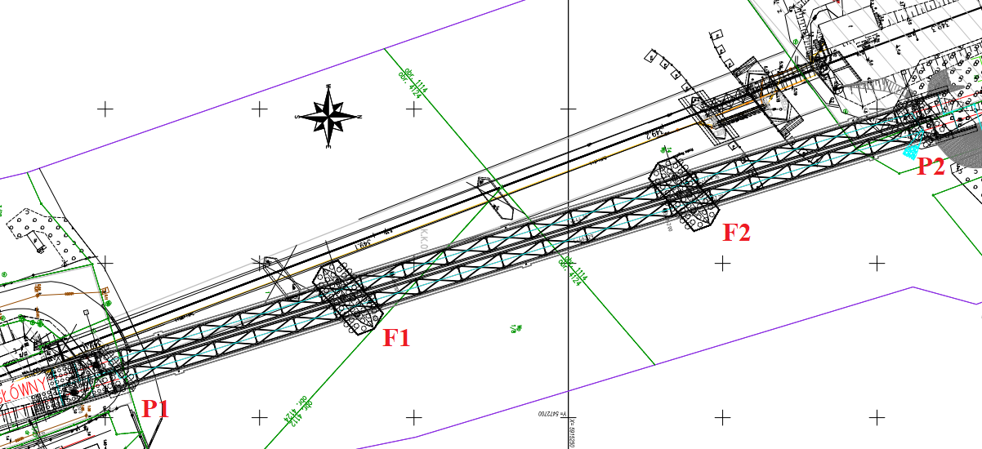
Figure 2 Drawing of a new bridge supports (pillars and bridgeheads)
Partial dismantling of the bridge
Dismantling of the existing spans and construction of the designed ones will be carried out using the slide-in (extension) longitudinal method. Existing spans will be pulled out behind the bridgehead No. l. The dismantling sequence will be as follows: A span, B span, C span (Fig. 1).
The individual spans will be based on fixed supports, in the form of steel pipe grid, driven into the riverbed and floating supports in the form of floating barge and river pusher sets. Once the individual spans are extended, it is planned to dismantle them using the 'bar by bar' method. The existing supports will be dismantled together with a part of the indirect foundation (wooden piles), in the shielding of perimeter sheet piling walls, driven in from a flat-bottomed floating vessel. Selection of the final method of spans disassembly and support disassembly (execution of technological design to be accepted by the Engineer) is the responsibility of the Contractor.
Construction of a new bridge
The bridgeheads and pillars of the new bridge will be made in the shielding of sheet piling. For the pillars, these will be perimeter sheet pile walls, driven in from a flat-bottomed vessel.
- in the first stage, the chamber will be filled with made ground (platform for the pile driver operation),
- then piling will be done from the platform,
- after the piles are made, the chamber bases are sealed, e.g. by inserting interlocking jet-grouting soil and cement columns, then the chamber filling is removed and the pillar caps and bodies are made.
Depending on the technology of works adopted by the Contractor, one or two stations will be prepared for joining the bridge construction elements. Then the span will be assembled using the longitudinal slide-on method on fixed supports and on floating supports.
Scope of works in the Regalica River bed:
- execution of bridgeheads in the sheet piling shielding, together with the foundation system;
- construction of pillars together with the foundation system in the sheet piling shielding, perimeter sheet piling walls driven in from a floating support;
- execution of fixed technological supports (used for assembly of new spans and disassembly of existing ones),
- installation of spans on fixed and floating supports.
- disassembly of existing spans on fixed and floating supports.
- dismantling of existing supports in sheet piling shielding, perimeter sheet piling walls driven in from a floating support.
It is planned to make casings from steel sheet piling sections, in the form of sheet piling walls, necessary for demolition of existing supports and making new supports. In the next stage, it is planned to make an indirect foundation from bored reinforced concrete piles together with concrete plugs as elements balancing the hydrostatic pressure.
During the execution of the bridge pillars, the top layers of river sediments will be removed from inside the tight chambers (made for the purpose of the execution of pillars). The final method will depend on the technology of execution adopted by the Contractor. It is expected that approximately 250 m³ of these sediments will have to be removed. The removal of sediments will be carried out inside the tight chambers. It is assumed that the sediments will be removed on a barge and transferred to a landfill, in accordance with the applicable regulations. The final method for sediment disposal proposed by the Contractor shall be subject to the approval by the Engineer.
Selection of the final technology for construction of the supports as well as for integration and assembly of the spans (making technological designs) and agreeing them with the Engineer will be the responsibility of the Contractor.
Works on the historic bridge span
As a part of the works related to the partial dismantling of the bridge, it was planned to preserve and protect the drawbridge span under conservation protection, including:
- installation of a front balustrade to prevent falls from the span D (Fig. 1) within the framework of the inspection traffic protection;
- arrangement of the drawbridge span area of the bridge;
- dismantling of the loose bearing elements of C-span on the support 4 (Fig. 1);
- securing the overhead contact line elements.
Railway bridge construction site
Preparation of the site yard will include:
- removal of vegetation, including felling and stubbing of colliding trees (about 600 trees - the results of the dendrological inventory are presented in the Section 5.6.1.);
- construction of temporary technological roads to ensure communication within the yard and access roads to the yard;
- construction of foundations for storage yards, assembly and parking yards, etc., requiring local reinforcement of the ground;
- regrading of the site to the given ordinates (including the construction of a part of the railway embankment behind the newly designed bridgehead, support No. 4), resulting from the integration technology issues;
- building of temporary construction service facilities, including, inter alia, social facilities;
- execution of technological supports necessary for the integration of span elements.
Due to the technology adopted for the construction of the designed and demolition of the existing spans, the location of the main part of the construction site, designed for the needs of the assembly of the structure and the location of the starting points, is envisaged behind the bridgehead No. 2 (support No. 4).
For the purpose of construction of the designed and demolition of the existing pillars, it will be necessary to build a temporary casing of supports from steel sheet piling sections in the riverbed in the form of sheet piling walls around the foundations of these supports. The construction of the designed and demolition of the existing bridgeheads determines the coverage of both river banks by the construction site.
The anticipated location of the construction site backup facilities covers the zone behind the bridgehead No. 1 and behind the bridgehead No. 2 (including the location of the yard for integrating the elements of the spans), using the area around the existing railway embankment. The anticipated area of the construction site backup facilities is about 2 x 3000 m².
Local reinforcement of the existing access dirt roads within the area of Podjuchy (about 1 km long) and construction of a paved technological road, adjacent to the planned railway embankment, connecting the area of the bridgehead No. 2 with the Florian Krygier Street (national road DK 31), about 950 m long.
Location of 2 storage yards for construction materials and technological equipment was assumed - in the zones behind the designed bridgeheads. Separate, properly secured areas of the storage yards are indicated as a place to store humus and other excavated material. It is also possible to use sites in the area of the existing Szczecin Podjuchy railway station.
Adaptation of the railway infrastructure and the existing infrastructure within the access roads to the bridge facility
The reconstruction of the facility results in the necessity to adjust the railway infrastructure and the existing utilities within the access roads to the facility, including the reconstruction of the Szczecin Podjuchy railway station layout and the departures of the line No. 428. The planned works to be carried out under the Contract 1B.5/1 are (the most important elements of the Task have been marked on the maps constituting the Attachment 5d):
- Construction of a railway bridge over the rebuilt Szklana Street in Szczecin.

Due to the solutions of the newly designed bridge and in order to provide access to the military complex No. 1926 and the adjacent properties, it is planned to reconstruct an internal road – the Szklana Street, about 280 m long (as a single carriageway as a target, two-lane, with a bituminous surface and a basic width of 5.0 m with sides on both parts), located under one of the spans of the existing railway bridge in approx. km 349 of the railway line No. 273, as well as the construction of a new railway bridge in the course of the railway line No. 273 Wrocław Główny - Szczecin Główny over the Szklana Street, in the form of a single-span reinforced concrete open frame, founded on large-diameter piles. The theoretical span of the reinforced concrete frame is approx. 21.45 m and is adjusted to the obstacle being crossed, while the height is adjusted to the required clearance for oversized vehicles of 5.0 m. The bridge will be made using formwork, with complete closure of the railway line.

- Construction of retaining walls at the bridge access points
In order to reduce the range of the railway embankment, it is planned to build a retaining wall in the form of monolithic reinforced concrete slab-angled structures topped with a cornice:
- double-sided wall between the extreme support of the new railway bridge over the Regalica River and the new railway bridge over the reconstructed Szklana Street, designed as a reinforced concrete tub. The length of the part along the track No. 1 is about 17.9 m, the length of the part along the track No. 2 is 12.2 m. The retaining walls will be made in the formwork, in one stage, in synchronisation with the construction of the bridgehead in km 733.7 of the Regalica River;
- one-sided wall along the track No. l of the railway line No. 273 in the vicinity of the railway line No. 428 and the Szklana Street with the length of 192.0 m in the reinforced concrete part and with the length of 88.0 m in the form of steel sheet pile sections topped with a reinforced concrete cornice. The construction of the retaining structure in the form of steel sheet piling sections is dictated by the necessity to maintain the railway traffic on the line No. 428 and to reduce the scope of earthworks. The walls in the reinforced concrete part will be made in stages in the excavation;
- one-sided along the plot of land in the Ministry of National Defence board, 26.0 m long. The wall will be made in an open excavation.
- Construction of the underground passage
In order to carry out pedestrian traffic between platforms l and 2 at the Podjuchy station without any collision, an underpass was designed in the form of a monolithic reinforced concrete closed frame 18.7 m long and 5.0 m wide clearance, with lifts for the disabled. The underpass enables communication between the Szczecin Podjuchy interchange and the platform No. 1 and the island platform No. 2. The underpass is accessed by stairs and lifts, which enable the disabled to move around. The communication routes will be marked to enable the visually impaired to move, as well as secured with railings and balustrades to ensure safety against falling from height. Due to the neighbouring investments and the high level of groundwater, the underpass will be made with the use of sheet piling walls from steel sheet piling sections and a concrete plug below the foundation level. This way of carrying out the works gives the possibility of staging the construction works.

- Reconstruction of the track system and power supply at the Szczecin-Podjuchy station
Due to the proximity of the Szczecin Podjuchy railway station and the necessity to adjust the solutions in the projection and cross-section to the investments being carried out in parallel, i.e.: reconstruction of the Szczecin Podjuchy station within the framework of the task "Construction of the Szczecin Metropolitan Railway using the existing sections of the railway lines No. 406, 273, 351" and construction of the P&R car park implemented by the Association of the Szczecin Metropolitan Area in partnership with the City of Szczecin, the scope of works covers a significant section of the railway line No. 273 and the line No. 428. The task concerns the construction of the main tracks No. 1 and 2 of the railway line 273 in km 346+574 - 350+010 and the construction of the main track of the railway line No. 428 in km 6+011 - 8+039 and the construction of the main additional tracks No. 4, 6 and 8 of the railway line 273 from km 347+007 to 348+316.
It is planned to reconstruct the infrastructure of the Szczecin Podjuchy railway station, while providing current service for passengers acting as the Szczecin Żydowce railway station and the platform No. 2, as well as maintaining the service of the PBH Odra siding and the ramp at the track No. 7 together with access to the ramp. In addition, due to the fact that the track grade line on the bridge is raised to the indicated values with the additional construction of the second track, the track system of the Szczecin Podjuchy station is planned to be reconstructed.
An inter-junction railway station was designed with three main tracks, three additional main tracks No. 4, 6 and 8 and side station tracks. The usable lengths of the main tracks No. 1, 2 and 3 and the main extra tracks will allow for the reception of trains of max. 800 m in length.
A part of turnouts in main tracks has been planned as curved switches created by curving of basic turnouts of the type 300 - 1:9 and 760 - 1:14. The exit from the main track No. 2 to the additional main tracks no. 4, 6 and 8 will take place using one-sided turnout of the type 500 - 1:12 - from the side of the acting Szczecin Żydowce station. The branch-off to tracks 6 and 8 will be made from curved turnouts of the type 300 - 1:9. The exit from the main additional tracks 4, 6 and 8 and the side ones from the track 3 (line 428) in the direction of the main tracks has been secured by a protective rib from the side of the acting Żydowce, and in the direction of the bridge over the Regalica River it has been secured by the 190 - 1:9 turnout 9 in the main arrangement to the military siding.
The exit from the track No. 1 to the track No. 3 is planned by means of an ordinary turnout of the type 500 - 1:12. The exit from the main additional track No. 3 in the direction of the main tracks has been secured by a protective rib with a 190 - 1:9 turnout type. The train movement on the main additional track can take place at the speed of 60 km/h.
The turnout head for leaving the station in the tracks No. 1 and 2 is designed with one-sided curved turnouts from the turnout of the type 300 - 1:9 and the turnout of the type 500 - 1:12. Trapezoidal connection between tracks 1 and 2 is designed with curved turnouts from the turnout of the type 760 - 1:14. The exit from the station enables changing direction of trains.
The exit from the track No. 1 to the main track of the 428 railway line will take place on curved turnouts from the 760 - 1:14 type junction at the speed of 60 km/h. From the track of the railway line No. 428, the exit to the siding tracks is designed in the area of the warehouse base by means of the ordinary 300 - 1:9 junction.
It is designed to build one double-edge platform between the tracks 1 and 2 with the useful length of 400 m. The width of the platform will vary from 6.65 m to 7.65 m. The width of the safety zone for the main tracks will be 1.50 m. The dimensions and limiting outlines of the platform have been adapted to the current standards, i.e. to the height generally of 0.760 m from the geodetic plane of the rail tracks, the horizontal limiting outline to the face of the platform wall of 1.780 m measured horizontally from the track centreline according to Id-22. The horizontal distance of the platform edge from the track centreline shall be designed as 1675 mm with the required increase or decrease of this distance due to the cant, radius and direction of the curve. The access to the double-edge platform will be made by a two-level access.
As part of the investment, it is also planned to reconstruct the railway and road crossing in km 6.228 of the railway line No. 428. The drainage of the crossing has been designed by means of drainage under small rubber slabs, with drainage of the water to the external rainwater drainage system.
The investment includes the dismantling of all existing steel and concrete supporting structures.
At the Szczecin Podjuchy station the contact line is designed:
- in tracks No. 1 and No. 2 [main and main principal tracks] - YC120-2CS150
- on tracks 3, 4, 6, 8 - C120-2c
- in turnout crossings between the main and the main principal tracks - C120-2c. It is designed to use galvanised and double-painted steel constructions: I-beam poles - cat. No. 1611, gate poles - cat. No. 3116, 3122, spatial poles - cat. No. 1906. These are galvanised and double-painted poles, adapted for fixing on pile foundations. When producing the poles, holes must be made (on both sides of the pole) for mounting the track axis adjustment signs.
The applied contact line YC120-2CS150 will be suspended from typical pipe extensions. In the spans for the YC120-2CS150 type system, the contact wires are anchored in a system of separate devices for anchoring the contact wires and separate devices for anchoring the carrying cables. The contact wire shall be hung at the height of 5.60 m. The contact line running through the newly built bridge on the Regalica River is expected to be suspended from the supporting structures attached to the pillars and to the bridge structure. All the supporting structures are planned to be incorporated into the open group earthing system.
In connection with the reconstruction of the Szczecin Podjuchy station, it is necessary to reconstruct the power supply to the existing power consumers and newly designed power equipment: electric heating of turnouts, platform lighting, lighting of underpass, lighting of railway areas and power supply of railway traffic control equipment (RTC).
Within the railway traffic control part (RTC), new external and internal devices are designed.
The construction of computerised railway traffic control equipment with unoccupied track and turnout control based on an axle counter is designed.
The location of the signalling devices has been designed in accordance with the GPL-1 limiting outline in force on the line. New internal devices will be built in a new signal tower with "SJ". The scope of reconstruction of the Szczecin Podjuchy station includes:
- disassembly of existing signalling devices,
- disassembly of existing drives of railway switches,
- disassembly of existing train protection equipment,
- the installation of a new cable network,
- the installation of new signalling devices,
- the installation of counter equipment for checking the unoccupied tracks and turnouts,
- the installation of new three-phase electric switch drives: un-split with controllers in main tracks, split with drive-controller in additional main tracks, split without drive control in side tracks,
- adaptation to the dependence in train runs and shunting equipment on cat. A crossing in km 347.056,
- the installation of new traffic protection devices at km 6.223 of the crossing should depend on the station equipment;
- adjustment to the dependence of the category C train crossing devices in km 346.454 unilaterally on new computerised RTC equipment;
- adjustment to the dependence of the category C train crossing devices in km 5.826 unilaterally on new computerised RTC equipment.
On adjacent routes: Szczecin Podjuchy - Szczecin Port Centralny, Szczecin Podjuchy - Daleszewo, Szczecin Podjuchy - Szczecin Zdroje, one-way computerised line interlocks will be built in.
In the field of non-traction power engineering, they following will be installed:
- Power supply for low-voltage non-traction loads,
- Lighting of the road crossing in km 348+877,
- Lighting of platforms at Szczecin-Podjuchy Station in km 348+178,
- Lighting of the underpass at Szczecin-Podjuchy Station,
- Power supply of lifts for the underpass,
- Power supply for pumping station for rainwater
- Lighting of railway station areas,
- Electric heating of turnouts - EHT at Szczecin Podjuchy Station,
- Control of turnout lighting and heating.

- Construction of signal tower
In connection with the adaptation of the railway infrastructure to the newly designed bridge, it is planned to demolish two signal tower buildings of Sj and Sj1 at the Szczecin Podjuchy station and to build a new signal tower building (as a single-storey building, without a basement, with the footprint area of about 282 m², equipped with water and sewage systems, central heating, mechanical ventilation and air-conditioning, as well as electrical and teletechnical systems) together with land management, access road, parking spaces for cars, radio mast and technical connections to the network of utilities.

- Rebuilding of the power, teletechnical, water supply, sanitary sewage system, storm water drainage, gas network, including:

- reconstruction of the 110kV NC power network: a single-track 110kV overhead line between Gryfino and Żydowce crosses the planned investment in the span 68 - 69 as well as a single-track line between Pomorzany and Żydowce in the span 28 - 29 and a double-track section of the Pomorzany - Żydowce line, Dąbie - EC Szczecin in the span 18/31 - 19/30. The Gryfino - Żydowce line, from the lattice pillar No. 65 to the line gate at the Żydowce transformer/switching station, is intended for reconstruction due to the failure to observe the normative distances from the designed railway facilities in terms of electric traction and the distance of the existing pillar No. 68 from the railway area.

- In connection with the reconstruction of the track system, it is necessary to reconstruct the LV and MV power network owned by Enea Operator and PKP Energetyka, as well as the lighting network owned by Enea Oświetlenie.

- In connection with the reconstruction of the track system it is necessary to reconstruct and secure the telecommunication networks owned by PKP Telkol, TK Telekom, PKP PLK and other operators and to build a platform drainage system on platforms 1 and 2 of the Szczecin Podjuchy station. In connection with the reconstruction of the track system, it was necessary to reconstruct the gas network and water supply systems in the area of the track. The water supply and gas networks in the area of the track system were designed to be constructed using the trenchless method in the drilling pipe.

- The investment also included reconstruction of the sewage system in the Szklana Street and construction of the sewage system and drainage of the track system and the bridge facility. Rainwater drainage was designed for the existing sewage system in the Metalowa Street (after applying retention) and the Regalica River.
A three-year implementation period is adopted for the Task from 2021 to 2023. At the stage of preparation of the EMP, the execution of the works is planned to commence in the spring of 2021, when the preparatory works, the organisation of the construction site and the execution of access roads will begin and will be completed at the end of 2023 (acceptance of works).
Note: The above characteristics of the Task are for illustrative purposes only and do not replace the design documentation for the Task.
All works should be carried out in accordance with the Technical Specifications for the Execution and Acceptance of Works, applicable to particular industries.

Institutional, legal and administrative conditions

Institutions involved in the implementation of the Task
The Investor of the Task is the State Water Holding Polish Waters in Warsaw, represented by the Director of the Regional Water Management Board in Szczecin, acting on behalf and for the State Treasury. Ongoing coordination of the implementation belongs to the tasks of the Project Coordination Unit for the Odra-Vistula Flood Management Project, which from 1 January 2020 functions as an organisational unit within the structures of the National Water Management Authority, which is an organisational unit of the State Water Holding Polish Waters. Additionally, implementation of the Task requires the involvement of public administration bodies in the scope of decisions on environmental conditions, decisions issued on the basis of the Act on Nature Conservation, the Act on Railway Transport or waste management arrangements.

Acts of national law in force in the field of the environment
According to the Polish law, the investment process in the field of environmental protection is regulated by several laws and regulations. A list of selected basic legal acts related to the above mentioned thematic scope and in force at the time of works on the EMP is presented in the Attachment 3 to the EMP. The number and the content of the legal acts listed therein may be subject to change, together with changes in the national environmental legislation. In any case, the Contractor shall be obliged to comply with all current legal regulations in force in Poland during the term of the Contract.

EIA procedure in Poland
The description of the environmental impact assessment procedure in force in the Polish legislation is included in the Environmental and Social Management Framework Plan (ESMF), published, inter alia, on the websites of the Project Coordination Unit for the Odra-Vistula Flood Management Project and the World Bank.

World Bank Guidelines
The Task in question is co-financed by the World Bank and the conditions for its implementation in the field of the environmental protection are consistent with the Operational Policies and the Bank Procedures in the field of environmental protection, including inter alia policies and procedures OP/BP 4.01 (concerning environmental impact assessment), OP/BP 4.04 (concerning natural habitats) and OP/BP 4.11 (concerning cultural resources) and OP/BP 4.12 (concerning involuntary resettlement).
In accordance with the above Operational Policies the herein EMP has been prepared for the Task, and all temporary and permanent land acquisition in connection with the Task are carried out on the principles set out in the Real Estate Acquisition and Resettlement Action Plan (LA&RAP) prepared for the Task.
The source texts of these policies and procedures can be found in The World Bank Operations Manual, and their descriptions are presented, inter alia, in the Environmental and Social Management Framework Plan (ESMF).

Current status of the EIA procedures for the Task
For the Task in question, according to the requirements of the national legislation, it is required to obtain a decision on the environmental conditions of the project implementation (environmental decision).
In accordance with the classification included in the EIA Regulation, the execution of the Task has been included in the group II, i.e. projects which may potentially significantly affect the environment, for which an environmental impact assessment may be required before the decision on environmental conditions is issued.
In the course of the procedure for the issuance of the decision on environmental conditions, the authority conducting the procedure, the Regional Director for Environmental Protection in Szczecin, ruled on the necessity to carry out an environmental impact assessment.
The procedure for issuing the decision on environmental conditions, during which the environmental impact assessment of the project was carried out, was completed with the decision of the Regional Director for Environmental Protection in Szczecin No. 1/2020 of 10.01.2020, Reference No.: WONS-OŚ.420.20.2018.KK.38. This decision defines the environmental conditions for the implementation of the Task. A copy of the decision constitutes the Attachment 4a to the EMP.
The environmental impact report, submitted in the proceedings for the issuance of the above mentioned decision, was published on the website of the public information bulletin of the Regional Directorate for Environmental Protection in Szczecin http://bip.szczecin.rdos.gov.pl in the tab Announcements and Notifications (together with the announcement of 26 July 2019 – Ref. No.: WONS-OŚ.420.20.2018.KK.24; http://bip.szczecin.rdos.gov.pl/obwieszczenie-regionalnego-dyrektora-ochrony-srodowiska-z-dnia-26-lipca-2019-znak-wons-os-420-20-2018-kk-24).
The conditions of the decision on environmental conditions are binding for the Investor and the Contractor and are included in this EMP in the Attachment 1 to the EMP (mitigation actions) and the Attachment 2 to the EMP (monitoring actions). The EMP is also supplemented by provisions resulting in particular from 1) World Bank policies (including EHS guidelines and anti-discrimination practices); 2) reporting principles in the implementation of the EMP ; 3) good construction practices; 4) occupational health and safety requirements. Additionally, provisions have been introduced which aim at eliminating extraordinary risks to human health and life or the protection of cultural assets (in particular, the conditions for dealing with the discovery of monuments, the conditions for providing a team of archaeological experts).
Irrespective of the above, the Contractor is obliged to obtain all further administrative decisions and permits necessary at the stage of the execution of works, if such a need arises during the Task implementation.

Grievance redress mechanisms
All project affected persons (PAPs) will have access to adequate and accessible grievance redress mechanisms. Everyone has the right to file a complaint or motion. Filing complaints or motions is not subject to fees. Furthermore, in accordance with the regulations, the person filing a complaint or request may not be exposed to any damage or allegation on account of such submission.
More information on Grievance redress mechanisms employed for projects co-financed from World Bank funds can be found in the Odra-Vistula Flood Management Project Operations Manual (POM) available on the website of the Project Coordination Unit at http://odrapcu2019.odrapcu.pl/doc/POM_ENG.pdf.

Description of environmental elements in the Task area

Land surface and landscape
The landscape of the Odra Valley in the area where the Task is located has been significantly transformed by centuries of human activity. The layout of the hydrological network was changed, many canals and ditches were built. The Eastern Odra (Regalica) was deepened and strengthened and adapted to the function of the waterway. The dominant bridges in the corridor zone are: the railway bridge in question and the road bridge. Due to its history, the railway bridge is also an interesting architectural object, unique in Europe. The steel and concrete construction is a tourist attraction, giving the industrial character of this section of the river. The riverside areas near the bridge on the right bank have been developed. The left bank of the river has got a more natural character, has been re-naturalised, along the banks there is a strip of rushes and willow-poplar riparian forests with a simplified structure. The right bank has been developed. The mobile element of the Regalica landscape are barges transporting goods, giving the river, apart from its natural function, a transport and economic function. In the southern direction, two high chimneys of the power plant are a specific dominant feature.

Climate
The area covered by the scope of the anticipated impact of the planned project on the environment according to the climatic regionalisation of Poland is located within the West Pomeranian Region (VI). This region is characterised by:
- relatively frequent occurrence of moderately cold frosty weather, with no precipitation and little cloudiness,
- less frequent days with precipitation and heavy clouds and moderately cold frosty weather,
- small number of days with moderately cold frosty weather with precipitation,
- relatively rare occurrence of moderately frosty weather with precipitation.
The climate of the development area can be described as mild with plenty of sunshine and no precipitation, moist and moderately warm.

Sanitary condition of the air
The analysed area is located within the Szczecin agglomeration. The assessment of the condition of the air quality is based on manual, automatic measurements with a passive method at fixed points as well as on the results calculated with the use of models of the spread of pollutants in the air or meteorological models. The closest to the project is the Szczecin Andrzejewskiego measurement station (station code: ZpSzczAndr01). Based on the results of measurements in 2018, contained in the currently available annual assessment of air quality in the West Pomeranian Voivodship, it can be concluded that only in the case of benzo(a)pyrene contained in the PM10 dust, the air quality standards were exceeded. This exceedance is mainly caused by low emissions from individual heating systems and occurs most frequently in winter. This standard was exceeded at 7 out of 8 measurement stations, including the station neighbouring the Task implementation area – in Andrzejewskiego Street. For this reason, the zone of the Szczecin agglomeration was awarded class C. In the case of other pollutants, the concentrations of which did not exceed the criteria established for health protection in 2018: sulphur dioxide (SO₂), nitrogen dioxide (NO₂), PM10 particulate matter, PM2,5 particulate matter, benzene (C₆H₆), carbon monoxide (CO), ozone (O₃) - target level, arsenic (As), cadmium (Cd), nickel (Ni) and lead (Pb), all three zones of the Szczecin agglomeration, the city of Koszalin and the West Pomeranian zone were given class A. To sum up, the condition of the air within the planned project is good regarding the majority of the measured substances.
Below there is a summary of measurement results of the measurement station Szczecin, An-drzejewskiego Street (station code: ZpSzczAndr01), located closest to the Task implementation area, included in the quoted report on the condition of air for basic pollution.

Sulphur dioxide (SO₂)
Criteria adopted for the 2018 assessment - protection of human health:
- 1-hour concentrations: permissible level = 350 µg/m³; permissible frequency of exceedance per calendar year = 24 times
- 24-hour concentrations: permissible level = 125 µg/m³; permissible frequency of exceedance per calendar year = 3 times

Sulphur dioxide (SO₂) | Yearly  average  [µg/m³] | Permissible value [µg/m³] | Number of exceedances per year | Permissible number of exceedances per year
Concentration 1h | 21 | 350 | 0 | 24
Concentration 24 h | 10 | 125 | 0 | 3

Nitrogen dioxide (NO2)

Criteria adopted for the 2018 assessment - protection of human health:
- 1-hourly concentrations: permissible level = 200 µg/m³; permissible frequency of exceedance per calendar year = 18 times
- annual average concentration: permissible level = 40 µg/m³
Nitrogen dioxide (NO₂) | Yearly  average (maximum concentrations)  [µg/m³] | Permissible value [µg/m³] | Number of exceedances per year | Permissible number of exceedances per year
Concentration 1h | 75 | 200 | 0 | 18
Annual average concentration | 17 | 40 | - | -

Particulate matter (PM10)
Criteria adopted for the 2018 assessment - protection of human health:
- 24-hour concentrations: permissible level = 50 µg/m³; permissible frequency of exceedance per calendar year = 35 times
- annual average concentration: permissible level = 40 µg/m³

Particulate matter (PM10) | Yearly  average  [µg/m³] | Permissible value [µg/m³] | Number of exceedances per year | Permissible number of exceedances per year
Concentration 24h | 41 | 50 | 22 | 35
Annual average concentration | 24 | 40 | - | -

Particulate matter (PM2.5) - protection of human health:
Criteria adopted for assessment in 2018:
- annual average concentration: permissible level = 25 µg/m³
- permissible level for PM2.5 to be achieved by 1 January 2020 (phase II) is 20 µg/m3

Particulate matter (PM2.5) | Average per year [µg/m³] | Permissible value 2017 [µg/m³] | Permissible value 2017 phase II [µg/m³]
Annual average concentration | 19 | 25 | 20

Benzo(a)pyrene in particulate matter - protection of human health:
Criterion adopted for assessment in 2018 - annual average concentration: the target level is 1 µg/m³
Particulate matter (PM10) | Concentration per year / [µg/m³] | Permissible value  [µg/m³]
Annual average concentration | 3 | 1

GEOLOGICAL STRUCTURE
The Task implementation area is located within the bottom of the Odra valley. The zone of the river and floodplain is built of Holocene sands covered with peat. On the left and right bank along the railway embankment and the bank zone of the riverbed there are anthropogenic soils. On the right bank, the railway embankment is located along the erosion edge that undercuts the upland. In the subsoil there are Quaternary sandy and muddy sediments.

Soil and land
The land use structure in Szczecin is typical for industrialised cities. In the surroundings of the railway bridge on the left bank of the Regalica River, which is planned to be reconstructed, mainly organic peat soils have developed. On the right bank there are anthropogenic soils associated with urbanised and industrial areas.
In the vicinity of the railway bridge and the railway line there are anthropogenic soils, fills. Within their area, the soil profile has been transformed.

Surface water
The Task implementation area is located in the water region of the Lower Odra and Western Coastal Region, in the estuarial section to the Lake Dabie. According to the abiotic classification, the Odra River is a large lowland river within the West Pomeranian Voivodeship - the abiotic type 21. In the area of the Task, the Odra River forms a diversified hydrological system, creating a dense network of canals and ditches. In the village of Widuchowa, the Odra River is divided into two streams - the Eastern Odra (Regalica), which flows into Lake Dąbie and the Western Odra. In the Międzyodrze area, the Odra River flows through several beds, of which the main ones are: Regalica, the Western Odra, Duńczyca, Parnica and Święta. Due to the lack of maintenance of the hydrotechnical facilities within the Międzyodrze area and damages to the majority of the regulation structures, re-naturalisation and secondary paludification took place.
In the discussed section, the Eastern Odra called Regalica is characterised by the average depth of about 7 m and width of about 160 m.
The Odra River is a regulated river as a result of extensive regulation works in the 19th and 20th century. The Odra River is a river regulated by extensive regulatory work in the 19th and 20th century. It is characterised by frequent low flows and at the same time frequent floods. The largest floods on the Odra River (since the beginning of water level measurements) occurred in: 1813, 1854 and 1855, 1879, 1888 and 1889, 1903, 1909, 1910, 1915, 1922, 1926, 1930, 1940, 1946, 1958, 1965, 1970, 1972, 1977, 1981, 1985, 1997, 2001, 2002, 2006 and 2009, 2010. During the low water level season of 2015-2018 the water level in the Odra riverbed decreased significantly, exposing the bottom zone.
The water quality of the Eastern Odra is affected by the treated wastewater from Gryfino and from the right-bank part of Szczecin.
According to the Odra River Basin Waters Management Plan (ORBWMP), the Task is located within the area of the Odra body of surface water (BSW) from the Western Odra to Parnica, code RW6000211971, 70.29 km long. The condition of the water was assessed as bad. The environmental objective is to achieve good ecological potential and good chemical condition as well as the possibility of migration of aquatic organisms.
The section of the Eastern Odra (Regalica) in the place of the planned reconstruction of the railway bridge was strongly transformed. The river banks are strengthened and the riverbed is continuously dredged for the needs of navigation. Such conditions are not favourable for the development of water species and the ecological potential is low.
The ecological condition/potential of the BSW Odra from Western Odra to Parnica with the code RW6000211971 was assessed as bad as a part of the State Environmental Monitoring in 2016 (the assessment was determined by benthic macro-vertebrates (MMI index) - class IV and fish fauna class IV, chemical condition of PSD.
In the year 2017, according to the State Environmental Monitoring, the condition of biological elements in measurement and control point PL02S0101_0463 Western Odra - motorway (village of Siadło Dolne) was assessed on the basis of phytoplankton (index value 0.63, class II), class of physicochemical elements 2, the condition was classified as a moderate ecological potential.
Monitoring data on the water status for the BUW 6000211971 Odra from Western Odra to Parnica are also available for 2018. In 2018, mainly physicochemical indicators from group 3.1-3.5 and several indicators of specific synthetic and non-synthetic pollutants and priority substances were surveyed. Among biological parameters, only phytoplankton was determined at one site in the Western Odra River (measurement and control point Western Odra - motorway (village of Siadło Dolne).
Classification and evaluation of the condition of the BUW Odra from the Western Odra to Parnica (PLRW6000211971) in 2018 according to data from the State Environmental Monitoring is presented in the table below (the table also takes into account the results of surveys from the years 2016 - 2017 discussed above).

Indicators |  | Code and measurement and control point name
 |  | PL02S0101_0478  Eastern Odra - the estuary to Dąbie Lake (Szczecin- Cłowy Bridge) | PL02S0101_0463  Western Odra - autostrada (village of Siadło Dolne) | PL02S0101_0464  Western Odra - in Mescherin
Biological elements: | Phytoplankton | - | class 3 | -
Class of biological elements: |  | - | class 3 | -
Hydromorphological elements: |  | - | - | -
Physicochemical elements (group 3.1-3.5) | Temperature | - | class 1 | class 1
 | Total suspension | - | - | class 1
 | Dissolved oxygen | - | class 1 | class 1
 | BZT₅ | - | class 1 | class 1
 | OWO | - | class 2 | class 1
 | Conductivity at 20°C | - | class 2 | class 2
 | Sulphates | - | - | class >2
 | Chlorides | - | - | class >2
 | Total hardness | - | class 1 | class 1
 | Reaction | - | class 1 | class 1
 | Ammonium nitrate | - | class 1 | class 1
 | Kjeldahl nitrogen | - | class 2 | class 2
 | Nitrate nitrogen | - | class 1 | class 1
 | Nitrite nitrogen | - | class 2 | class 2
 | Total nitrogen | - | class 1 | class 1
 | Phosphate phosphorus | - | class 1 | class 1
 | Total phosphorous | - | class 1 | class 1
Class of physicochemical elements (3.1-3.5): |  | - | class 2 | class >2
Physico-chemical elements (Group 3.6 specific synthetic and non-synthetic pollutants) | arsenic | class 2 | - | class 2
 | zinc | class 1 | - | class 2
 | copper | class 2 | - | class 2
Class of physical and chemical elements (3.6): |  | class 2 | - | class 2
Ecological condition / potential: |  | moderate
Priority substances | anthracene | class 1 | class 1 | -
 | Brominated diphenylethers | class 1 | - | -
 | Cadmium and its compounds | class 1 | class 1 | class 1
 | Fluoranthene | class 1 | class 1 | -
 | Lead and its compounds | class 1 | class 1 | class 1
 | Mercury and its compounds | class 1 | class 1 | class >1
 | Nickel and its compounds | class 1 | class 1 | class 1
 | Benzo(a)pyrene | class >1 | class >1 | -
 | Benzo(b) fluoranthene | class 1 | class 1 | -
 | Benzo(k) fluoranthene | class 1 | class 1 | -
 | Benzo(g,h,i) perylene | class 1 | class 1 | -
 | Trubutyltin compounds | class 1 | -
Class of chemical condition: |  | Chemical condition below good | Chemical condition below good | Chemical condition below good
BSW CONDITION ASSESSMENT: |  | BAD WATER CONDITION
Explanations: "-" not tested
The above classification and assessment of the condition of BSW was carried out on the basis of the Regulation of the Minister of the Environment of 21 July 2016 on the method of classification of the condition of surface water bodies and environmental quality standards for priority substances (Journal of Laws 2016 item 1187).

Underground water
The area of the planned investment is located in the area of the body of underground water BUW No. 4 (with the code PLGW60004), where the main catchment area is the Odra River. The condition of the BUW No. 4 was assessed as good, both in quantitative and chemical terms, and obtained the status of "not at risk" in the risk assessment of failure to meet environmental objectives. As the sources of pollution, the town of Gryfino and the Port of Szczecin with a system of warehouses and storage yards as well as unregulated sewage management in the Międzyodrze area in Szczecin were indicated. The most numerous point sources of groundwater pollution are the industrial plants located in the Odra Valley in Szczecin and south of the city.
The area where the project will be implemented is located outside the areas of the Main Underground Water Reservoirs.
The assessment of the water condition in the BUW No. 4 in 2012 and 2016 was good both in terms of quantitative and chemical status. The data from the State Environmental Monitoring for the BUW No. 4 for 2018 are not available, and in 2017 the BUW was not examined. The monitoring data for 2016 are presented in the table below.
Point number | Indicators in class | Final class | Comment on the change of quality class
 | Nr BUW: PLGW60004
1129 | Class II: HCO₃, Mn, Ca  Class III: Fe, temp., O₂ | II | Isolated level, Fe of geogenic origin, O₂ measurement in different environmental conditions, temperature is a parameter sensitive to weather conditions.
1158 | Class II: N0₃, SO₄, PEW, HCO₃, Mn, O₂  Class III: K, Fe, Ca | III
Source: Report on the condition of bodies of underground water in river basins - state as of 2016, PGI-PIB (in the cited study the requirements of the Regulation of the Minister of the Environment of 21 December 2015 on criteria and method of assessment of the condition of underground water bodies (Journal of Laws 2016 No. 0 item 85) were referred to).

Acoustic climate
In the EIA report, the current state of the acoustic climate in the area of the railway line was determined on the basis of data obtained from the Investor, the state of the track and bridge and on the basis of the acoustic map of Szczecin from 2014. As the result of the obtained acoustic analyses, it was not shown in the EIA report that the permissible noise levels in the areas covered by acoustic protection in the existing state were exceeded. On the other hand, the technical condition of the bridge was determined to be insufficient, which affects the increased noise emission to the environment.
The results of the obtained acoustic analyses (modelling of noise emission in the current state) for the receptors located at the border of the area requiring acoustic protection were presented in the EIA report.

Receptor No. | Height above the ground level [m] | Development | Permissible noise level [dB]* |  | Calculated noise level [dB] |  | Exceedance of permissible noise levels [dB]
 |  |  | LAeqD | LAeqN | LAeqD | LAeqN | LAeqD | LAeqN
1 | 4 | MN | 61 | 56 | 60.7 | 56.2 | --- | 0.2
2 | 4 | MN | 61 | 56 | 56.8 | 52.2 | --- | ---
3 | 4 | MN | 61 | 56 | 60.5 | 56.0 | --- | ---
4 | 4 | MN | 61 | 56 | 56.6 | 52.1 | --- | ---
5 | 4 | MN | 61 | 56 | 55.9 | 51.4 | --- | ---
6 | 4 | MN | 61 | 56 | 56.5 | 52.0 | --- | ---
7 | 4 | MN | 61 | 56 | 56.3 | 51.8 | --- | ---
8 | 4 | MN | 61 | 56 | 56.8 | 52.3 | --- | ---
9 | 4 | MN | 61 | 56 | 56.5 | 52.0 | --- | ---
10 | 4 | MN | 61 | 56 | 57.6 | 53.1 | --- | ---
11 | 4 | MW | 65 | 56 | 57.1 | 52.5 | --- | ---
12 | 4 | MN | 61 | 56 | 56.1 | 51.6 | --- | ---
13 | 4 | MN | 61 | 56 | 55.4 | 50.9 | --- | ---
14 | 4 | MN | 61 | 56 | 54.9 | 50.4 | --- | ---
15 | 4 | MN | 61 | 56 | 55.3 | 50.8 | --- | ---
16 | 4 | MN | 61 | 56 | 55.4 | 50.9 | --- | ---
17 | 4 | MN | 61 | 56 | 55.6 | 51.1 | --- | ---
18 | 4 | MN | 61 | 56 | 56.0 | 51.5 | --- | ---
19 | 4 | MN | 61 | 56 | 56.7 | 52.2 | --- | ---
20 | 4 | MN | 61 | 56 | 57.6 | 53.0 | --- | ---
21 | 4 | MW | 65 | 56 | 57.2 | 52.7 | --- | ---
22 | 4 | MW | 65 | 56 | 62.4 | 57.9 | --- | 1.9
23 | 4 | MW | 65 | 56 | 62.6 | 58.1 | --- | 2.1
24 | 4 | MN | 61 | 56 | 62.2 | 57.7 | 1.2 | 1.7
25 | 4 | MN | 61 | 56 | 61.9 | 57.4 | 0.9 | 1.4
26 | 4 | MN | 61 | 56 | 61.9 | 57.3 | 0.9 | 1.3
27 | 4 | MN | 61 | 56 | 61.6 | 57.1 | 0.6 | 1.1
28 | 4 | MN | 61 | 56 | 62.3 | 57.8 | 1.3 | 1.8
29 | 4 | MN | 61 | 56 | 62.3 | 57.8 | 1.3 | 1.8
30 | 4 | MW | 65 | 56 | 61.3 | 56.8 | --- | 0.8
31 | 4 | MN | 61 | 56 | 62.2 | 57.7 | 1.2 | 1.7
32 | 4 | MN | 61 | 56 | 58.1 | 53.6 | --- | ---
33 | 4 | MN | 61 | 56 | 56.3 | 51.8 | --- | ---
34 | 4 | MW | 65 | 56 | 56.8 | 52.3 | --- | ---
35 | 4 | MW | 65 | 56 | 57.9 | 53.4 | --- | ---
36 | 4 | MN | 61 | 56 | 53.6 | 49.1 | --- | ---
37 | 4 | MN | 61 | 56 | 55.7 | 51.2 | --- | ---
38 | 4 | MN | 61 | 56 | 56.8 | 52.3 | --- | ---
39 | 4 | MN | 61 | 56 | 55.2 | 50.7 | --- | ---
40 | 4 | MN | 61 | 56 | 52.4 | 47.8 | --- | ---
41 | 4 | MN | 61 | 56 | 56.4 | 51.9 | --- | ---
42 | 4 | MN | 61 | 56 | 58.0 | 53.5 | --- | ---
43 | 4 | MN | 61 | 56 | 55.5 | 51.0 | --- | ---
44 | 4 | MN | 61 | 56 | 60.4 | 55.8 | --- | ---
* Regulation of the Minister of Environment of 14 June 2007 on permissible noise levels in the environment (consolidated text: Journal of Laws 2014, item 112).

Wildlife

Forms of nature protection
The planned project is located within the following areas protected under the Nature Conservation Act of 16 April 2004:
- Special Protection Area for birds Natura 2000 - Lower Odra Valley PLB320003 - the objects of protection are 50 species of birds, mostly associated with large rivers, swamp areas and forests;
- Lower Odra Valley Natura 2000, a site of the Community importance - Lower Odra Valley PLH320037 - meadows, alder carrs and riparian forests and oxbow lakes with water and animal species (snails, insects, amphibians, fish, birds and mammals) associated with these habitats are under protection;
- buffer zone of the Szczecinski Park Krajobrazowy "Puszcza Bukowa" [Szczecin Landscape Park “Beech Forest”] - the objects of protection are the forests of the Beech Forest on the Beech Hills.
At the distance of about 200 m to the west there is a border of the Lower Odra Valley Landscape Park, and at the distance of about 160 m - the border of its buffer zone.
The ecological corridor of the North Odra Valley runs about 1.5 km to the south-east of the investment.
Natura 2000 Area of Lower Odra Valley PLB320003
The area covers the Odra Valley between Kostrzyn and the Szczecinski Lagoon (about 150 km long) together with the Lake Dabie.
The Lake Dabie is a shallow delta reservoir (5600 ha, max. 4 m deep) with a diversified coastline. It is supplied both by rain and river waters and by sea waters (the phenomenon of backwater). The lake is separated from the Odra River by the islands: Czapla Ostrów, Sadlińskie Łąki, Mienia, Wielka Kępa, Radolin, Czarnołęka, Dębina, Kacza and Mewia. The south-eastern shore of the lake is adjacent to the meadows and wetlands of Rokicina, Sadlińskie and Trzebuskie Łęgi [riparian forests]. The Lake Dąbie has rich water vegetation. The shores are occupied by a wide strip of rushes (mainly reed and club-rush), behind which riverside herb vegetation develops.
Large areas are occupied by riparian forests and willow bushes. The interiors of large islands are covered with alder carrs and ash-alder riparian forests.
In the estuarial part of the Odra River there are two main branches - the Eastern Odra and the Regalica Rivers. The area between the main branches (Międzyodrze) is a flat plain with numerous lakelets and smaller canals. It is marshy and covered with periodically flooded meadows and fragments of riverside riparian forests.
Within the area boundaries there are at least 43 bird species from the Annex I of the Birds Directive and 14 species from the Polish Red Book (PRB). This is a very important area, especially for wetland birds during the breeding, migration and wintering periods.
During the breeding period, in the area there is at least 1% of the national population of the following bird species: bittern (Botaurus stellaris), Montagu's harrier (Circus pygargus) and greylag goose (Anser anser). There occur at a relatively high density: black tern (Chlidonias niger), red-backed shrike (Lanius collurio) and aquatic warbler (Acrocephalus paludicola). At least 1% of the population of the migratory route of the following bird species occurs during the migration period: taiga bean goose (Anser fabalis) and greater white-fronted goose (Anser albifrons); in a relatively high density there are: whooper swan (Cygnus cygnus), great crested grebe (Podiceps cristatus), gadwall (Mareca strepera), northern lapwing (Vanellus vanellus) and European golden plover (Pluvialis apricaria); in the autumn staging area, the common cranes (Grus grus) occur in the quantities of up to 5 000 individuals. In winter, the great crested grebe (Podiceps cristatus) occurs in high-density of population.
Natura 2000 Area of Lower Odra River PLH320037
The area covers a total of 30 458.09 hectares. It is elongated, connected with the river valley and stretches for about 90 km.
In terms of landscape, wetlands and peat bogs dominate there. In terms of phytocenosis, it is dominated by meadows, alder carrs and riparian forests and oxbow lakes with water. A large proportion of the area is covered by natural floodplains, flooded annually in spring and occasionally in summer and autumn. The sanctuary also includes fragments of the edge zone of the Odra valley with patches of xerophyte vegetation, including xerothermic grasslands and oak broadleaved forests and beech forests. The areas surrounding the sanctuary are largely used for agriculture, through meadow management and cattle pasturage.
Międzyodrze, which is a peat island located between the Eastern Odra and the Western Odra, is the area of the largest fluviogenic peat bog in Europe. The network of canals, oxbow lakes, ditches and floodplains of the Międzyodrze area has got the total length of about 200 km. There are habitats for many rare and endangered animal species, such as the pond bat (Myotis dasycneme), a species listed in the Annex II of the Council Directive 92/43/EEC. The Natura 2000 Area of the Lower Odra River PLH320037 is also an important bird sanctuary of the European rank E006 for wetland species. The site features well-preserved habitats, including 21 habitat types of the Annex I to the Council Directive 92/43/EEC. The key ones in the refuge are the habitats dependent on flowing waters: oxbow lakes and natural eutrophic reservoirs with Nympheion and Potamion (habitat code: 3150; area of 397.81 ha), lowland and sub-mountain rivers with communities of buttercups (habitat code: 3260; area of 3.25 ha), flooded muddy river banks (habitat code: 3270; area of 2.82 ha), moor grass meadows of variable dampness from the alliance of Molinion (habitat code: 6410; area of 10.13 ha), mountain herb vegetation Adenostylion alliariae and riverside herb vegetation Convolvuletalia sepium (habitat code: 6430; area of 0.66 ha) and alluvial meadows from the alliance of Cnidion dubii (habitat code: 6440; area of 22.23 ha). Vast areas are occupied by willow, poplar, alder and ash riparian forests (91E0; area of 1966.1 ha). Two reservoirs of hard-water oligo- and mesotrophic type with underwater swamp meadows (Charteum) were found in the refuge (habitat code: 3140). In the Międzyodrze canals there are, inter alia: floating fern (Salvinia natans) and fringed water lily (Nymphoides peltata) (species endangered in Poland). Rare and endangered animal species are also numerous, including 17 species from the Annex II of the Council Directive 92/43/EEC. The old oxbow lakes are connected to lesser ramshorn snail (Anisus vorticulus), crested newt (Triturus cristatus), European fire-bellied toad (Bombina bombina). Fish fauna is represented by three species from the Habitats Directive: northern whitefin gudgeon (Romanogobio albipinnatus), asp (Aspius aspius) and spined loach (Cobitis taenia). Among mammals, the subjects of protection in the area are: greater mouse-eared bat (Myotis myotis) and pond bat (Myotis dasycneme), beaver (Castor fiber), Eurasian otter (Lutra lutra) and wolf (Canis lupus).

Plant cover
For the purposes of characterising the elements of the environment in the EIA report, the following field studies of flora and natural habitats within the meaning of the Habitats Directive were carried out. The field works, which aimed at obtaining data describing the elements of the natural environment of the area in question, were carried out in the seasons 2017, 2018 and 2019. Literature data were also used.
The area of the inventory and the found sites of protected plant species are presented in the Attachment 6.
Flora, including macrophytes
In the analysed area, no species rare on regional or national scale, which are not subject to legal protection were found.
In the area of the inventory carried out, 3 species of vascular plants and 4 species of mosses under protection under the Regulation of the Minister of the Environment of 9 October 2014 on plant species protection were found.
Protected vascular plants include: water caltrop (Trapa natans), broad-leaved helleborine (Epipactis helleborine) and dwarf everlast (Helichrysum arenarium).
The following species were found among mosses under species protection in the study area: neat feather-moss (Pseudoscleropodium purum), springy turf-moss (Rhytidiadelphus squarrosus), pointed spear-moss (Calliergonella cuspidata), red-stemmed feathermoss (Pleurozioum schreberi).
No macrophytes were found in the water during the inventory in the section examined.
Natural habitats
Two habitat types of the Community interest were found to exist in the area concerned:
- natural habitat 91E0* - Willow, poplar, alder and ash riparian forests (Salicetum albae, Populetum albae, Alnenion glutinoso-incanae, alder carrs) – unsatisfactory condition of preservation, area approx. 1500 m². Small fragments of riparian forests are found in the analysed area. They are located on the plot No. 8, precinct 1114 of Szczecin, at the base of the railway embankments - partly also on embankment slopes.
- natural habitat 9190 – acidophilus oak forests (Quercion robori-petraeae) – bad condition of preservation, area approx. 15 000 m². The presence of acidophilus birch-oak forests was found on the plot No. 8, precinct 1114 of Szczecin.

Animals
For the purposes of characterising the elements of the natural environment in the EIA report, field studies of the fauna were carried out on the occurrence of representatives of: invertebrates, fish, amphibians and reptiles, birds and mammals, including bats. Field works, which aimed at obtaining data describing elements of the natural environment of the Task area and its vicinity, were carried out in the seasons 2017, 2018 and 2019. Literature data were also used.
The area of the inventory and the found sites of protected animal species are presented in the Attachment 6.
Invertebrates (macrobenthos, malacacofauna, entomofauna)
The site investigation of the inventoried area showed the presence:
- 2 species of insects: common carder bee (Bombus pascuorum), buff-tailed bumblebee (Bombus terrestris);
- 2 species of molluscs: Roman snail (Helix pomatia), river orb mussel (Sphaerium rivicola).
All the above mentioned species are subject to protection in Poland under the Regulation of the Minister of Environment on the protection of animal species and are under partial protection.
Fish
The available materials on the species composition of the Regalica River fish fauna lack information on the section in the immediate vicinity of the planned investment. In November 2017 (as a part of the preparation of the EIA report), fishing took place about 3 km down the Regalica River from the railway bridge in question, in the estuarial section of the Klucz - Ustowo Cut. At that time, 8 fish species were found, but there were no protected species among them. However, in June 2015, as a part of the nature inventory related to the modernisation of the railway line No. 428, fishing was carried out directly in Regalica, but also near the Klucz - Ustowo Cut.
During the studies, 13 species of fish were recorded, including spined loach (Cobitis taenia) and asp (Aspius aspius).
On the other hand, information obtained from professional fishermen fishing in this section of the river shows that during the autumn and winter season, during spawning trips fish belonging to the following species are caught: European river lamprey (Lampetra fluviatilis) and Atlantic salmon (Salmo salar). In addition, Heese (2002) showed the presence of the northern whitefin gudgeon (Romanogobio albipinnatus) in the Regalica estuary.
Among the species found in Lower Odra waters there were also those covered by the Habitats Directive. Due to the suitable habitats in the close vicinity of the planned investment, the following species contained in the Annex II of the Habitats Directive can be expected here with high probability: asp (Aspius aspius), spined loach (Cobitis taenia), northern whitefin gudgeon (Romanogobio albipinnatus) and European bitterling (Rhodeus sericeus) and during the spawning trips, European river lamprey (Lampetra fluviatilis) and Atlantic salmon (Salmo salar).
Amphibians and reptiles
In the area of the planned investment and within the radius of up to 50 m from its borders there are no places of regular amphibian breeding and development (no convenient habitats in the form of water reservoirs and watercourses). No sites of European fire-bellied toad (Bombina bombina) were found as well as of smooth newt (Lissotriton vulgaris) and of the northern crested newt (Triturus cristatus) – species which, are the subject to protection in the Natura 2000 Area of Lower Odra PLH320037.
In the course of the works, only one species representing reptiles was found, i.e. sand lizard (Lacerta agilis), covered by partial species protection. Four found sites of sand lizard (Lacerta agilis) were located outside the direct range of the area of the planned investment, in the area of the road embankment under the street of Florian Krygier and at the access road nearby.
The results of the observations carried out and the analysis of available source materials indicate that the planned project does not cross significant migration routes of amphibians and reptiles.
Birds
In the area covered by the inventory, presence of 65 bird species was found, including 4 species listed in the Annex I of the Birds Directive (2 breeding: red-backed shrike (Lanius collurio) and black woodpecker (Dryocopus martius) and 2 non-breeding: European honey buzzard (Pernis apivorus) and common tern (Sterna hirundo).
Nesting of European stonechat (Saxicola rubicola) is noteworthy as well as of great grey shrike (Lanius excubitor) – species of the average number or few in Pomerania. In the forest between the Regalica River and the street of Florian Krygier, nesting of a common buzzard was reported (Buteo buteo).
On the railway bridge over the Regalica River in July 2018 a breeding white wagtail (Motacilla alba) was probably observed as well as common wood pigeon (Columba palumbus). Two uninhabited nests were noted on the upper structure of the bridge. Their structure resembled the nests of hooded crows (Corvus cornix), and the birds themselves were observed in the vicinity of the bridge, but it was not possible to confirm the nests’ belonging.
In the immediate vicinity of the discussed area (about 360 m from the railway line) on the chimney in the closed "Wiskord" factory there was a breeding site of the peregrine falcon (Falco peregrinus), which has been occupied for many years.
During the inspection in July 2018, only 9 non-breeding species were recorded. On and in the immediate vicinity of the railway bridge, black-headed gulls (Chroicocephalus ridibundus) were observed, European herring gulls (Larus argentatus), common gulls (Larus canus), and under the bridge on the right bank of the Regalica River mallards (Anas platyrhynchos) and mute swans (Cygnus olor). The European honey buzzard (Pernis apivorus) was observed over the forest in the northern part of the Task implementation area.
The railway bridge over the Regalica River is located in the Lower Odra Valley, which is a cross-border ecological corridor. It is used both by birds migrating in the north-south direction during spring and autumn flights and by nomadic birds and birds relocating locally such as ducks (Anas sp.), geese (Anser sp.), tufted ducks (Aythya fuligula), Eurasian coots (Fulica atra), greater scaups (Aythya marila), common pochards (Aythya ferina), gadwalls (Mareca strepera), great crested grebes (Podiceps cristatus), gulls (Larus sp.), common cranes (Grus grus), whiskered terns (Chlidonias hybrida), great cormorants (Phalacrocorax carbo).
The analysis of the abundance of individual species and trends in changes in abundance shows that common species with large populations prevailed in the studied area.
Among the species of great importance one can mention: common gull (Larus canus) and European herring gull (Larus argentatus), common kestrel (Falco tinnunculus), common tern (Sterna hirundo) and European honey buzzard (Pernis apivorus), and of average importance - grey heron (Ardea cinerea), great cormorant (Phalacrocorax carbo), mute swan (Cygnus olor), common buzzard (Buteo buteo) and hooded crow (Corvus cornix).
Mammals
As the result of the works involving tracing and analysis of traces and direct observations, the occurrence of representatives of hunting species was recorded: European badger (Meles meles), wild boar (Sus scrofa), raccoon dog (Nyctereutes procyonoides), red fox (Vulpes vulpes), European roe deer (Capreolus capreolus) and partially protected: European hedgehog (Erinaceus europaeus), Eurasian otter (Lutra lutra) and Eurasian beaver (Castor fiber). Fresh beaver bites were recorded on the left bank of the Regalica River, near the existing bridge, whereas the remnants of older bites - in the northern part of the Task implementation area, in the area of wet woodland. Traces of otter movement were recorded under the bridge, also on the left bank.
Bats
In the entire bridge facility, including the bridgehead shelter on the east bank, there were no bats' hiding places or potential living places, including wintering ones. The minimum probability of presence of single bat hiding places during the season of activity of these mammals (male hiding places / mating hiding places) can be indicated for a post-shelter room at the bridgehead on the east bank of the river.

Material and cultural goods
In accordance with the decision No. L.dz.DZ-4140/47/O/K/2008/2009 (Register No. A545 of 07.12.2009), the drawbridge span of the railway bridge over the Regalica River, which is a movable part of the bridge being partially demolished as a part of the Task, is under the monument conservation protection.
The second monument in the area of the implementation of the Task entered in the Register of Monuments (Register No. A-283 of 22.11.2006) is the villa at 42 Metalowa Street with its surroundings, located in the vicinity of the Podjuchy Railway Station, where works related to the reconstruction of the track system will be carried out. At Metalowa / Romana Dmowskiego, Walczaka and Kruszcowa streets or in the area of the Wolności Square there are many tenement houses, residential and railway buildings, entered in the Municipal Register of Monuments of the City of Szczecin. The listed buildings are located outside the area where the project will be implemented, however, they may be located in the vicinity of access roads to the construction site.

Summary of the Environmental Impact Assessment

Land surface and landscape
During the reconstruction of the bridge there will be changes in the surface of the ground and the landscape, which will primarily result from the functioning of the construction backup facilities and reconstruction of the track system. This will be particularly important on the left bank of Regalica, where the areas adjacent to the bridge and the railway line are covered with forest to be cleared. However, due to the relatively small scope of the works carried out and their linear character, limited to the stage of the bridge reconstruction and the majority of works carried out within the PKP [Polish State Railway] areas, no significant environmental impact is expected in the long term.
The impact of the investment will not significantly affect the landscape, because the planned railway bridge will be built in place of the existing bridge (with a slight change of location), therefore a completely new landscape dominant will not be created.
At the operation stage, the railway bridge will not have a significant impact on the soil and the landscape. In the case of the railway infrastructure planned for reconstruction, soil protection will require the implementation of appropriate operational procedures by the infrastructure operator, in particular with regards to the management of oil-derivative products.

Climate
Due to the nature of the Task, no negative impact of the investment on the climatic conditions of the Odra Valley is expected, both at the stage of the works and at the stage of operation of the Task. According to the findings of the environmental impact assessment, the results of which are summarised in the justification of the decision on environmental conditions (see Attachment 4a to the EMP), the nature of works carried out within the framework of the implementation of the planned Task will have no impact on the climate and the occurring impacts will not be significant from the point of view of adaptation to climate change. The nature of the impacts of the investment in question on the emission of greenhouse gases will be temporary, of relatively low intensity, occurring only at the construction stage. During the analysis of the determination of the possibility of occurrence of phenomena causing a natural disaster in connection with the implementation of the investment, its location was taken into account (determination of the possibility of exposure to a given factor of natural forces).. This analysis shows that in connection with the execution of the investment, the following natural threats of extreme events may occur, i.e.: floods, extreme precipitation, strong winds, storms and ice phenomena on the river. The area of the planned investment is partly located in the floodplain, but this is the case only for the bridge infrastructure. The railway infrastructure is located outside the floodplain zones. The correct design of the bridge and elements of the railway infrastructure, in accordance with the regulations in force, makes the facilities resulting from the implementation of the investment resistant to the impact of the above mentioned factors, such as: storms, heavy rainfall, strong winds. The structure of the new bridge will increase its resistance to the ice phenomena in comparison with the current 5-span facility - by using new supports of increased massiveness and reducing their number in the river current. The increased clearance under the bridge will also further increase the resistance in the event of flooding as well as it will increase the resistance to the risks of ice-jam formation by improving working conditions for icebreakers. In addition, the facility should be used in a manner consistent with its intended use and environmental protection requirements and should be maintained in a technically and aesthetically sound condition, without excessive degradation of its performance and technical efficiency. If the above recommendations are met, the risk of a construction disaster is assessed as low. Due to the location of the investment, no significant risk of other climatic risk factors was identified. Location of the infrastructure covered by the project does not apply to areas where there is a threat of natural phenomena such as natural fires or landslides.

Sanitary condition of the air
The emission of particulate and gaseous pollutants will mainly occur at the construction stage. In the operation phase, after the completion of the construction works, no significant changes in the emission of pollutants into the air are expected to occur in comparison with the condition before the bridge was reconstructed.
During the Task implementation there will be a short-term (limited to the implementation period) local emission of gaseous and dust pollutants. The operation of construction machinery and vessels participating in the works will generate pollution, in particular from combustion of fuels in engines (e.g. nitrogen oxides, sulphur dioxide, carbon monoxide, aliphatic hydrocarbons).
The pollutants will be emitted at low altitude, therefore no significant permanent impact on the air quality is expected.

Surface water
For the purposes of preparing the EIA report, the potential impact on the ecological condition of the body of surface water (BSW) Odra from the Western Odra to Parnica, with the code RW6000211971 related to the implementation of the Task was identified. The main factors of the impact of the investment on particular elements of the water quality (biological, hydromorphological, physicochemical) include earthworks carried out in the Regalica River bed, causing, inter alia, an increase in the suspended solids concentration in water, disturbance of the riverbed, noise and air pollution emission. Earthworks in the riverbed, including the liquidation of the foundations of the pillars of the old bridge, will result in the mixing of bottom sediments and, consequently, in the deterioration of living conditions of water organisms.
The local change of the structure of the banks and the bottom in the area of the bridge and the change of the course of the fairway and the depth of the current may continue at the operation stage. Local change of water flow conditions at the bridge pillars may also occur.
The main influence on the BSW Odra River from the Western Odra to Parnica, with the code RW6000211971 is as follows:
- impact on the living conditions of aquatic organisms by changing the physical chemistry of water (in particular increasing the concentration of suspended matter in water) and flow conditions at the stage of the project implementation - time impact of limited spatial range;
- loss of habitats in the zones covered by the works in the bed.
The implementation of the Task will not change the potential of the BSW Odra from the Western Odra to Parnica with the code RW6000211971, which has been designated as a strongly changed water body.
At the implementation stage there will be a temporary deterioration of the physicochemical elements of the BSW Odra from the Western Odra to Parnica, with the code RW6000211971 in terms of physical, oxygen and biogenic indicators. At the operation stage no negative impact of the project on the ecological potential of the whole BSW is expected.
The implementation of the project will not affect the condition of the hydromorphological elements of the BSW, and it will not affect the morphological continuity of the BSW.
Nevertheless, the execution of the works requires the introduction of mitigation measures, which aim in particular at limiting the temporary deterioration of living conditions of aquatic organisms or eliminating the impacts in the periods of the greatest sensitivity of aquatic organisms.

Underground water
The implementation of the Task and then the operation of the reconstructed railway and bridge infrastructure will not cause the inflow of pollutants to the underground water, so it will not affect the deterioration of the chemical condition of the body of underground water No. 4 (with the code PLGW60004) in the basin where the Task is located. The Task will also not have a negative impact on the environmental objectives concerning the quantitative status of the underground water.

Wildlife

Impact on plants, animals and natural habitats
Vascular plants and mosses
During the implementation of the Task the possibility of collision of the planned works with the following sites of protected plant species is foreseen:
- dwarf everlasts (Helichrysum arenarium) - one site of this species was found on a dirt road, which is an extension of Chocimska Street, directly on the road and on its side;
- dwarf everlasts (Helichrysum arenarium), springy turf-moss (Rhitidiadelphus squarrosus) on the area of about 12 m² and red-stemmed feathermoss (Pleurozium schreberi) on the area of about 10 m², found on the plot of land 23/4, precinct 4142 Szczecin under a 110 kV power line, which will be subject to reconstruction;
- broad-leaved helleborine – several specimens (Epipactis helleborine), neat feather-moss (Pseudoscleropodium purum) on the area of about 3 m² and pointed spear-moss (Calliergonella cuspidata) on the area of about 0.25 m²– the sites were found on the edge of the alder carr (wetland forest) at the section from the Florian Krygier Street to the bridge abutment, where construction works will be carried out in connection with the relocation of the track system.
* they occur in the form of small scattered patches covering the total area of about 3m².

These species are quite common on a local and national scale. They also have their sites outside the Task area, therefore the implementation of the investment will not affect the depletion of their population. Taking into account the fact that at the present stage of the Task there are no final arrangements as to the location of some facilities, including supporting structures, first of all the sites of the above mentioned species will be secured against destruction, e.g. by fencing them, while in case of the necessity of their destruction appropriate permits will be obtained.

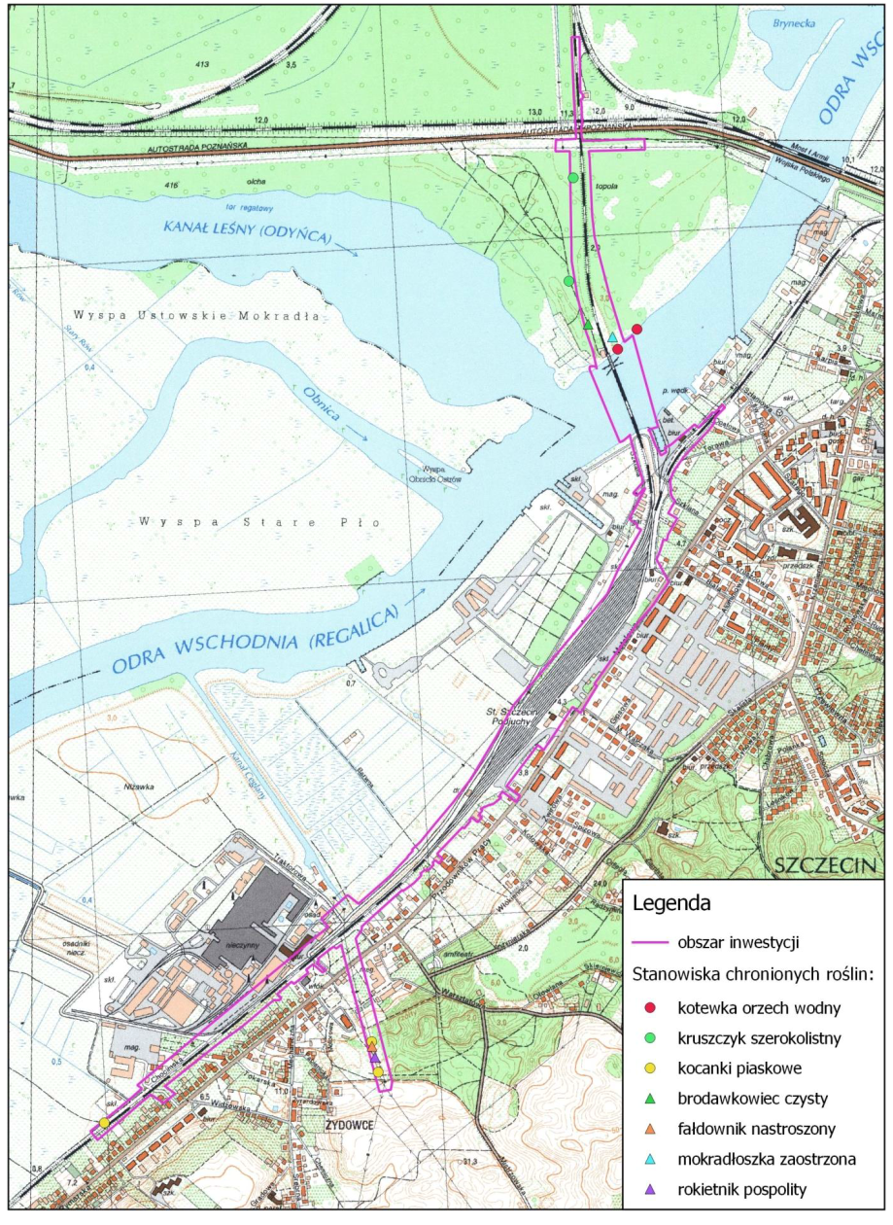
Sites of protected plant species:
Key:
Area of investment
Water caltrop
Broad-leaved helleborine
Dwarf everlast
Neat feather-moss
Springy turf-moss
Pointed spear-moss
Red-stemmed feathermoss
Figure 3 Sites of protected plant species (vascular plants and mosses)
Source: Report on the environmental impact of the project for the project entitled "Partial demolition [...]", April 2019.
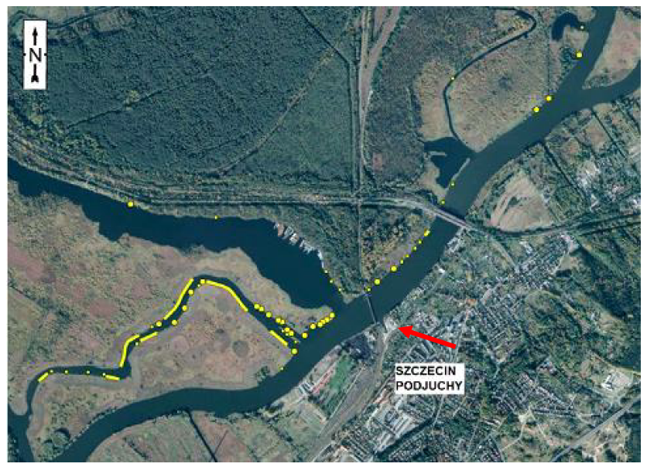
In the 2018 vegetation season, no presence of macrophytes was found in the water in the section studied. However, according to the literature data, in the summer of 2017 the presence of water caltrop (Trapa natans) was found in the Lower Odra valley, within the area of the Obnica Północna canal and on the western bank of Regalica. Location of the water caltrop (Trapa natans) in the valley of the Lower Odra River near Szczecin in July 2017 is shown in the figure below.
Figure 4 Location of the water caltrop (Trapa natans) in the valley of the Lower Odra River near Szczecin in July 2017.
Source: Ławicki Ł. et al. 2017; Natural valorisation of the city of Szczecin 2018
Therefore, the area of the bridge on the west bank of the Regalica River is a potential habitat for the water caltrop (Trapa natans). Spatial data from the Natural Valorisation of the city of Szczecin indicate that there were single individuals of water caltrop within the range of the planned investment (at the distance of 35 m to the east of the bridge), while a larger patch made of about 20 individuals was at the distance of about 115 m to the northeast of the northern span of the railway bridge. At the construction stage, increased vessel traffic and construction works in the bank zone may cause mechanical damage to the macrolytes. However, these activities are not expected to have a significant impact on the conservation status of this species. The water caltrop is a species that requires clean water, so there may be a temporary limitation in the plant development in the area affected by the increased suspended matter concentration in the area of executed works in the Regalica River bed. However, it is estimated that this will be a temporary, short-term, local, transient phenomenon that will not permanently change the habitat conditions within the river bed. Due to the small area occupied by the construction works in relation to the width of the river and the volume of flow in this section of the Regalica, the dispersion of the suspended matter is to be expected, without negative effects on the natural environment.
The work carried out assumes the maximum reduction of damage to plant sites and that their fencing will be made in order to protect them at the stage of construction works as described in the Section 6.7.
Natural habitats
The analysis of the maximum potential impact shows that the loss of natural habitats on the scale of the total area of a given habitat type within the borders of the analysed Lower Odra Natura 2000 area PLH320037 will be minimal.
- 91E0* - willow, poplar, alder and ash riparian forests (Salicetum albae, Populetum albae, Alnenion glutinoso-incanae, alder carrs): during the construction phase, there will be a risk of destroying 860 m² of habitat, which is 0.004% of the resources within the Lower Odra sanctuary PLH320037, due to the construction works carried out during the reconstruction of the railway line.
- 9190 - Pomeranian acidophilous birch and oak woods (Betulo-Quercetum): during the |design works, the scope of works in the section from the bridgehead No. 2 to the Floriana Krygiera Street was made more detailed and no interference with the natural habitat 9190 is expected. Nevertheless, the Contractor is obliged to use a temporary fence to protect the patch of this habitat during the works.
Taking into account currently the poor (in case of the habitat 9190) and unsatisfactory (in case of the habitat 91E0) condition of habitats and the fact that the expected loss of habitats during the planned works will be much smaller than the maximum potential, it should be considered that the impact on natural habitats will not be significant.
In order to protect the patches of habitats during the construction works, a temporary fence will be made to prevent interference of construction machines and people with the patches of these habitats.
Fish
The analysis of the presented scope of works indicates a potential for occurrence of unfavourable factors for the aquatic environment and fish at the construction stage.
These factors may include:
- deterioration of the natural habitat quality (hydromorphological criteria, loss of structural elements important for biodiversity),
- periodic silting or mechanical destruction of habitats as the result of works carried out in the bed,
- unintentional killing of individuals of fish species living in silt or on the bottom,
- disruption of the life cycle of fish (spawning, migration, overwintering), if works are carried out at the wrong time.
Potential risks to the soil and water environment in the Regalica catchment area are also associated with the use of faulty construction and transport machinery and equipment and improperly managed materials and equipment, waste and sewage, including faulty fuel systems of transport vehicles and construction machinery.
Impacts on fish fauna will be effectively minimised by applying the measures described in the Section 6.7., in particular adapting the dates of carrying out particular works to periods of particular sensitivity of fish (migration and spawning periods) and carrying out works in the bed with a sheet piling shielding.
As a result of the implementation of the Task, the bottom microforms constituting potential habitats and fish feeding places will be destroyed by removing the supports of the existing bridge. The reduction of the food base at this level affects the most carp species - those from the benthic group - which feed on benthic organisms., e.g. common bream, white bream, crucian carp, tench or ide. However, the depletion of the food base will be spotty and short-term. Taking into account the available biomass of macrobenthos in the entire width of 200 m of the Regalica bed at the site of the works, it will easily ensure continuity of the food base for these fish species, especially since after the completion of the works the process of recolonisation of the bottom by benthic organisms will begin. In terms of the habitat depletion, measures will be taken to create potential habitat for lithophilous fish species, e.g. by dumping gravel mixed with stones, in places after the decommissioned supports and around the bottom occupied by the new supports.
Invertebrates
The investigation of the area under inventory showed the presence of representatives of four protected species. Three of the protected species are generally quite numerous components of the fauna: buff-tailed bumblebee (Bombus terrestris), common carder bee (Bombus pascuorum) and Roman snail (Helix pomatia). Occupation of land for the purposes of the Task will not have a significant impact on bumblebees and Roman snails, as they are relatively common and widespread species. It is not expected that there will be a need for measures to minimise the negative impact dedicated to these species. However, less frequently occurring species include a representative of freshwater mussels – river orb mussel (Sphaerium rivicola). No work is planned at the site of the inventoried presence of the river orb mussel (on the northern side of the existing bridge). This species is, however, sensitive to water pollution and oxygen deficits, which may be a secondary consequence of the execution of works in the Regalica River bed. Impacts on this species will be minimised by applying mitigation measures identified for the protection of fish fauna.
Amphibians and reptiles
No significant long-term impact is expected to threaten the continuity of amphibian and reptile populations or significantly reduce their quantity. The habitats of the observed species will not be significantly changed. The species identified in the field are numerous in the vicinity of the investment in the undeveloped area. After the completion of the construction and the site cleanup, at the stage of the bridge's operation in its new shape, the habitat conditions along the Regalica river bank line and in the remaining area will return to their pre-construction condition.
Birds
The removal of trees and shrubs is planned during the implementation phase of the investment, so it is necessary to obtain an appropriate permit - to remove or replant trees and shrubs.
For the purpose of the Task, a dendrological inventory was made in the area located along the tracks of the Szczecin-Gryfino railway line, in the section from the track signal tower located between the Floriana Krygiera Street and the Księżna Anna Street, to the passage on the Chocimska Street in Szczecin - Żydowce. These are urbanised and industrial areas, arranged allotment gardens and house gardens, wastelands and forest areas with the features of an ash-elm, ash-alder and willow-poplar riparian forest. It has been estimated that the maximum range of felling, assuming that all the trees and shrubs inventoried within the boundaries of the project will be felled, will cover: 659 trees, of which 558 trees requiring an administrative decision for felling; 3 558 m² of shrubs, of which 2 655 m² of shrubs requiring an administrative decision for felling. A fragment of the forest usable land on the plot of the land No. 414 from the 1114 precinct, on the area of 0.38 ha, will also be felled. The forest plot is located on the left side of the railway line. This is a very wet area. During the tree inventory, observations of the presence of protected species were made by a detailed inspection of tree trunks and crowns in order to determine the presence of protected species. The following presence was found: 17 nests of protected bird species hooded crow (Corvus corone), Eurasian magpie (Pica pica), song thrush (Thrudus philomelos), common blackbird (Turdus merula), red-backed shrike (Lanius collurio), 2 nests of hunting species common wood pigeon (Columba palumbus) and inactive feeding and breeding holes of woodpecker (on 2 trees). No protected flora species were found.
The planned investment is located in the surroundings of vast areas much more valuable for birds. Therefore, it is not expected that the execution of the investment on a relatively small scale will have a significant negative impact on the populations of identified bird species, among which common species, also inhabiting urban areas, predominate. The application of time restrictions during the removal of trees should effectively minimise the impact to insignificant levels. In particular, the application of time constraints will prevent the destruction of the clutches, and the hanging of nesting boxes on trees in the vicinity of the planned investment will minimise the impact of losing potential nesting sites. It is also not expected that the operation of the new bridge, with its relatively low structure, will pose a risk to local bird populations or to groups of seasonally migrating birds.
Mammals
The construction and operation of the new bridge over the Regalica River is not expected to have a significant negative impact on terrestrial and semi-aquatic mammals, no negative impact on the inventoried species is expected to occur – Eurasian beaver (Castor fiber) and Eurasian otter (Lutra lutra). The relatively small scale of the project and the concentration of works on a small area allow to assume that significant impacts on mammalian fauna will not occur, especially as the results of the inventory did not show that the area around the bridge was particularly intensively used by mammals. After completion of the construction works, both above mentioned species are likely to return to the bridge area.
Bats
The construction and operation of the new bridge is not expected to have a significant negative impact on bats. At this stage, there are no indications to predict collisions with breeding colonies or winter shelters, and the project will also not significantly disturb bat feeding habitats.

Impact on forms of nature protection
Natura 2000 Areas
The Task will be implemented within the boundaries of two Natura 2000 areas - PLH320037 Lower Odra and PLB320003 Lower Odra Valley. The objects of protection of the "Odra Valley" area are natural habitats and habitats of several animal species (except birds), characteristic for areas of large flood valleys. The objects of protection in the “Lower Odra Valley” area are bird species and their habitats ecologically related to the Odra Valley.
The implementation of the Task, which consists in the reconstruction of the existing railway infrastructure, will not affect negatively the processes conditioning the preservation of the desired natural structure of the Międzyodrze area, in particular it will not change the extent and duration of floods, and it will not cause fragmentation of habitats or isolation of population.
There are mitigation measures, which may enable to achieve the technical assumptions of the project while limiting to an acceptable level the negative effects on the environment, including protected species and habitats.
For the species and habitats listed below, adequate mitigation measures are assumed.
Lower Odra Special Habitat Protection Area PLH 320037:
- 9190 acidophilus oak forests (Quercion robori-petraeae) and 91E0* willow, poplar, alder and ash riparian forests (Salicetum albae, Populetum albae, Alnenion glutinoso-incanae, alder carrs)
In order to protect the patches of the natural habitat during the construction, a temporary fence will be used to prevent interference by the construction machinery and people.
- 1318 pond bat Myotis dasycneme, 1324 greater mouse-eared bat Myotis
An air-raid shelter on the left bank, intended for demolition, can be a place of refuge during the summer period. Its demolition will be preceded by a visit of a bat fauna specialist and will be carried out under environmental supervision.
- 1130 asp Aspius, 1149 spined loach Cobitis taenia, 6144 northern whitefin gudgeon Romanogobio albipinnatus (=1124 Gobio albipinnatus)
Mitigation measures will be implemented in order to exclude the execution of works in the bed causing an increase in the suspended matter concentration (installation of sheet pile walls) during the spawning period.
- 1088 great capricorn beetle Cerambyx cerdo, 1083 stag beetle Lucanus cervus, 1084 hermit beetle Osmoderma eremita
The species have not been inventoried within the impact range of the project, while the natural habitat 9190 - acidophilus oak forests (Quercion robori-petraeae) (on the left bank of the Regalica River on the left side of the embankment) may be a potential habitat for the occurrence of the species; the range of removal of trees and shrubs will be reduced to a minimum.
Special Bird Protection Area Lower Odra Valley PLB320003:
Due to the fact that in the area of the planned investment only four species being objects of protection were identified in the sanctuary (mallard Anas platyrhynchos, mute swan Cygnus olor, European honey buzzard Pernis apivorus, great cormorant Phalacrocorax carbo), but there are available potential habitats of other species in the surroundings of the investment, the removal of trees and shrubs in the period from 15 October to 1 March should be a sufficient measure to minimise the risks of destruction of potential breeding sites.
The planned investment is located in the surroundings of vast areas of the Międzyodrze, which are much more valuable for birds’ life. Among the inventoried species, common species predominate, also inhabiting urban areas, which are not considered as objects of protection of the area. Therefore, it is not expected that the implementation of the investment project of a relatively small scale will have a significant negative impact on the populations of the identified species. The application of time restrictions during the removal of trees should effectively minimise the impact to insignificant levels. It is also not expected that the operation of the new bridge of a low structure will pose a risk to local bird populations or to groups of seasonally migrating birds.
Other forms of nature protection
As other types of the nature protection forms: national park, landscape parks, nature reserves, protected landscape areas, ecological sites, documentation sites and nature and nature-landscape complexes as well as nature monuments, are located far away from the place of the planned investment, and taking into account the size of the investment and the scope of works, no possibility of influencing their protection objectives is expected.
In the light of the analysis of the impact of the planned investment, no significant impact on animals and plants and fungi subject to species protection was found.
The project is located about 350 m from the ecological corridor of the North Odra Valley. Due to the nature and scope of the project and the distance from the indicated corridor, no negative impact of the investment on its functioning is expected.

Acoustic climate
During the implementation of the Task, the generated noise emissions will be of a local nature, limited to the area of executed works.
During the execution of the construction works, unfavourable acoustic phenomena will occur in the area of the works. The potential source of noise during the execution of the project will be machines and equipment working on the construction site and means of transport. The range of noise impact will depend both on the phase of executed works, number of simultaneously working machines, their type and working time. The largest, although short-term source of noise will be earthworks, connected with the preparation of the construction site.
The planned track technology to be applied to the bridge and track section is characterised by reduced noise emission to the environment and will result in a reduction in noise emissions compared to the existing state. The analysis of the acoustic impact for the time horizon after the completion of the Task (year 2025) carried out for the purposes of the environmental impact report showed that the permissible levels of environmental noise were not exceeded.

Population and material goods
In the area of the existing buildings in Metalowa Street, the executed works will only include the reconstruction of the railway line together with the accompanying technical infrastructure. After the completion of the project and the commissioning of the new bridge, the traffic layout of the Szklana Street will be reconstructed, providing similar access to facilities and areas located between the railway line and the Regalica River. The impact on the material goods associated with the operation of the railway line will not change significantly compared to the current state.
In order to protect material goods at the construction stage, the Contractor will be obliged to implement a number of measures to minimise the impact both in the vicinity of the construction site and access roads and will be responsible for repairing any possible damage. In addition, during the implementation of the Task within the area of the Regalica River, including transport operations within the area of waterways, the Contractor will be responsible for ensuring safe navigation on the waterway during the execution of works and prevention of shipping accidents.

Cultural monuments
As a part of the bridge demolition works, the drawn span of the bridge has been planned to be preserved and protected. Taking into account the scope of construction works, the manner of carrying out the works and the fact that the drawbridge's part under conservation protection will be properly secured, no negative impact of the project on this monumental object is expected.
Execution of construction works related to the reconstruction of the track system in the area of the Szczecin-Podjuchy housing estate will be carried out outside the area directly adjacent to the buildings under the monument conservation protection and included in the municipal register of monuments, and thus will not pose risk to their condition. Due to the location of historic buildings in the area of access roads to the construction site, it is possible that temporary impacts on buildings located directly by the roads may occur. Therefore, it will be necessary to implement the mitigation measures identified for the protection of material goods in the area of the Task implementation.
As the result of demolition works carried out, the historic span of the bridge will be renovated and properly secured and prepared to be made available to tourists.

Human health and safety
The impact on the human health and safety during the implementation of the Task may be related, inter alia, to the following factors:
- increased noise emissions,
- pollution by oil-derivative substances,
- access of unauthorised persons to the area of construction works,
- occurrence of increased water levels and ice jams in the Odra River, which pose a risk to the work execution area and adjacent areas,
- transport of materials and elements of the bridge construction by water and/or transport of large elements by land,
- carrying out works within the area of waters and the bank slope areas in close proximity to water,
Detailed selection of equipment units for the purpose of carrying out the Works covered by this Task is left to the discretion of the Contractor, after prior consultation with the Engineer. Equipment, machines or tools, which do not guarantee compliance with the quality requirements of the Works, the Health and Safety Regulations and the Safety and Health Plan regulations, and which may cause damage to the existing infrastructure and elements of buildings and land development will not be allowed to the Works by the Engineer.
The operation of the floating equipment, execution of works using it as well as the movement of employees in the immediate vicinity of the riverbed also poses a risk to the health and life of people carrying out these works. It is therefore important to ensure that workers are provided with appropriate equipment to protect their health and life during the execution of the works (e.g. appropriate protective equipment), and that appropriate safety procedures are developed and implemented when carrying out the works.
During the implementation of the Task, the generated emissions of pollutants into the air and noise emissions will be of a local nature, limited to the area of the executed works. The works will be carried out in the river bed and directly on the river bank and within the railway areas, which means that they will not pose a risk to the health of people living in built-up areas, located in the area of the Task implementation sites.

Extraordinary risks (crisis and emergency situations)
The implementation of the planned Task entails the possibility of the following crisis or emergency situations, which may cause extraordinary risks to the environment:
- Uncontrolled emissions (leakage) of oil-derivative products
During the construction phase, an emergency situation may occur, resulting in the leakage of oil-derivative substances from vehicles, floating equipment, construction machinery, tanks, etc., resulting in contamination of surface water or soil (including soil). During the execution of works, the risk of occurrence of an emergency situation will be minimised by ensuring that appropriate procedures and measures are in place to limit losses in the event of environmental damage.

- Fire or explosion of flammable substances
During the construction phase, an emergency situation related to the occurrence of a fire may occur (e.g. due to the equipment failure, personnel negligence, explosion of flammable substances, lightning strike, etc.). The occurrence of such a situation poses a risk to both the Contractor's personnel and the environment. Nevertheless, in order to minimise occurrence of such situations, among other things, only equipment in proper technical condition will be used, which will be properly operated and maintained.

- Finding of unexploded shells and ordnance
It is possible to find unexploded ordnance or unexploded shells in the course of construction works, such as: fuses, missiles, aerial bombs, artillery and rifle cartridges, bazookas, grenades, all types of mines, explosive charges, scrap metal containing residual explosives and others. The task will be carried out in such a way as to eliminate the risk of any danger to the Contractor's staff and local residents. Procedures will be developed in case of occurrence of such a situation and appropriate personnel will be involved (sapper's supervision).

- Sudden water rises, flooding
The area of the Task implementation includes the Regalica River and the areas adjacent to the river. During the construction stage there may be a sudden increase in the water level on the construction site or a flood, putting at risk the health and life of personnel and causing material damage to the construction site. During the period of high water levels or floods, within the river bed and in the bank zone, there may be Contractor's equipment and elements of the construction backup facilities. Procedures will therefore be developed in the event occurrence of such a situation.

CUMULATIVE AND CROSS-BORDER IMPACTS
In the environmental impact assessment procedure, issues related to cumulative impact were analysed. According to the information contained in the justification of the decision on environmental conditions issued for the Task (see the Attachment 4a), the cumulative impact was taken into account in particular in the context of the tasks carried out in the Odra River within the framework of the Odra-Vistula Flood Management Project.:
- 1 B.3/1 Stage I - Construction of berthing and mooring base for icebreakers;
- 1B.4/1. Improvement of floodwater flow in the winter period from the Lake Dabie;
- 1B.4/2. Dredging of the Klucz-Ustowo cut.
In addition, projects concerning the following have been analysed:
- reconstruction of the Szczecin Podjuchy station;
- construction of a P&R car park at the Szczecin Podjuchy station.
For task 1 B.3/1 Stage I - Construction of berthing and mooring base for icebreakers, a decision on environmental conditions has been issued. The area where the base for icebreakers will be constructed is located at the distance of about 300-350 m from the project in question. Accumulation of impacts with the task in question may occur if both tasks are carried out at the same time, causing an increase in the amount of suspended matter in the water of the Regalica river. Nevertheless, the impacts will be of temporary nature and will cease when the works are completed. A similar type of impact may occur in the case of Task 1B.4/2. Dredging of the Klucz-Ustowo cut. For this task a notification was made under the Article 118(6)(1) of the Nature Conservation Act of 16 April 2004, to which the Regional Director for Environmental Protection in Szczecin did not raise any objections. The accumulation of impacts in terms of the increase of suspended matter could take place if the works under the projects were carried out at the same time. These impacts would cease when the works stop.
For the Task 1B.4/1: Improvement of floodwater flow in the winter period from the Lake Dąbie, the decision on environmental conditions has not yet been obtained. The Lake Dąbie is located about 8 km down the river from the Task implementation area. Taking into account the location of the investment, it was assessed that there will be no significant accumulation of the impact of the Task with the activities carried out within the area of the Lake Dąbie.
Taking into account the specific nature of the works, no significant negative cumulative impact on the water stages is expected due to the reconstruction of the Podjuchy station and construction of a P&R car park.
In the context of the cumulative impact in terms of noise emission on acoustically protected areas, during the assessment of the cumulative impact the total impact of the planned Task with the following investments and existing facilities was taken into account:
- reconstruction of the Szczecin Podjuchy station within the framework of the task named "Construction of the Szczecin Metropolitan Railway with use of the existing sections of the railway lines No. 406, 273, 351";
- reconstruction of the Gryﬁtów Bridge in the course of the national road No. 31 (north of the investment);
- reconstruction of the existing road system in the vicinity of the planned project, i.e. Metalowa Street and Floriana Krygiera Street – the national road No. 31.
In the above mentioned analysis, the study entitled "Excerpt from the Feasibility Study "Szczecin Metropolitan Railway" Stage 7 Detailed analysis for the selected option of the line modernisation, Volume I, Facilities for passenger traffic" was used (update/status as on 16.10.2017). The analysis of the cumulative impact shows that the dominant source of noise is the existing road system in the vicinity of the investment, i.e. the national road No. 31, and it is the reason for exceeding the permissible standards in the environment.
Within the framework of the environmental impact assessment, in the context of the possibility of occurrence of a cross-border impact, no possibility of a significant cross-border environmental impact was found. This is due to the nature of the Task and its location in relation to the German border. Taking into account the small range of the environmental impact of the planned Task, limited in most cases to the width of the technological zone, and the fact that the investment is located at the distance of about 12.5 km east of the Polish-German border, the Regional Director for Environmental Protection in Szczecin decided that the implementation of the investment will not cause a cross-border environmental impact.

Description of mitigation measures
In order to limit the negative impact of the planned Task on the environment, the Attachment 1 to the EMP provides a set of mitigation actions that shall be taken by the Contractor. These actions were developed on the basis of the conditions contained in the administrative decisions in force in the field of environmental protection issued for the Task, with the supplementing of additional conditions established at the stage of preparation of the EMP. The implementation of the mitigation measures should ensure that the Task is carried out taking into account World Bank guidelines (Environment, Health and Safety Guidelines): The Environmental, Health, and Safety (EHS) Guidelines. The requirements for the construction stage are set out in the General EHS Guildelines), in particular in the Section 4 (“Construction and Decommissioning” stage).
Temporary and permanent occupation of land in connection with the implementation of the Task takes place according to the rules specified in the Land Acquisition and Resettlement Action Plan (RAP).
In order to supervise and monitor the mitigation actions included in the EMP, a dedicated position of EMP Coordinator in the Contractor's team will be appointed within the Contractor's structure (see item 128 of Cat. O - Requirements for the Contractor's personnel involved in the EMP implementation) .
Selected, characteristic mitigation actions are presented below, broken down into individual environmental components discussed in the Section 5 of the EMP.

Land surface and landscape
In order to limit the negative impact of the Task on the ground surface and landscape, mitigation measures have been planned during the execution of construction works and prior to their commencement.
The stage of carrying out the construction works should be preceded by the works related to the preparation of the Task implementation site, including e.g. preparation of storage sites for construction materials, construction backup facilities, etc. The occupation of the land and the transformation of the land surface during the works should be limited to the necessary minimum. The use of the site will be agreed with the site manager, and any possible permits or derogations required by the law shall be obtained. The selection of sites for temporary storage yards and routes of possible access roads will be consulted and accepted by the environmental supervision.
Internal technological roads, storage yards and construction site backup facilities should be located in such a way as to preserve trees and shrubs growing outside the places necessary to be occupied due to the execution of works. Access to the construction site backup facilities should be routed via public roads.
Mitigation measures to reduce the impact on the ground surface and landscape are in particular the following items in the table in the Attachment 1 to the EMP:
- items 3 - 14 (cat. B – Requirements for the transport service of the Task implementation area),
- items 18 - 21 (cat. C – Requirements for the location of construction backup facilities and roads, material storage and parking areas),
- items 52 - 56 (cat. H - Requirements for the conservation of protected natural resources),
- items 57 - 62 (cat. I – Requirements for the restoration of natural resources after completion of construction).

Climate
In the case of this Task, no mitigation actions were found necessary to be carried out to protect local climatic conditions.

Condition of the air
The implementation of the Task requires the implementation of standard solutions, which limit the emission of exhaust fumes to the atmosphere from machines and vehicles used for the implementation of the Task and reduce dust during earthworks or transport of materials. In connection with the above, the Contractor will implement the following mitigation measures aimed at reducing/eliminating the negative impact of the Task on the air quality:
- equipment used during the stage of execution of construction works must be fully operational and meet current legal requirements to protect against dust and gas emissions into the air;
- running time of the combustion engines of construction machinery and vehicles at standstill must be limited (reduce emissions during the so called idling) and to switch off unnecessary machines that are not in use at any given time;
- loose materials intended for use in the construction phase should be protected against blowing away and excessive dusting from their surface both during transport, storage and installation;
- reduce dust caused by means of transport by, inter alia, cleaning the wheels of vehicles before entering public roads, cleaning the surfaces of internal technological roads, using vehicles with tarpaulins for transporting dusty materials or transport loose materials in packaging, using tarpaulins for transporting dusty materials or transport loose materials in packaging on vessels, other measures to prevent dirtying of local roads with sand and mud moved by vehicles, spraying the surfaces of internal technological roads.
Measures to limit the impact on the air condition are indicated in the table in the Attachment 1 to the EMP in the following items:
- 65, 75 - 82 (cat. J - Requirements for the prevention of environmental pollution (including the limitation of emissions into the environment)).

Soil and land
During the implementation of the Task, measures shall be implemented to mitigate negative impacts on soils with respect to the reduction of the area of temporary sites and the prevention of soil and land contamination.
Soil humus layer should be removed and used for post-construction land reclamation or for purposes of greenery formation. Equipment, machinery and vehicles used for construction works must have permanently designated parking place(s), which will be hardened and equipped with appropriate sorbents to prevent the entry of petroleum substances into the soil and water environment. When equipment, machinery and vehicles are not in use, they must be parked at these designated points. Lubricants and fuels should be stored in suitably adapted places, with a suitable degree of tightness and equipped with a sorbent to neutralise oil-derivative substances.
Zones where parking of machinery and vehicles working on the construction site will be arranged, parking spaces for employees, places to refuel vehicles, places to store hazardous materials (e.g. fuels, lubricants, solvents, paints), places to store hazardous waste should be sealed (e.g. lined with insulating materials) against possible penetration of hazardous substances into the ground and water environment.
Equipment used for the construction works must be fully operational and meet the requirements permitting it for use. The type and the technical condition of equipment used during the construction must ensure protection of the ground. The technical condition of working construction and transport machinery must be checked to prevent leakage of oil-derivative hydrocarbons to the ground.
In the event of possible spillage of oil-derivative substances, the spills shall be removed immediately, and the contaminated soil layers will be removed (with the help of a specialised company) and managed in accordance with the applicable regulations. Such sites will be restored to their original condition.
Mitigation measures to reduce the impact on soil and land are in particular the following items in the table in the Attachment 1 to the EMP:
- item 18 (cat. C – Requirements for the location of construction backup facilities and roads, material storage and parking areas),
- items 20 - 25 (cat. D - Requirements for the management of earth masses),
- items 26 - 31 (cat. E - Requirements for handling the humus layer),
- items 57 - 61 (cat. I – Requirements for the restoration of natural resources after completion of construction),
- items 63, 65 - 71, 83 (cat. J - Requirements for the prevention of environmental pollution (including the limitation of emissions into the environment),
- items 84 - 89 (cat. K - Requirements for waste and waste water management).

Surface water and underground water
Measures for the protection of surface water and groundwater are consistent with those for protection against soil and ground pollution and include mainly the implementation of measures and procedures to minimise the risk of water pollution and to remove pollution if it enters the environment. Additionally, it will be necessary to introduce measures to minimise the risk of direct pollution of surface waters during works in the riverbed or bridge construction. Therefore, apart from the activities indicated in the item 6.4, the Contractor shall be obliged to implement such activities as:
- demolition of the existing supports and renovation of the supports of the historic span in the casing from sheet piling, which will effectively protect the river's water against pollution associated with the Task,
- carrying out works related to the construction of supports in the current in tight chambers and monitoring of suspended matter and dissolved oxygen concentrations during spot-based dredging works (monitoring activity in item 135 of the Attachment 2 to the EMP),
- installation of special protective sheets or nets under the supporting structure of the disassembled bridge in order to catch waste generated during cutting of the supporting structure elements.
Moreover, the Contractor will be prohibited from moving earth masses by pushing them within the area of the riverbed.
In the event of a leakage of oil-derivative substances into surface waters, the Contractor is obliged to ensure immediate limitation of the spreading of contamination and mechanical collection of oil-derivative substances from the water surface.
The construction site must be organised and equipped in such a way as to limit the risk of pollutants getting into water. The contractor is also obliged to use fully operational equipment in an appropriate manner, the use of which for the purposes of the works will not pose a risk to water condition.
Mitigation measures to reduce the impact on the surface water and the groundwater are detailed in particular in the following items in the table in the Attachment 1 to EMP:
- items 22 - 25 (cat. D - Requirements for the management of earth masses),
- items 44 - 45 (cat. H - Requirements for the conservation of protected natural resources),
- items 63 - 71, 83 (cat. J - Requirements for the prevention of environmental pollution (including the limitation of emissions into the environment)),
- items 84 - 89 (cat. K - Requirements for waste and waste water management).

Acoustic climate
During the construction stage, there may be an increase in the noise level due to the operation of construction machinery as well as the noise generated by heavy vehicles delivering construction materials. In order to limit the duration and impact of the works on the acoustic climate to the immediate surroundings of the worksites, mitigation measures such as the following must be implemented:
- execution of noise-generating works during the daytime from 6:00 a.m. to 10:00 p.m. (it is possible to carry out works during the night time only if their necessity is forced by technological reasons),
- informing the residents about the planned works prior to the commencement of construction works and, if necessary, using portable noise barriers,
- use of technical solutions ensuring appropriate acoustic conditions in the vicinity of the existing buildings, use of equipment and machines meeting the environmental requirements and standards (including equipment properly silenced, technically efficient, with low emission of pollutants into the air) and the least acoustically burdensome technologies of carrying out the works,
- shutting down equipment and machinery that is not currently in use, limiting the operation of engines at top speed and avoiding overlapping and piling up impacts of one nature, e.g. simultaneous operation of generators, excavators and transport vehicles,
- location of the backup facilities as far as possible from residential buildings and transport routes in the area of the least nuisance to people.
Mitigation actions to reduce the impact of the noise emission are detailed in particular under the following headings in the table in the Attachment 1 to the EMP:
- items 3 - 4 (cat. B - Requirements for the transport service of the Task implementation area),
- item 19 (cat. C - Requirements for the location of construction backup facilities and roads, material storage and parking areas),
- items 65, 72 - 80 (cat. J - Requirements for the prevention of environmental pollution (including the limitation of emissions into the environment)),
- item 86 (cat. H - Requirements for waste and waste water management).

Wildlife and protected areas
During the execution of the works, the Contractor shall be obliged to observe the standards, prohibitions and instructions and to respect the restrictions resulting from the existence of areas and objects created on the basis of the Nature Conservation Act. The requirements resulting from the location of the task in the vicinity and within the protected areas have been taken into account within the framework of mitigation measures specified for the protection of natural habitats and protected species. In order to protect natural values in the area of Task implementation and its vicinity, the Contractor is obliged to provide its own environmental supervision team, which will be involved in the proper implementation, during the execution of the works, of EMP, DEC [Decision on Environmental Conditions] (see the Attachment 4a), the species decision included in the Attachment 4b and other species decisions if their obtaining is required for the Task implementation. The environmental supervision team of the Contractor will include specialists in such fields as: botany, dendrology, fish fauna, bird fauna, herpetology, bat fauna, mammalian fauna, entomology. The specialists of the environmental supervision team must have documented experience in this field and have education in biology or related fields. One specialist in the Contractor's team may combine up to two of the above functions. The tasks of the environmental supervision team will include:
- training of employees supervising the construction site in dealing with wild animals and notifying the environmental supervision,
- carrying out an initial nature inventory prior to the commencement of works,
- carrying out the necessary environmental checks and taking appropriate protective measures ,
- ongoing specialist factual assistance,
- preparing reports on all significant events relating to protected environmental components;
- controlling the progress of works carried out, in particular in relation to:
- removal of trees and shrubs, with particular emphasis on the removal of trees within the habitat 9lE0,
- securing the patches of natural habitats: 91E0* and 9190;
- interference with the Regalica River bed and its bank area, including driving of sheet piling and piling works,
- creating a potential habitat for lithophilous fish species, in places after the decommissioned supports and in the vicinity of the bottom occupied by the new supports,
- carrying out electro-fishing in the area of the planned sheet piling works and in the bank zone in the area of the planned bridgeheads,
- protecting species of protected vascular plants and mosses such as: dwarf everlast Helichrysum arenarium, water caltrop Trapa natans, springy turf-moss Rhytidiadelphus squarrosus, red-stemmed feathermoss Pleurozioum schreberi and pointed spear-moss Calliergonella cuspidata,
- organisation of the construction site, including the use of appropriate measures to prevent animals from entering the site (e.g. fencing off all or part of the site),
- demolition of the object located next to the bridgehead on the eastern bank of the river,
- hanging bird nesting boxes,
- the relocation of the anthills of the red wood ants (Formica rufa).
Mitigation actions will be carried out primarily with the objective of:
- direct physical protection of valuable natural sites against accidental destruction,
- protection of birds’ clutches during removal of trees and demolition works,
- protection of bats during demolition works,
- preventing animals from entering the site,
- protection of fish fauna and species of protected aquatic fauna and flora during works in the river bed,
- protection of trees and shrubs not intended to be removed from accidental damage and, in the case of damage to a tree, carrying out the necessary maintenance measures under the supervision of the environmental supervision team, limiting the effects of damage.
The works should be carried out in such a way as not to kill animals. In particular, the Contractor shall be obliged to carry out electro-fishing in the area of the planned sheet piling works and in the bank zone in the area of the planned bridgeheads in order to remove small fish, including such protected species as spined loach, Amur bitterling and white-finned gudgeon, inhabiting growing submerged and floating hydrophytes, from the endangered area. If fish occur inside the sheet piling enclosure they will be caught and then released into the Regalica River. In order to minimise possible negative impacts on the animal species colonising the trees and the bridge to be demolished, the methods of conduct and environmental supervision were indicated to limit possible negative impacts on populations of protected species (e.g. inspections of trees to be cut and the bridge by appropriate experts). In case there is a need to relocate individuals of protected species, the Contractor is obliged to first plan these activities, obtain relevant permits, effectively carry out these activities and also carry out other activities required in this permit (e.g. prepare and submit reports to the authority issuing the relevant permit).
The implementation of the Task will most probably result in the 91E0* habitat depletion - willow, poplar, alder and ash riparian forests (Salicetum albae, Populetum albae, Alnenion glutinoso-incanae, alder carrs): During the construction phase, there will be a risk of destroying 860 m² of habitat, which represents 0.004% of the resources within the Lower Odra sanctuary PLH320037, in connection with the railway line reconstruction works. Taking into account the unsatisfactory condition of this habitat, it was concluded that this impact will not be significant. A temporary fence will be constructed to protect the habitat patches during construction to prevent interference of construction machinery and people with the habitat patches.
The nature inventory carried out for the purposes of the report showed that during the implementation of the investment a collision with the following species of protected vascular plants and mosses may occur, i.e. dwarf everlast (Helichrysum arenarium) on the area of about 3 m2, springy turf-moss (Rhitidiadelphus squarrosus) on the area of about 12m² and red-stemmed feathermoss (Pleurozium schreberi) on the area of approx. 10 m², several specimens of broad-leaved helleborine (Epipactis helleborine), neat feather-moss (Pseudo-scleropodium purum) on the area of approx. 3 m₂ and pointed spear-moss (Calliergonella cuspidata) on the area of approx. 0.25 m². These species are quite common on a local and national scale. They also have their sites outside the Task implementation area, therefore the implementation of the Task will not significantly affect the depletion of their populations. Taking into account that at the current stage of Task preparation there are no final arrangements as to the location of some facilities, including supporting structures, first of all the sites of the above mentioned species will be secured against destruction, e.g. by fencing them, whereas in case of necessity of their destruction the Contractor will obtain appropriate permits in this respect.
Moreover, during the construction stage of the investment, one site of a species under strict protection, i.e. the water caltrop (Trapa natans) located in the waters of the Regalica River, along the left bank, may be destroyed. The area of the Task implementation in the area of the bridge on the western bank of the Regalica River is a potential habitat of the above mentioned plant species. According to the records of the Nature Valorisation of the city of Szczecin (Szczecin, 2018), there are single specimens of water caltrop within the range of the planned Task (at the distance of 35 m to the east of the bridge), while a larger patch made of about 20 specimens is at the distance of about 115 m to the north-east of the northern span of the railway bridge. The destruction of a few to a dozen or so specimens of the water caltrop will not affect the conservation status of this species. Nevertheless, in order to protect the water caltrop sites above the existing bridge and below the construction site of the designed bridge, the construction site will be fenced in the area of the bridgehead on the left bank of the Regalica River reaching the bank line. This will determine the section of the bank where e.g. barges can moor.
Due to the removal of supports for the existing bridge, the habitats and fish feeding areas associated with these supports will be destroyed. The depletion of the food base will be point-based and will not be significant taking into account the available biomass of the macrobenthos in the entire width of 200 m of the Regalica riverbed at the site, all the more so as after the completion of the works the process of the bottom recolonisation by benthic organisms will start. In terms of the habitat depletion, measures will be taken to create potential habitat for lithophilous fish species, e.g. by dumping gravel mixed with stones, in areas after the decommissioned supports and around the bottom occupied by the new supports.
In connection with the implementation of the Task, there will be a collision with a fragment of forest area, on the area of about 0.38 ha, located on the left side of the railway line. The dominant species in this stand is Canadian poplar with an admixture of black alder and white willow. In connection with the planned works, including, inter alia, the need to cut down trees in order to change the course of the track system, there will be direct destruction of the habitats of some protected species nesting on trees. In order to minimise the impact of the investment on the protected bird species as the result of works related to the removal of trees and shrubs, the Contractor will hang nesting boxes for birds of types "A", "B" and "D" in the amount of at least 16 pieces, in the section running through the forest areas from the left bridgehead to the Floriana Krygiera Street and on trees in the vicinity of the Task implementation area in the area of the Żydowce housing estate, with parameters adjusted to the existing species and maintaining an appropriate distance between the boxes. In order to assess the effectiveness of the actions taken, the decision on environmental conditions (Attachment 4a to the EMP) requires the Investor to control the technical and sanitary condition of the installed boxes for the period of 10 years and, if necessary, to repair or replace them with new ones.
Prior to the commencement of the construction works, the Contractor shall carry out a site investigation of the Task implementation area with the participation of the environmental supervision team in order to determine the location of sites of natural value and to clarify the scope of the required mitigation actions. If habitats and species of fauna and flora subject to protection are found, for which it will be necessary to violate the prohibitions specified in the applicable regulations, decisions shall be obtained by the Contractor allowing for derogations from the principles of the plant, fungi and animal species protection. The Contractor shall be obliged to implement the conditions contained in the described decisions precisely and on time.
The mitigation measures for the reduction of impacts on the wildlife are detailed in particular in the table in the Attachment 1 to the EMP:
- item 20 (cat. C - Requirements for the location of construction backup facilities and roads, material storage and parking areas),
- item 24 (cat. D - Requirements for the management of earth masses),
- items 26 - 31 (cat. E - Requirements for handling the humus layer),
- items 32 - 33 (cat. F- Requirements for removal of trees and shrubs),
- items 34 - 35 (cat. G - Requirements for protection of trees and shrubs not designed for removal),
- items 36 - 56 (cat. H - Requirements for the conservation of protected natural resources),
- items 58 - 62 (cat. I - Requirements for the restoration of natural resources after completion of construction),
- item 63 (cat. J - Requirements for the prevention of environmental pollution (including the limitation of emissions into the environment)),
- items 113 - 116 (cat. O - Requirements for the Contractor's personnel involved in the implementation of the EMP),
- items 119 - 122 (cat. P - Reporting requirements for the reporting of the EMP implementation).

Cultural landscape and monuments
The knowledge and materials collected concerning the planned Task indicate that it will not cause significant direct, negative impacts on monuments and cultural landscape. However, the contractor is obliged to implement preventive measures in case of negative impacts that may appear at the stage of the execution of works (and are currently impossible to determine).
As a part of the bridge dismantling works, it is planned to preserve and secure the drawn span of the drawbridge under monument conservation protection.
In view of the above conditions, in order to protect the cultural landscape and monuments, the Contractor should ensure that:
- construction works will be carried out under archaeological supervision,
- works on the monument (drawn drawbridge span) will be carried out in accordance with the project of conservation works and the records of the decision authorising the works on the monument
- procedure will be established for dealing with finding an object that has the characteristics of a monument, which will include the following steps:
- stopping any works that may damage or destroy the found object,
- securing, by the means available, such object and the place of its finding,
- immediate notifying the relevant voivodeship monument conservator, and if this is not possible the Mayor of the City of Szczecin.
In order to implement the above mentioned EMP provisions related to the protection of cultural heritage and monuments, the Contractor will also obtain, if necessary, the permit of the Voivodeship Monuments Conservator (VMC) to carry out archaeological rescue surveys and will carry them out.
In addition, measures will be implemented aimed at protecting material goods, with particular emphasis on objects entered into the municipal register of monuments, against damage as the result of construction works and transport operations in the Task implementation area and in the area of access roads. The Contractor will be responsible for any damage caused by him or his Subcontractors during the execution of the works and will immediately repair any resulting damage at his own expense in agreement with the monument protection services.
Mitigation measures to reduce the impact on the cultural landscape and monuments are listed in particular in the table in the Attachment 1 to the EMP:
- item 95 (cat. L - Requirements for the protection of human health and safety),
- items 109 - 112 (cat. N - Requirements for the protection of cultural monuments),
- item 118 (cat. O - Requirements for the Contractor's personnel involved in the implementation of the EMP).

Material goods
Temporary and permanent land acquisition in connection with the Task are carried out on the principles set out in the Real Estate Acquisition and Resettlement Action Plan (LA&RAP). When acquiring a property, the Contractor will be obliged to apply the World Bank Policy expressed in the Project of the Odra-Vistula Flood Management Project Operational Manual (POM) and apply the LA&RAP. The negotiations and agreements between the Contractor and an owner of the property regarding temporary occupation will be supervised by the Consultant to ensure the integrity of the agreement and its beneficial nature for the land owner.
The Contractor shall be liable for any damage to structures and buildings, roads, drainage ditches, culverts, water and gas pipelines, pillars and power lines, cables, geodetic network positions and installations of any kind, and other objects such as vertical and horizontal signs, navigation signs, information boards, cultural goods objects, etc., caused by him or his Subcontractors during the execution of works. The contractor shall be also responsible for restoring the patency of ditches and drainage systems in the area of the works being carried out and the transport routes being used, in the event of damage caused by the works and transport related to the works. The Contractor shall immediately repair at his own expense any damage caused and, if necessary, carry out any other works ordered by the Engineer.
Prior to the commencement of works, during which vibrations may occur that pose risk to the surrounding residents and nearby buildings, infrastructure facilities or cultural goods, the Contractor shall carry out an inventory of the existing buildings and facilities, with particular emphasis on cracks and damages. During the execution of the above mentioned works, the Contractor shall monitor the condition of these buildings and facilities on an ongoing basis.
The conditions related to the use of roads for the implementation of the Task were also defined. Prior to the commencement of works, the Contractor shall present to the Engineer for approval the traffic organisation and works security designs and the Time Schedule agreed with the Road Operator and traffic management body.
The Contractor is obliged to agree with the Road Operator on traffic organisation and work security designs. The Contractor shall be obliged to carry out traffic organisation according to the agreed designs (marking and securing the works area and marking diverted traffic and recommended road markings connected with the change of the traffic organisation, etc.).
The Contractor shall prepare designs of traffic organisation for the duration of the work execution in accordance with the provisions contained in the Technical Specifications and requirements of the Road Operator concerning transport routes and conditions of their use.
During the execution of the works, the Contractor should make every effort to minimise the nuisance to the existing road traffic in the area of works (e.g. by securing the access to the property, access to public utility places).
The conditions related to securing the existing road infrastructure are also defined. During the execution of the works, the Contractor shall comply with the statutory limits of load per axle when transporting materials and equipment to and from the worksite.
The Contractor shall also obtain all necessary permits from the authorities for the carriage of non-standard cargo and shall notify the Engineer of any such carriage on a continuous basis.
During the implementation of the Task, including transport by waterways, the Contractor shall be responsible for observing the navigational regulations on inland waterways. This applies both to its own units as well as those of Subcontractors. Mitigation measures are therefore focused on ensuring safe navigation conditions on the waterway during the execution of the works and prevention of shipping accidents.
Mitigation actions to reduce the impact on material goods are specifically detailed in the table in the Attachment 1 to the EMP:
- items 3 - 17 (cat. B - Requirements for the transport service of the Task implementation area),
- item 95 (cat. L - Requirements for the protection of human health and safety).

Human health and safety
Activities related to the protection of the human health and safety have been identified, relating to the appropriate organisation of works, technical measures, fire protection, construction sites, the condition and use of vehicles and machines and training in the scope of spreading HIV-AIDS, including e.g. COVID 19.
In the course of carrying out the works, the Contractor shall ensure the supervision of the works (carried out by the team of the sapper supervision), including the sapper site investigation before the commencement of the works and current checking and cleaning of the area during the earthworks, from dangerous objects of military origin together with their disposal.
When preparing the Health and Safety Protection Plan (see 6.13.), the Contractor will be obliged to place particular emphasis on the safety of the works within the area of waters and in the immediate vicinity of flowing water (describe in detail the procedures for carrying out the works and equipping employees with appropriate personal protective equipment).
With regards to the area of the Regalica River and using the equipment the following guidelines shall also be applied:
- means of transport (floating sets) must meet the requirements of relevant regulations in force on the territory of the Republic of Poland in the field of inland navigation;
- means of transport (floating sets) in terms of parameters must be adapted to the conditions resulting from the current waterway class;
- the Contractor shall obtain the required arrangements for carrying out works within the waterway and using the waterway facilities with the Director of the Inland Navigation Office in Szczecin and the relevant waterway administration;
- the work area and the waterway must be marked in accordance with the Inland Navigation Act and the local law to inform about the existing hazards and restrictions in shipping traffic. The method of marking and the location of the marking should be agreed with the Director of the Inland Navigation Office in Szczecin and with the competent waterway administration.
Despite the use of protective sheets (see Section 6.5.), when the bridge is being demolished, waste debris or steel elements may fall into the river and endanger the safety of the vessels. Therefore, after completion of the construction works, the Contractor will carry out a bottom certification in the area of the reconstructed bridge in order to ensure that in connection with the Task, no obstacles have formed that limit the bridge operation or put at risk the safety of vessels.
The Contractor's health and safety supervision will be responsible for proper marking of the construction site in accordance with the applicable law. This marking will be checked regularly, and in case of destruction or theft of the marking, the Contractor shall immediately reconstruct or supplement it. The Contractor shall ensure the implementation of detailed guidelines on occupational safety requirements, including the establishment and implementation of safety procedures for the execution of works and equipping employees with appropriate personal protective equipment.
Additionally, in order to limit the impact on human health in the Task area and in the vicinity of the Task area, mitigation measures in other categories have been introduced in the Attachment 1 to the EMP:
- limitation of the impact of the planned Task on the sanitary condition of the atmospheric air (see Section 6.3);
- limitation of the influence of implementation of the planned Task on the acoustic climate (see Section 6.6);
- ensuring appropriate response to emergency situations (see Section 6.11).
The mitigation actions for the human health and safety are summarised as follows in the Attachment 1 to the EMP, these are in particular the following items in the table:
- items 3 - 17 (cat. B - Requirements for the transport service of the Task implementation area),
- item 19 (cat. C - Requirements for the location of construction backup facilities and roads, material storage and parking areas),
- item 88 (cat. K - Requirements for waste and waste water management),
- items 90 - 100 (cat. L - Requirements for the protection of human health and safety),
- items 101 - 108 (cat. M - Requirements for exceptional environmental hazards),
- items 123 - 131 (cat. R - Specific requirements of the ES World Bank policies).

Exceptional environmental hazards
Crisis situation
In the event of occurrence of an emergency situation, competent services must be notified first:
Service | Telephone number
Emergency number from a mobile phone | 112
Police | 997
Fire Brigade | 998
Emergency medical services | 999
Municipal Police | 986

Rules for notification of crisis situations are contained in the Attachment of the 1 EMP:
- item 102 (cat. M - Requirements for exceptional environmental hazards).
Flood
The equivalent of an industrial accident in relation to this Task can be considered to be the occurrence of high water levels or the occurrence of jam floods, within the riverbed. Prior to the commencement of works, the Contractor shall draw up an appropriate procedure plan for the occurrence of such type of incidents (Site Flood Protection Plan) and shall obtain the Engineer's approval for its content. This document will describe, among other things, the procedures to be followed in case of such phenomena (see Section 6.13).
The requirement to prepare and approve the aforementioned plan is included in the Attachment 1 to the EMP:
- item 101 (cat. M - Requirements for exceptional environmental hazards).
Leakage of oil-derivative substances
Another type of extraordinary hazard is the leakage of oil-derivative substances into water or soil. In order to reduce the risk of environmental pollution, appropriate preventive measures will be implemented relating, inter alia, to the relevant organisation and equipping of construction sites and facilities as well as possible leakage places in appropriate sorbents and ongoing monitoring of the condition of the construction equipment used. In the event of possible spillages of oil-derivative substances, containment measures must be taken, and the contamination shall be removed immediately. If contaminated soil layers are present, they should be managed in accordance with the applicable regulations.
Due to the risk of a possible leakage of oil-derivative substances, the Contractor will prepare a document called the "spillage procedure" (see Section 6.13) and shall obtain its acceptance by Engineer.
The mitigation measures set out in the Attachment 1 to the EMP for the protection of the soil and water environment are indicated in Sections 6.4. to 6.5. These items include:
- item 22 (cat. D - Requirements for the management of earth masses),
- items 65 - 71, 83 (cat. J - Requirements for the prevention of environmental pollution (including the limitation of emissions into the environment)),
- item 87 (cat. K - Requirements for waste and waste water management),
- item 104 (cat. M - Requirements for exceptional environmental hazards).
Finding of unexploded shells and ordnance
Hazardous materials of military origin, e.g. unexploded ordnance or shells may be found during the construction stage. In such a case, the Contractor should immediately stop the work and evacuate employees and notify the police, a licensed sapper's unit and the Engineer and the PIU.
The Contractor shall ensure the sapper supervision during the execution of earthworks (supervision by the Contractor's sappers) including sapper’s investigation before the commencement of works and current checks and cleaning of the area during execution of earthworks, from dangerous objects of military origin together with their disposal. Under no circumstances may workers carrying out the works lift, dig out, bury, carry or throw into fire or into places such as rivers, canals, oxbow lakes, ditches the found unexploded ordnance or shells etc. The Employer has not carried out a prior inspection of the work site for the presence of unexploded ordnance or shells.
Mitigation actions relating to the risks associated with finding unexploded ordnance and shells are defined in the following items in the Attachment 1 to the EMP:
- item 94 (cat. L - Requirements for the protection of human health and safety),
- item 103 (cat. M - Requirements for exceptional environmental hazards),
- item 117 (cat. O - Requirements for the Contractor's personnel involved in the implementation of the EMP).
Fire
The Contractor shall be responsible for fire protection in the area of the Task implementation. Detailed procedure in case of fire will be included in the Health and Safety Protection Plan prepared by the Contractor (see Section 6.13.). The requirement to prepare the Health and Safety Protection Plan by the Contractor and obtain approval of the Engineer for its contents is specified in item 90 of the table in the Attachment 1 to the EMP.
Navigational accident
Taking into account the specificity of the works, a potential risk is also a collision of vessels used during the Task implementation. The guidelines concerning waterway safety / prevention of shipping accidents are included in the item 105 -108 (cat. M - Requirements for exceptional environmental hazards) in the Attachment 1 to the EMP. Additionally, in the item 100 (cat. L - Requirements for the protection of human health and safety), the Contractor has been obliged to carry out a certification of the bottom cleanliness in the area of the reconstructed bridge in order to ensure that in connection with the execution of the Task, in particular demolition works, no obstacles formed that could endanger the safety of the vessels.
Epidemiological hazard
In the event that an epidemic hazard or state of epidemics is in force during the execution of works, the Contractor shall be obliged to act in accordance with legal requirements, in particular the Act of 5 December 2008 on preventing and combating infections and infectious diseases in humans (consolidated text: Journal of Laws of 2019, item 1239 as amended), all obligations resulting from announcing an epidemic or state of epidemic emergency and relevant World Bank guidelines. The Contractor's actions should reduce the risk of spreading the infection both to the Contractor's staff as well as to the staff of the Employer and the Engineer and the local community. Guidelines on how to deal with an epidemic hazard or state of epidemics are presented in item 132 (cat. S - Guidelines on procedures in case of an epidemic hazard or state of epidemics in force during the execution of works) in the Attachment 1 to the EMP.
Regardless of the above, in accordance with item 99 (cat. L - Requirements for the protection of human health and safety), the Contractor shall implement an awareness-raising programme for the spread of infectious diseases (e.g. COVID 19).

Waste and waste water
During the implementation phase of the Task, significant amounts of waste will be generated, which should be basically divided into three main groups: demolition rubble - concrete, brick, ceramic aggregate, soil; road and track construction waste - asphalt or concrete surface waste, steel scrap, paving stones and curbs, broken stone, sand, gravel and construction site waste - paper, cardboard, plastics, metal, paints, varnish. Unpolluted soils and other naturally occurring materials excavated in the course of construction works may be used for construction purposes on the site.
During the execution of the Task, the largest amount of waste will be generated as the result of demolition of the existing bridge:
- Spans (steel) - about 700 tonnes
- Supports (reinforced concrete, brick) - about 1750 m³.
During earthworks, including the excavations for the bridgeheads, earth masses (soil) will be created from the excavations in the amount of about 2500 m³. During the construction of the bridge pillars, the top layers of river sediments will be removed from the inside of the tight chambers (constructed for the purpose of the execution of pillars) in the amount of about 250 m³. It is assumed that the sediments will be disposed of on a barge and transferred to a landfill in accordance with the applicable regulations. The final method of sediment management proposed by the Contractor shall be subject to acceptance by the Engineer.
Prior to the commencement of the works, the Contractor will prepare a Waste Management Plan (WMP), including waste from the bridge demolition and reconstruction of the railway infrastructure and shall obtain its acceptance by the Engineer. The Contractor will also determine in the WMP the method of handling sediments removed during the construction of the bridge supports. The method of managing the sediments should be determined in accordance with separate regulations on waste management. The Contractor will carry out qualitative tests of the sediment according to the proposed method of sediment management (in accordance with legal requirements and the requirements of the recipient of the sediment).
The amount of waste should be minimised and its negative impact on the environment should be limited during the execution of works. The waste management should be executed in accordance with the provisions of the Waste Act of 14 December 2012. The principle of waste minimisation should be followed. The generated waste should be properly segregated, and its successive collection should be ensured. During temporary waste storage, appropriate containers must be provided and/or storage areas separated and properly adapted to prevent dusting and dispersal of light fractions and their negative impact on the environment.
Due to the planned demolition of the bridge, significant amounts of construction waste will be generated, including structural elements of the bridge. The contractor shall ensure their ongoing collection by authorised entities. Temporary collection of waste in the Task area should be limited as much as possible.
Handling of hazardous waste should be carried out in the following way: until it is handed over to entities holding a permit for its disposal, it should be stored in a way that prevents hazardous substances from entering the environment, i.e. in tightly closed containers, in roofed areas (if a risk of leaching hazardous substances occurs and their possible infiltration into the ground), with hardened and impermeable ground, protected against access by third parties. Places for storage of hazardous waste should be designated outside the floodwater range.
If it is not possible to discharge household waste water into the existing sanitary sewage system, the waste water should be collected in tight, outflow-free tanks and its regular collection by authorised entities shall be ensured.
Mitigation measures for waste management are in particular the following items in the table in the Attachment 1 to the EMP:
- items 22 - 25 (cat. D - Requirements for the management of earth masses),
- items 84 - 89 (cat. K - Requirements for waste and waste water management),
- item 100 (cat. L - Requirements for the protection of human health and safety).

Requirements for the implementation of action plans
at the construction stage
In order to ensure proper organisation of the works, as well as to properly implement the conditions specified in the Attachments 1 and 2 of the Environmental Management Plan, the Contractor shall prepare and obtain the approval of the Engineer, and then implement the following documents for execution:
Construction site organisation plan, which should include, inter alia, the following elements:
- location of backup facilities;
- development of backup facilities;
- securing the backup facilities;
- technological roads;
- environmental protection in the backup facilities.
Waste management plan should include, inter alia, the following elements:
- types and quantities of waste found and anticipated,
- methods of preventing the negative impact of waste on the environment,
- method of waste management, including collection, transport, recovery and neutralisation of waste,
- type of waste generated and method of its storage (with particular emphasis on hazardous waste).
Quality assurance plans for particular categories of works and other types of activities of the Contractor (depending on the needs, including the Engineer's requirements), which should include inter alia:
- information on the planned organisation of the execution of a given category of works or activities;
- information on the conditions of execution of a given category of works or activities contained in the EMP.
- information on possible other ways of counteracting negative environmental impacts of a given category of works.
Flood protection plan for the construction site, which should include, inter alia, the following elements:
- monitoring the hydrological and meteorological situation,
- conditions for the passage of freshet flows during the period of the works;
- rules of work of the Contractor's team during the period of flood risk;
- basic duties of key members of the company's flood management team;
- list of functionaries in the period of flood risk;
- list of equipment and means of transport needed for rescue operations.
The provisions of the Flood Protection Plan for the construction site should ensure that in the case of the predicted high water stages in the Regalica River, the construction site will be protected against the negative effects of the surface water flow, and people, equipment and materials will be evacuated according to the extent of the hazard.
Spillage procedure, which should include, inter alia, elements concerning the procedure of handling the spillage of chemical and oil-derivative substances, i.e.:
- procedure for equipping with appropriate materials in relation to the anticipated risks and substances,
- procedure for alarming and notifying each service,
- procedure to reduce spillage,
- procedure for dealing with sorption materials.
In the Spillage Procedure, the Contractor shall in particular take into account carrying out works with the use of floating equipment, as well as work within and in the immediate vicinity of flowing water.
ES Contractor's Code of Conduct for the Contractor's Personnel (Code of Conduct ensuring the implementation of measures to address environmental and social risks associated with the implementation of the Task, including the risk of sexual abuse, sexual exploitation and sexual harassment).
- The Contractor shall submit the ES Code of Conduct containing provisions defining the obligations of the Contractor selected as the result of the contract award procedure, in particular with respect to the environmental protection, social matters, health and safety in accordance with the template, after it has been signed (on each page) together with the bid. Thus, it acknowledges the need to apply the requirements contained therein at each stage of the contract execution.
The Code of Conduct is a part of measures aimed at remedying environmental and social risks related to the implementation of the Task, including the risks related to sexual harassment and mobbing, as well as discrimination based on gender. It concerns all Contractor's staff, workers and other employees in the area of Task implementation. It also concerns the staff of each Subcontractor and any other staff assisting the Contractor in implementing the Task.

ES Management Strategies and Implementation Plans (Management Strategies and
Implementation Plans for environmental, social, health and safety risks), which include, inter
alia, elements such as:
- description of actions taken to manage risks;
- description of materials and equipment used, management processes, etc. that will be carried out by the Contractor and its Subcontractors in order to minimise risks;
The Contractor is obliged to submit for approval of the Engineer and then to implement the Contractor's Environmental and Social Management Plan (C-ESMP), in accordance with the Terms and Conditions of the Contract, Sub-Clause 4.1 SW, including, inter alia, the agreed ES Management Strategies and Implementation Plans and the Contractor's Code of Conduct for the Contractor's Personnel (ES). The Environmental Management Plan (EMP) will be a binding part of the C-ESMP. The Contractor is not entitled to modify the provisions and conditions set out in the EMP. The Contractor shall review the C-ESMP plan periodically and update it in accordance with the requirements of the Contract to make sure that it includes actions suitable for the Works. The updated C-ESMP shall be submitted to the Engineer for inspection. The procedures for reviewing the C-ESMP and updating it are as described in Subclause 4.4.1 SW.
The Contractor shall develop, in accordance with the applicable regulations, a Health and Safety Plan (so called BIOZ plan), which should include, inter alia, the following elements:
- indication of elements of the plot or area development, which may pose a risk to the human safety and health;
- information on anticipated risks occurring during the execution of construction works, specifying the scale and types of risks and the place and time of their occurrence, including in relation to the natural environment;
- information on the delimitation and marking of the site of construction works, according to the type of risk;
- information on the manner of conducting instruction of employees before proceeding with particularly dangerous works;
- determination of the method of storage and movement of hazardous materials, products, substances and preparations on the construction site;
- indication of technical and organisational measures to prevent hazards resulting from executing the construction works in areas of special health risks or in their vicinity, including those ensuring safe and efficient communication, enabling quick evacuation in case of fire, breakdowns and other hazards;
- indication of the place where construction documentation and documents necessary for proper operation of machines and other technical devices are stored.
The BIOZ Plan BIOZ will include information on combating problems related to epidemiological threads such as COVID-19, including measures provided in item 132 (cat. S - Guidelines on procedures in case of an epidemic hazard or state of epidemics in force during the execution of works) in the Attachment 1 to the EMP.
The Contractor, while preparing the above mentioned documents, will take into account relevant operational policies of the World Bank concerning health, environment and safety rules, including EHS Guidelines. Before implementation, these documents must be approved by the Engineer, who then also monitors their proper implementation.
The Contractor will take into account the relevant operational policies of the World Bank concerning the protection of health, environment and safety rules including EHS Guidelines when developing the above-mentioned documents. Before implementation, these documents must be approved by the Engineer, who then also monitors their proper implementation.
The Contractor will also conduct training on the terms and conditions of the implementation of the EMP for the Contractor's managerial and engineering staff, as well as regular training of Employees in occupational health and safety, raising awareness of the prevention of sexual harassment and mobbing and in the prevention of coronavirus infection.
The requirement to develop and obtain acceptance of the content of the above mentioned documents, to ensure compliance with the ES policy and the ES Code of Conduct, and to conduct training on the terms and conditions of the EMP, as well as training in occupational health and safety and raising awareness on combating sexual harassment and mobbing is indicated in particular in the table in the Attachment 1 to the EMP in the items:
- item 22 (cat. D – Requirements for the management of earth masses),
- item 84 (cat. K – Requirements for waste and waste water management),
- items 90 - 92 (cat. L – Requirements for the protection of human health and safety),
- items 101, 104 (cat. M – Requirements for exceptional environmental hazards),
- item 113 (cat. O – Requirements for the Contractor's personnel involved in the implementation of the EMP).
- items 123 - 131 (cat. R - Specific requirements of the ES World Bank policies).

Specific requirements in the scope of the World Bank’s ES policies (environmental and social aspects, including the risk of sexual abuse, mistreatment for sexual exploitation and sexual harassment)
The implementation of the Task is related to the need to meet a number of ES requirements (environmental, social, health and safety aspects), which are regulated by national regulations governing environmental protection, health and safety at work and labour law. The state institutions and bodies supervise their observance. In particular, as regards compliance with the occupational health and safety regulations and the labour law, the authorities of the state health and safety inspection and the state labour inspection are authorised to control the activities of entrepreneurs, including those on construction sites. However, due to the high importance attached by the World Bank to the ES requirements, the terms and conditions of contracts co-financed by the World Bank loan impose obligations to ensure the implementation of existing regulations. Particular attention is given to issues such as:
- Protection of juveniles employed in the execution of the Contract.
- Elimination of inappropriate forms of conduct of persons employed in the execution of the Contract (including sexual harassment and mobbing).
- Ensuring safety and health protection of persons employed in the execution of the Contract, including the provision of health and safety services required by law.
- Ensuring proper social and employment conditions for the employees employed in the execution of the Contract (including fair pay conditions).
Below there is a list of issues in the form of requirements for the Contractor related to the WB’s ES policies. It should be noted that the ES requirements and conditions set out for the Contractor and its employees also apply to the Contractor's Subcontractors and their employees or Subcontractors.
- The Contractor shall conduct training and implement an awareness-raising programme on the prevention of sexual harassment and mobbing. These activities shall be carried out throughout the entire term of the Contract, including the period of notification of defects at least every two months. These will take the form of information, education and awareness-raising campaigns.
- The Contractor shall inform the Consultant immediately about all reported cases and suspicions concerning sexual harassment and mobbing.
- The Contractor will inform all employees on the construction site about the possibility of lodging complaints about working and pay conditions and will provide an information leaflet with the necessary information on how to lodge complaints and requests, in which it will ensure that there are no repercussions for the person reporting a problem. The content of the leaflet will be agreed with the Consultant.
- The Contractor shall inform the Consultant about all accidents involving employees and third parties in accordance with the procedure provided by the Consultant. In the event of an accident, the Contractor shall take all actions, which it is obliged to take under the applicable laws, such as the Construction Law and the Labour Code.
- The Contractor shall ensure equal pay for employees executing the same work without taking into account gender, sexual orientation and age, moreover, persons employed under the Contract shall not be persecuted or discriminated against on the basis of gender, sexual orientation and age.
- The Contractor, in accordance with the possibilities and conditions and the Polish Labour Code provisions, will meet the living and social needs of employees in the workplace.
- The Contractor shall facilitate the improvement of professional qualifications of employees.
- The Contractor may employ only such a young worker who is at least 15 years old, has completed primary school of at least eight years duration and has presented a medical certificate stating that the work in question does not endanger his / her health. The Contractor shall ensure that juvenile employees (persons under 18 years of age) will not perform works prohibited to juvenile employees, including in particular works which create accident hazards, such as inter allia construction and demolition works.
- The Contractor shall employ a health and safety specialist with qualifications and professional experience in accordance with the Polish labour law.
With regards to the above, in the table of mitigation action in the Attachment 1 to the EMP (items 123 - 131, cat. R – Specific requirements of the ES World Bank policies), detailed conditions binding for the Contractor, covered by the obligation to monitor and report during the Task implementation period are included. It should be stressed, however, that the Contractor shall apply and comply with all provisions of the Labour Code and shall comply with the ES Code of Conduct.

activities at the operation stage
The Task does not require the implementation of mitigation measures specified in the EMP going beyond the construction stage, however, as indicated in the Section 7.2, the Investor will be obliged to control for 10 years the technical and sanitary condition of the installed bird nesting boxes/shelves, which will be located in the vicinity of the Task implementation area. If necessary, the nesting boxes/shelves will be repaired or replaced with new ones.

Description of monitoring actions

Environmental monitoring during the execution of works
Attachment 2 to the EMP provides a set of monitoring activities applicable to the Contractor for the Task. These activities were developed on the basis of the conditions contained in the administrative decisions in force issued for the Task, supplemented by additional conditions established at the stage of preparing the EMP.
The monitoring activities listed in the Attachment 2 to the EMP include carrying out monitoring of the implementation of mitigation measures listed in the Attachment 1 to the EMP (items 1-132 in the Attachment 2 to the EMP), leakage control of tanks, in which fuels and oils will be stored, inspection of the technical condition of construction equipment and transport vehicles, check of compliance with the rules entered into the documents prepared for the purpose of the Task implementation (items 133 - 137 in the Attachment 2 to the EMP).

Environmental monitoring in the operation period
There is no need to carry out environmental monitoring of the Task at the operation stage. The implementation of mitigation measures ensures that the scale and intensity of possible negative impacts are reduced only until the duration of the works. After the completion of the project, the operation of the bridge will not require monitoring, except for periodic inspection of the technical condition of the facility.
However, in accordance with the conditions of the decision on environmental conditions (Attachment 4a), the Investor will be obliged to inspect for 10 years the technical and sanitary condition of the installed bird nesting boxes / shelters, which will be located in the vicinity of the Task implementation area in order to minimise the impact of the investment on the species of protected birds as the result of works related to the removal of trees and shrubs. If necessary - repair or replacement of nesting boxes / shelters for new ones will be carried out. The report on the technical condition control of the facilities will be presented to the Regional Director for Environmental Protection in Szczecin, three times within 10 years (i.e. after 3, 5 and 10 years), within 3 months of completion of these works.

Public consultations

Public consultations on the Environmental and Social Management Framework Plan for the OVFMP (2015)
The draft document entitled Environmental and Social Management Framework Plan (ESMF) for the OVFM Project (including Component 1, covering this Task) was subject to a public consultations procedure, conducted in accordance with the World Bank's OP 4.01 operational policy. Its purpose was to enable the public to acquaint with the content of this document and to provide them with the opportunity to submit any comments, questions or requests to its content.
The Documentation of the public consultation process of the above mentioned document is available on the website of the Project Coordination Unit for the Odra–Vistula Flood Management Project.

Public consultations at the stage of environmental procedures for the Task
The Director of the Regional Water Management Board in Szczecin of the State Water Holding Polish Waters submitted an application on 10.04.2018 for issuing a decision on environmental conditions for the Task.
In the administrative proceedings, the number of parties exceeded 20 persons, therefore and in accordance with the statutory order specified in the Article 74 par. 3 of the EIA Act, the parties to the proceedings were notified of all the activities of the authority conducting the proceedings by way of announcements. Considering the territorial range of the project impact, the Regional Directorate for Environmental Protection in Szczecin published its announcements (apart from the notification on the notice board and in the Public Information Bulletin of the office) through the Szczecin City Hall on the notice board.
In the course of the proceedings to issue a decision on environmental conditions, the Regional Director for Environmental Protection in Szczecin, taking into account the opinion of the Minister of Maritime Economy and Inland Navigation and the State District Sanitary Inspector in Szczecin and the Military Centre for Preventive Medicine in Gdynia, ruled on the need to carry out an environmental impact assessment and determined the scope of the environmental impact report (decision of 29.06.2018, Reference No.: WONS-OŚ.420.20.2018.KK.9).
In view of the above, in the course of the proceedings carried out, a procedure on the environmental impact assessment was conducted for the Task, ensuring, in accordance with the Article 33 par. 1 in connection with the Article 79 of the EIA Act, the possibility of public participation in the proceedings. As a part of the public consultations, the Regional Director for Environmental Protection in Szczecin by the announcement of 26.07.2019, Reference No.: WONS-OŚ.420.20.2018.KK.24 published information on the conducted proceedings on the environmental impact assessment for the project in question. The announcement included the information referred to in the Article 33 par. 1 of the EIA Act, including the possibility to submit comments and requests, at the same time indicating the place and 30-day deadline for their submission falling within the period from 30.07.2019 to 28.08.2019 inclusive. The information was made public by making the information available on the website of the Public Information Bulletin of the Regional Director for Environmental Protection in Szczecin and announcing the information in the usual way, i.e. on the notice board, in the seat of the Regional Director for Environmental Protection in Szczecin and in the Szczecin City Hall. In the quoted announcement the public was also informed that:
- comments and requests may be submitted in writing, orally to the minutes or by electronic means without the need for a qualified electronic signature.
- all documents concerning the project in question are available in the seat of the Regional Directorate for Environmental Protection in Szczecin (in 20 Teoﬁla Firlika Street) by prior arrangement by telephone (at +48 91 43 05 200), whereas the environmental impact report with its attachments and supplements is also available on the website http://bipszczecin.rdos.gov.pl/ in the section Announcements and notifications.
- comments and request submitted in this procedure will be considered by the Regional Director for Environmental Protection in Szczecin.
During the public consultations, the Regional Director for Environmental Protection in Szczecin did not receive any comments or requests concerning the implementation of the Task.
Once the evidence has been collected, before the environmental decision is issued, by the Notice of 29.10.2019, Reference No.: WONS-OŚ.420.20.2018.KK.32 the parties were notified of the possibility of reviewing the case file and the time limit for doing so. No comments were received within the time limit set.
After the decision on environmental conditions was issued by the notice of 14.01.2020, Reference No.: WONS-OŚ.420.20.2018.KK.40 the Regional Director for Environmental Protection in Szczecin has published information about the decision in question and the possibility to get acquainted with its content.
The way of ensuring public participation in the proceedings was described in the justification of the decision on environmental conditions issued for the Task. The decision is included in the Attachment 4a.

Public EMP consultations
Draft of the Environmental Management Plan (EMP) for Contract 1B.5/1: Reconstruction of a bridge to ensure minimum clearance - a railway bridge at 733.7 km of Regalica River in Szczecin was subject to public consultation conducted in accordance with the requirements of the World Bank's operational policy (OP 4.01). The purpose of the consultation was to enable natural persons, institutions, and all interested parties to become acquainted with the content of this document and to provide them with the opportunity to submit any comments, queries, and requests related to its content. Because of the state of epidemiological threat, the formula for conducting public consultations on the draft EMP document has changed. There was no open meeting for all interested parties and the consultation was conducted in the form of a webinar.
Once the draft EMP was prepared, the document was submitted to the World Bank for approval to begin the publishing procedure. After obtaining the approval of the World Bank to begin the draft EMP publishing procedure, the electronic version of the document with the notice of public consultation was published on the following websites:
- State Water Management Polish Waters, Regional Water Management Authority in Szczecin – (Fig. 5);
- Odra-Vistula Flood Management Project Coordination Unit – (Fig. 6);
- Szczecin City Hall – (Fig. 7);
- portal wszczecinie.pl – (Fig. 8)
- Odra-Vistula Flood Management Project – (Fig. 9)
Information on the possibility to review the content of the EMP draft and to submit requests and comments, along with detailed information (correspondence address, e-mail address, and phone number) was published in local press. The notice was published on 15.05.2020 in the local supplement to Gazeta Wyborcza (Fig. 10) and on 18.05.2020 in Kurier Szczeciński (Fig. 11). The published Notice contains information about the revised formula for conducting public consultations due to the state of epidemiological threat in Poland, which included the website address and a step-by-step instruction on how to join the online meeting conducted as part of concluding the public consultations of the EMP draft (along with the date, time, website where the link to the webinar will be posted, and the purpose of the meeting).
Information (Fig. 12) about the initiated EMP draft publishing procedure and the possibility to submit requests and comments as well as the invitation to participate in the webinar was sent via email to the identified project stakeholders. The list of persons, institutions, and organisations, to which the invitation was sent, is included in Attachment 8 to the EMP.
In order to ensure the widest possible access to information on the EMP draft due to the epidemiological threat in Poland, it was decided that the electronic version of the documentation would be posted and accessible to all interested parties during the period from 18.05.2020 to 08.06.2020 (i.e. 16 working days) on the following websites:

- State Water Management Polish Waters the Regional Water Management Authority in Szczecin, at www.szczecin.wody.gov.pl;
- Odra-Vistula Flood Management Project Coordination Unit, at www.odrapcu2019.odrapcu.pl;
- Szczecin City Hall, at www.szczecin.pl;
- Odra-Vistula Flood Management Project, at www.bs.rzgw.szczecin.pl.
Information about the planned webinars was also posted on social media sites (Facebook) of PGW Polish Waters (Fig. 13) and portal w Szczecinie (Fig. 14).
Consultation meeting
After the end of the EMP draft publishing period (electronic version of the documentation was available to all interested parties from 18.05.2020 to 08.06.2020), an open online meeting was organised in the form of a webinar for all interested parties. The meeting was organised on 08.06.2019 and took place via the Microsoft Teams programme. In order to take part in the webinar, one had to go to http://bs.rzgw.szczecin.pl/aktualnosci/, where a link to the webinar was posted in the entry on the consultation meeting for the draft Environmental Management Plan for Task 1B.5/1. As indicated in the notice, the meeting started at 5 p.m. Representatives of the PIU and PCU joined the online meeting. For the purpose of the meeting, a multimedia presentation was prepared containing information on the principles of development and functioning of the EMP during the implementation of investments co-financed by the World Bank and detailed information on the draft EMP for Contract 1B.5/1: Reconstruction of a bridge to ensure minimum clearance - a railway bridge at 733.7 km of the Regalica in Szczecin The meeting ended at 7 p.m. The webinar was chaired by the Consultant at the headquarters of Sweco Consulting. Recording from the webinar was made available on the website of PGW Polish Waters RZGW in Szczecin, the Project Coordination Unit.
COMMENTS SUBMITTED DURING THE PUBLISHING PERIOD
No comments on the content of the EMP or its attachments were submitted in the course of the publishing procedure.
Therefore, the public consultation process was deemed completed.

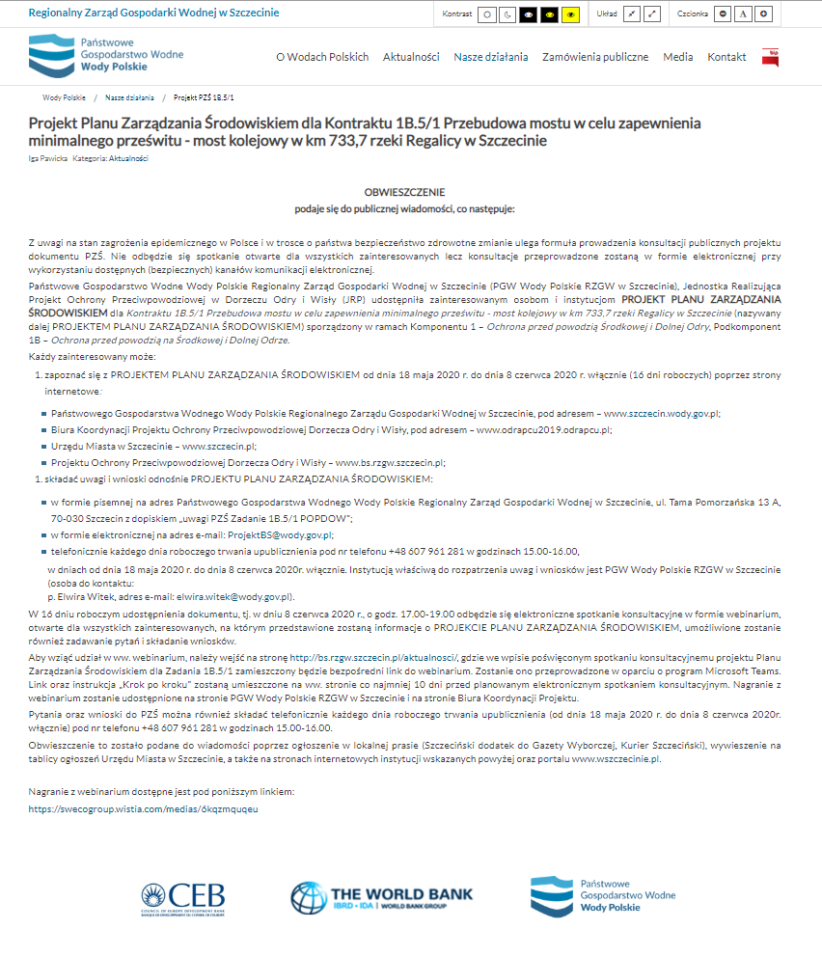
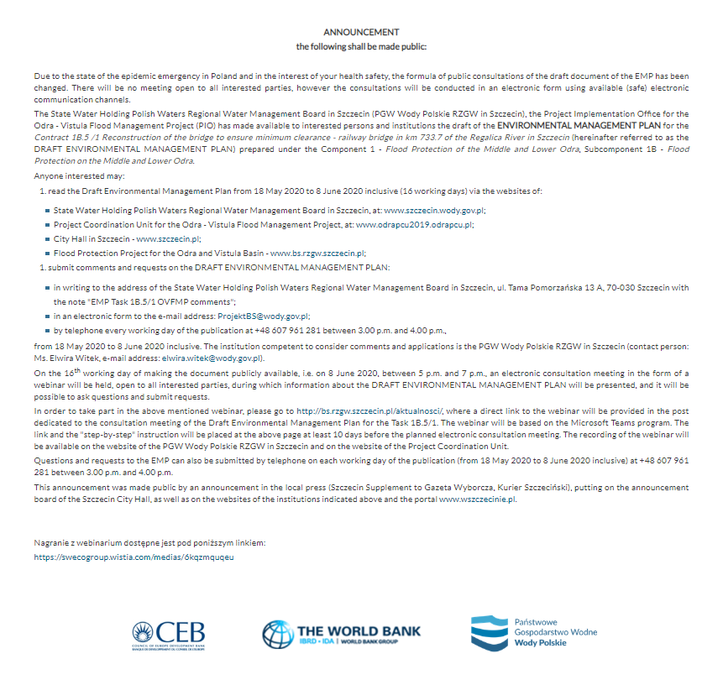
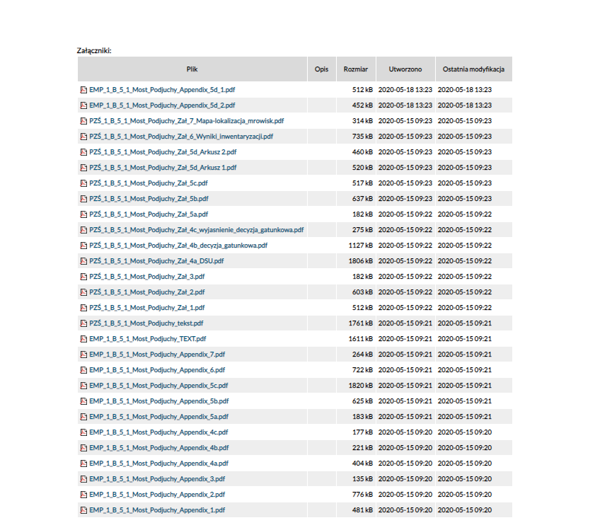
Fig. 5 Notice on RZGW Szczecin website
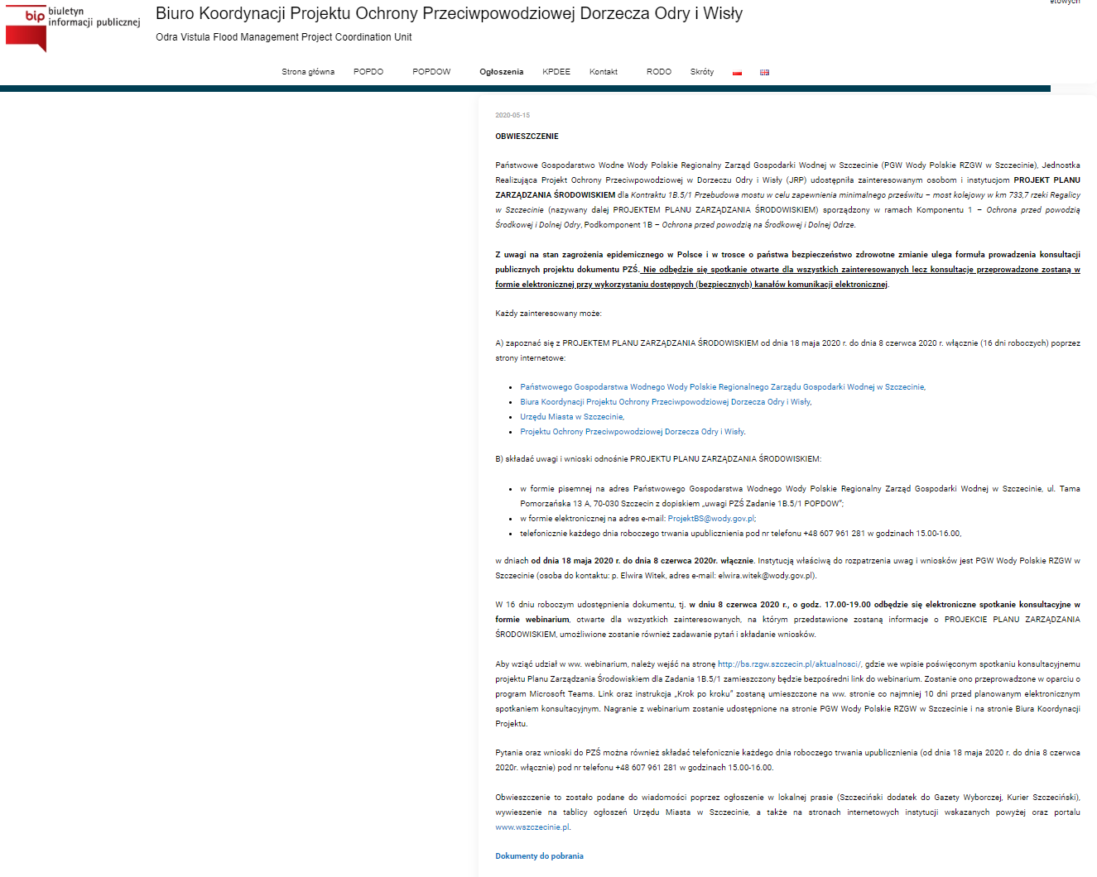
Fig. 6 Content of the draft document on the OVFM PCU website
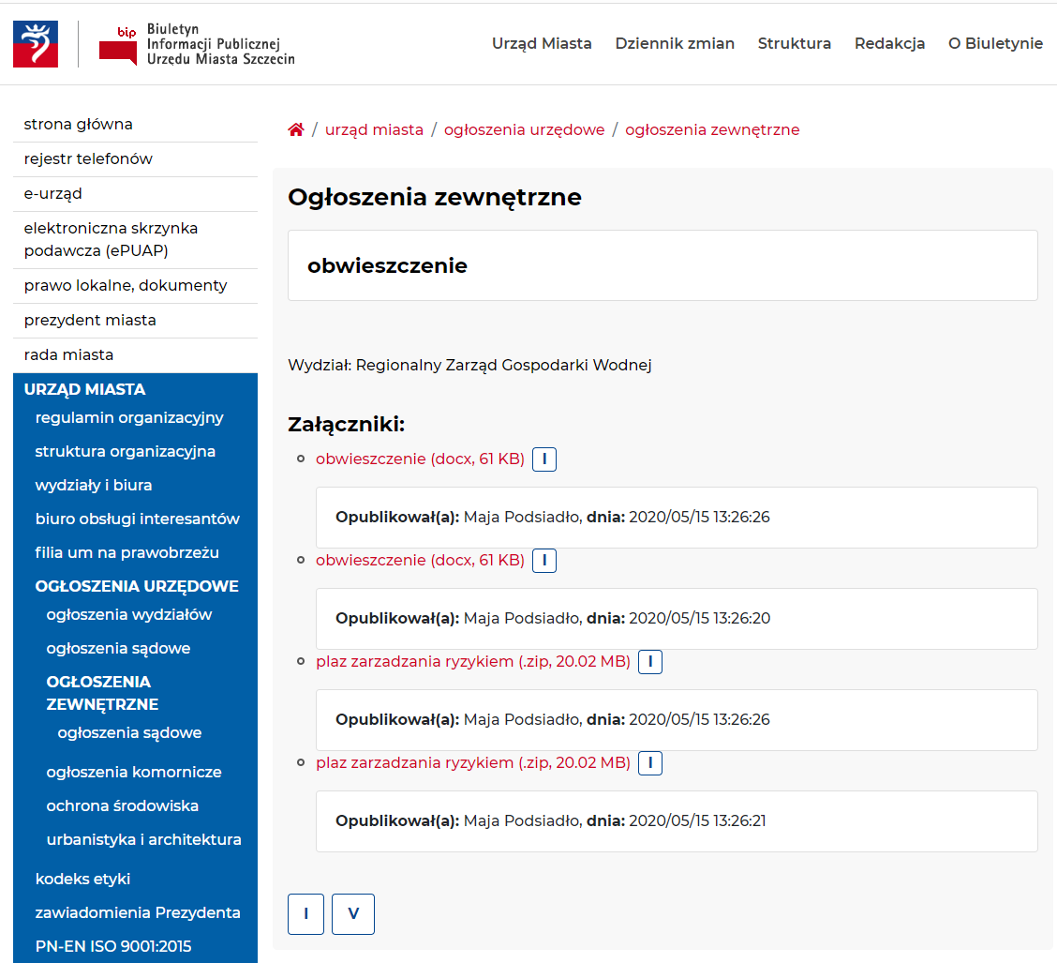
Fig. 7 Notice on the website of the Szczecin City Hall
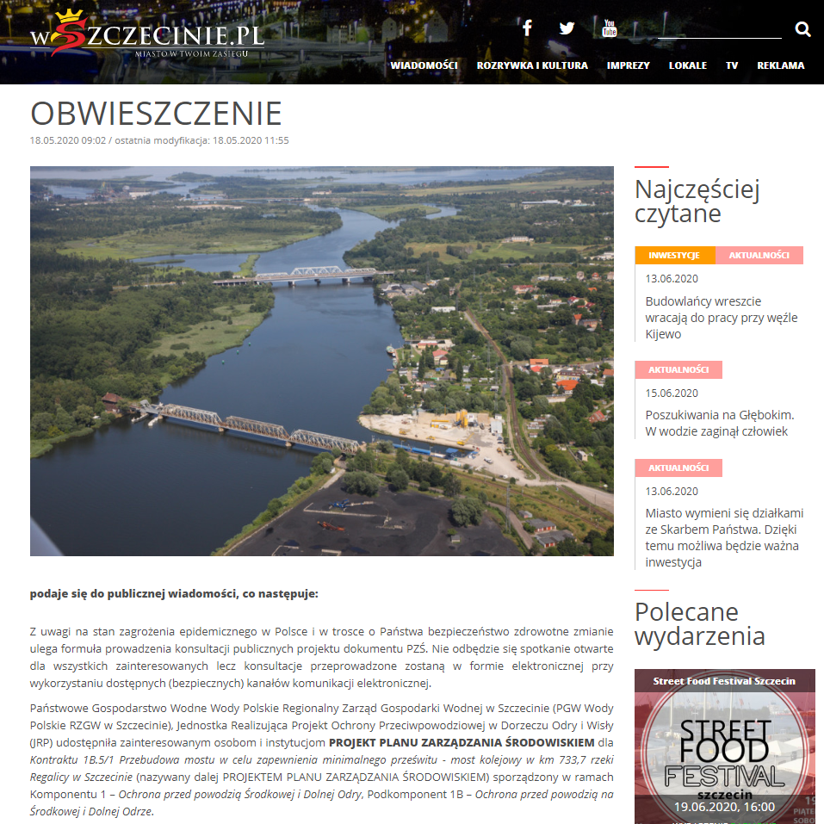
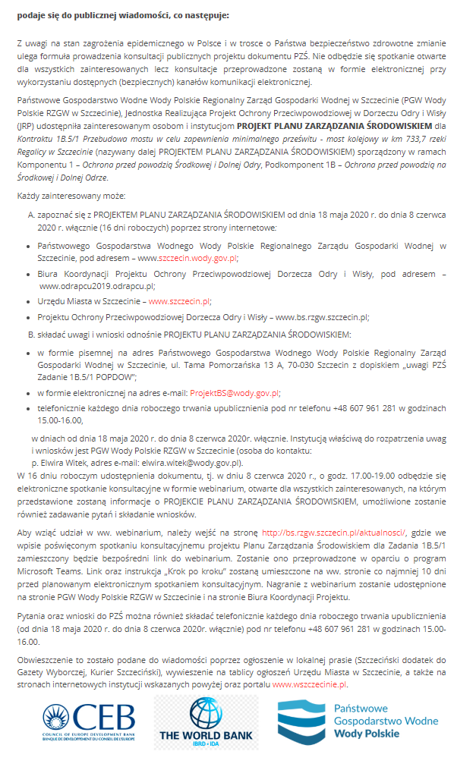
Fig. 8 Notice on the wszczecinie.pl website
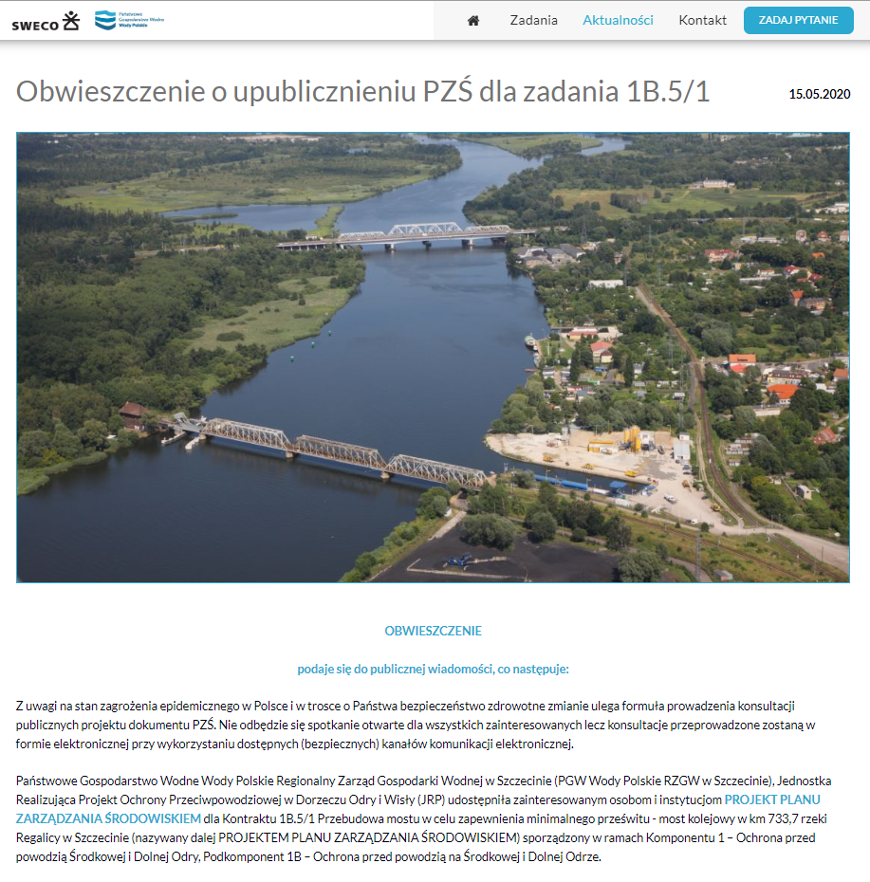
Fig. 9 Notice on the Project website – bs.rzgw.szczecin.pl
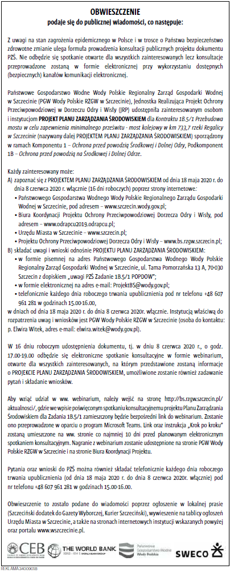
Fig. 10 Notice in the supplement to Gazeta Wyborcza of 15.05.2020
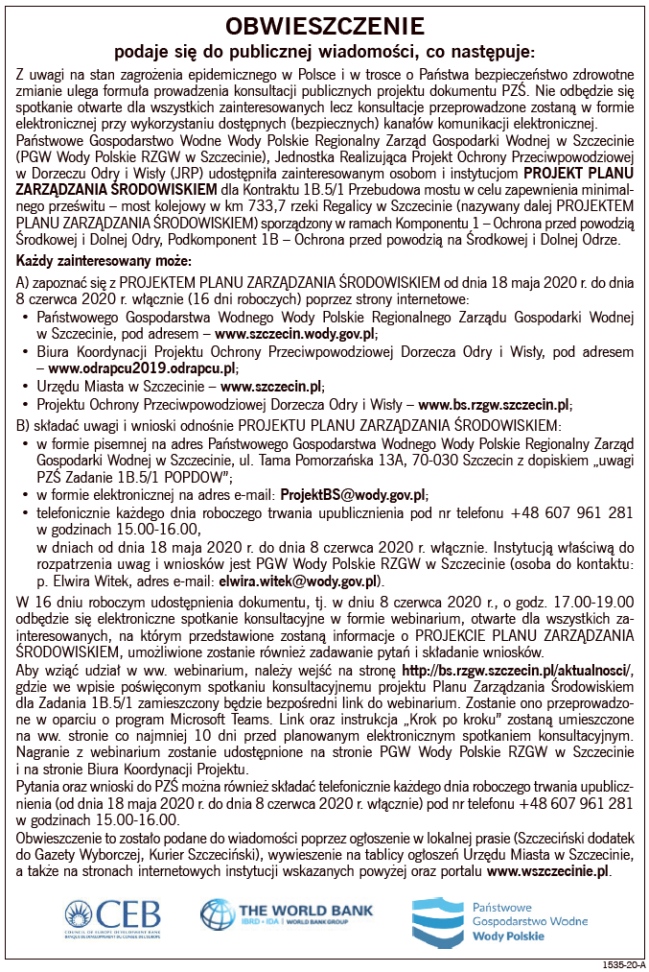
Fig. 11 Notice in Kurier Szczeciński dated 18.05.2020
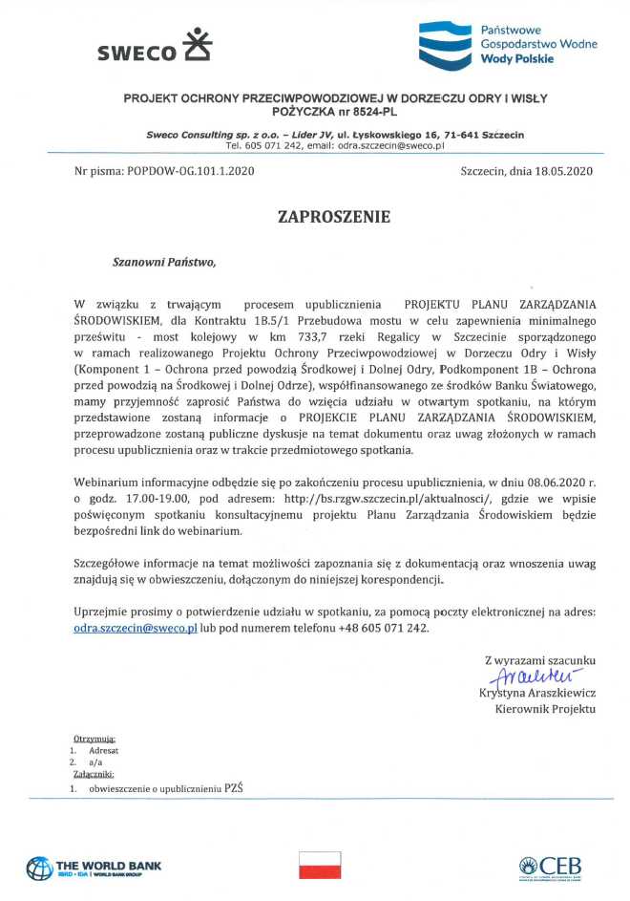
Fig. 12 Invitation to the meeting sent to representatives of local governments, private individuals, and NGOs
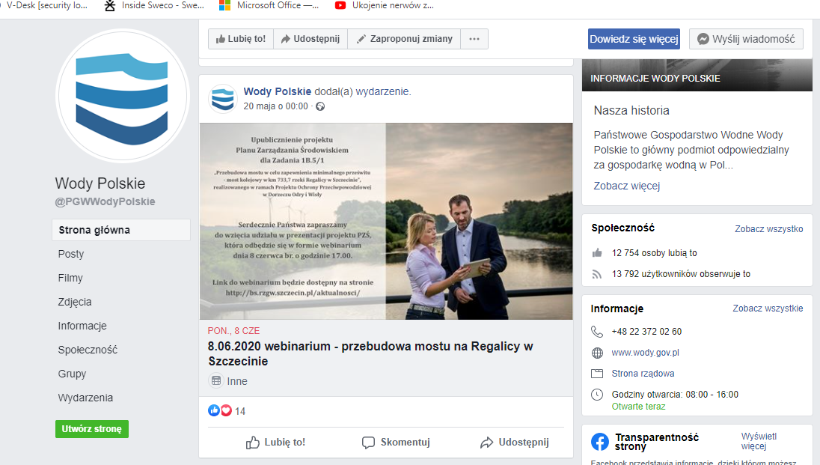

Fig. 13 Information about the webinar posted on the PGW Polish Waters social media profile

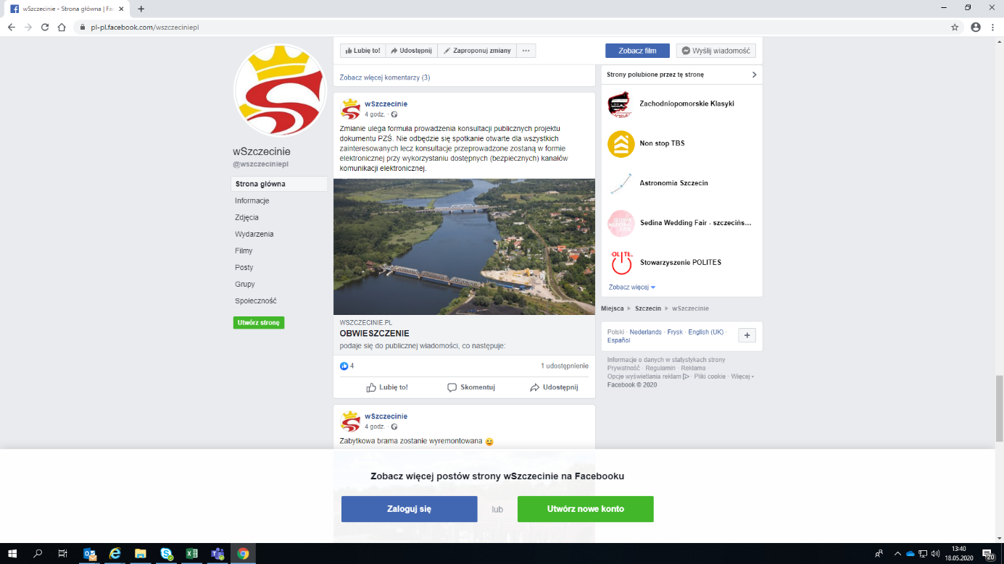
Fig. 14 Information about the webinar posted on the social media profile of portal wszczecinie.pl

ORGANISATIONAL STRUCTURE for THE IMPLEMENTATION OF THE EMP
The Task, which is the subject of this EMP is implemented within the framework of the Odra-Vistula Flood Management Project (see Section 2.1), co-financed from the World Bank funds, the Council of Europe Development Bank (CEB), the Cohesion Fund and the state budget. Therefore, the structure of supervision of the implementation of the EMP must comply with both Polish law and the Bank's requirements.

Project Coordination Unit for the Odra - Vistula Flood Management Project (PCU OVFMP)
The overall coordination of the implementation of the particular EMPs within the Project is the responsibility of the Project Coordination Unit (PCU), which functions as an organisational unit within the structures of the National Water Management Authority, which is an organisational unit of the Polish Water Holding Polish Waters.
The scope of tasks of PCU OVFMP includes, inter alia:
- Management of tasks of Project Implementation Offices (PIO) and Project Implementing Units (PIU) in the scope of implementation of tasks included in the Projects,
- Technical assistance and support to the PIO and PIU in the implementation of the tasks included in the Projects, including the application of the World Bank procedures on procurement, environmental protection and social issues,
- Preparation of annual work programmes for the Projects and evaluation of their progress,
- Supervising the works under the Projects and evaluation of their progress,
- Ongoing control and monitoring of funds allocated for the implementation of the Projects and participation in the management of funds of the Projects,
- Reporting, including preparation and submission of quarterly reports on the implementation of the Projects to the World Bank, the BRRE and the Steering Committee,
- Ongoing cooperation with the World Bank and the BRRE, including, but not limited to, conducting the Correspondence concerning the Projects, organising and participating in World Bank and BRRE visits and monitoring missions.

Project Implementing Unit (PIU) and Project Implementation Office (PIO)
The entity directly responsible for the implementation of the Task and monitoring the progress of its implementation will be the Project Implementing Unit (PIU), i.e. the Państwowe Gospodarstwo Wodne Wody Polskie Regionalny Zarząd Gospodarki Wodnej [State Water Holding Polish Waters Regional Water Management Board] in Szczecin.
In connection with the implementation of the OVFMP Project, the Project Implementation Office (PIO) was separated within the structure of the PIU, constituting a separate organisational unit and supervised by the Chairman of the State Water Holding Polish Waters. Such a structure is transparent and has a very high decision-making level, which increases the effectiveness of the Project implementation. In the organisational structure positions of specialists in environmental, technical, public procurement, legal, financial, real estate and resettlement and international cooperation have been appointed, who will be involved in the implementation of the EMP. As part of the supervision of the implementation of the EMP, the PIO carries out the following tasks:
- monitoring of the EMP implementation progress;
- financial management and accounting;
- drawing up the necessary reports for monitoring the implementation of the EMP and coordinating its implementation by all departments involved in the implementation of the EMP.
The scope of responsibilities of the PIO employees related to the supervision of the implementation of the EMP is as follows:
- managing, coordinating and supervising the implementation of the EMP by the Consultant and the Contractor;
- direct supervision of the proper implementation of the Task;
- cooperation with the PCU;
- administrative and legal supervision of the implementation of the EMP;
- verification of reports on the implementation of the EMP prepared by the Consultant and the Contractor;
- exercising financial supervision of the implementation of the EMP;
- supervision of the correctness of the application of formal procedures in the implementation of the EMP, resulting, inter alia, from the requirements of the Contract, Construction Law, Environmental Protection Law and other relevant administrative decisions and legal acts.

Consultant / Engineer
The role of the Consultant/ Engineer is to support PIU (State Water Holding Polish Waters Regional Water Management Board in Szczecin) in the effective implementation of the entire investment process - from the preparation of the project to its settlement.
The Consultant/Engineer was selected using the QCBS (Selection based on quality and price) method, in accordance with the "Guidelines for Selection and Employment of Consultants by World Bank Borrowers".
In accordance with the planned structure of the Engineer - Technical Support Consultant team, at the stage of the works implementation, the Engineer's Team (supervision inspectors in cooperation with the environmental team, coordinated by the Key Environmental Expert) will supervise the proper execution of construction works and the observance and implementation of the provisions of the EMP. It is envisaged to involve in the environmental team, apart from the Key Expert, three experts, including two who will be involved in the ongoing monitoring of the implementation of the EMP by the Contractor, including reporting and documenting activities related to the supervision of the implementation of the EMP, and one expert who will provide substantive support to the Key Expert during the implementation of the construction works contract, especially in situations related to e.g. the need to resolve divergent positions of the Contractor's environmental team and the Engineer's team.
In accordance with the scope of activities specified in the Technical Support Consultant Contract, the Engineer-Consultant will be obliged to ensure that the team is composed in such a way that it can properly supervise the implementation of the EMP through, inter alia, the following:
- monitoring of the implementation of the EMP;
- monitoring of the activities of the Contractor;
- checking the quality of construction works carried out by the Contractor and embedded construction products, and in particular preventing the use of defective products and products not permitted for use in the construction industry;
- representing the Investor on the construction site by controlling the compliance of its implementation with the project and permit for execution, environmental regulations and technical knowledge principles;
- supervising all issues related to the environmental protection by specialists in the field of environmental protection and other Engineer's personnel;
- constant monitoring of the correctness of execution of measures mitigating the negative impact on the environment;
- carrying out additional tests in case of the need to verify the Contractor's reports;
- identification of problems resulting from the harmful impact of the works on the environment and presenting proposals for solving these problems;
- checking and acceptance of construction works that will be covered or removed from sight and preparing and participating in acceptance activities of finished construction facilities and their commissioning;
- confirmation of actually performed works and remedying of defects, as well as, at the request of the Investor, control of construction settlements.
Social issues will be monitored during the execution stage by the real estate team of the Consultant, coordinated by the Key Real Estate Expert, who will work closely with the team of construction supervision inspectors.

Contractor
In order to implement the Contract, a Contractor will be selected who will be responsible for the implementation of the EMP. The Contractor's obligations in this respect include:
- carrying out construction works on the terms and conditions specified in the EMP, contractual conditions and the project documentation, in accordance with applicable law and the requirements of administrative decisions issued for the Task;
- implementation of the Engineer's recommendations (including environmental supervision specialists and investor supervision inspector) concerning the implementation of the EMP;
- ensuring that the Health and Safety Protection Plan, the Waste Management Plan, the Quality Assurance Plan, the Site Flood Protection Plan and the construction site organisation design are drawn up prior to the commencement of construction for the duration of the execution of works;
- submission of the signed ES Code of Conduct together with the bid (thus, the Contractor acknowledges the need to apply its provisions in each phase of the Contract implementation)
- submission for the Contract Engineer's approval the ES Code of Conduct and the ES Management Strategy and Implementation Plans described in the bidding documentation, developed at the bid submission stage, and verifying these documents as the result of periodic recommendations of the CI;
- keeping the construction site documentation;
- preparation of monthly reports and inspection reports;
- preparation of reports on environmental protection;
- applying to the Investor for changes in design solutions, if it is justified by the need to increase the safety of construction works or improve the construction process in the scope concerning the implementation of the EMP.

In the Contractor's team a Coordinator for EMP will be appointed, whose duties will include, but not limited to, the following:
- supervision of the implementation of particular conditions of the EMP in subsequent stages of the Task implementation;
- ongoing monitoring of the state of implementation of particular conditions of the EMP in the area of Task implementation;
- current informing the management of the Contractor's team about the obligations resulting from the EMP at a given stage of works, as well as about problems in the implementation of the EMP;
- cooperation with the remaining part of the Contractor's team, including in particular the natural supervision team of the Contractor (consisting of representatives of the following specialisations: botanist/phytosociologist, dendrologist, entomologist, ichthyologist, herpetologist, ornithologist, teriologist, chiropterologist), health and safety services of the Contractor (health and safety at work and ES) as well as sapper's and archaeological supervision of the Contractor;
- reporting on the implementation of the EMP (in accordance with the rules set out in items 134 - 135);
- cooperation with persons responsible for the EMP implementation in the Engineer and Employer team.

time schedule FOR THE IMPLEMENTATION OF THE EMP AND REPORTING PROCEDURES
The implementation of the EMP enables the parties involved in the preparation, implementation and supervision of the Task:
- identification of various environmental aspects, which have a significant impact on the condition of the environment, and which may give rise to economic effects so that they can be controlled, corrected and reduced;
- correction of the adverse consequences of the works carried out during the implementation for the benefit of the environment and financial results;
- determination of objectives and tasks implemented within the adopted environmental policy, covered by the EMP, which require outlays and bring measurable effects;
- identification and elimination of potential hazards and accidents, prevention and elimination of environmental effects, which may be related to them and entail losses disproportionate to the preventive costs;
- rational use of natural assets, with minimal environmental losses and optimal cost generation.
Moreover, the implementation of recommendations and actions resulting from the EMP may reduce or even eliminate the risk on the Contract, in particular:
- risk of omission of the environmental protection issues in the process of the Task implementation by the Contractor;
- risk of escalation of protests of local communities as the result of the Contractor's failure to comply with the work technology and environmental procedures approved by the Engineer;
- risk of additional environmental penalties;
- risk of incurring additional losses in the environment
Taking into account the importance of issues determining environmental and social conditions, the following procedures for implementation of the EMP are envisaged:
- before selecting the Contractor, the Employer will submit a draft of this EMP to the World Bank for its opinion;
- the EMP will then be subject to public consultation;
- after the public consultation (and supplementing the document with the results of the consultation), the EMP will be completed and the final version will be submitted to the World Bank for approval;
- after the approval of the EMP by the World Bank, the final document will be included in the bidding documentation for the selection of the Contractor;
- all activities of the Contractor will be reported at regular intervals (monthly), in paper and electronic format, with respect to obligations under the EMP and other contractual documents. These reports will be subject to approval by the Engineer and the Employer.
- monthly meetings (of the parties to the Contract and PCU) will be held especially devoted to discussing the problems of implementing the provisions of the EMP during the implementation of the Contract.
Environmental monitoring in the scope of the impact of the task on the environment consists, among other things, in:
- Control of the execution of construction works related to the implementation of the Task under the supervision of a team of environmental specialists appointed by the Contractor (Contractor's environmental supervision team) for the Contract implementation period.
- The Contractor's environmental supervision team shall carry out activities including, but not limited to:
- review and on-going control of the Task implementation area prior to the commencement of works and inspections during the execution of the Works, together with preparation of appropriate reports, constituting documentation of the proper performance of environmental supervision and, at the same time, informing about the proper implementation of mitigation measures,
- formulating and submitting to the Engineer conclusions regarding the need to take mitigation measures (including their implementation) necessary to mitigate the potential adverse effects of the Task on natural habitats and species of fauna and flora of interest to the Community and subject to legal protection (species), unforeseeable and/or impossible to reveal at the stage of determining the conditions of the Task implementation. The measures can only be implemented after the Engineer's approval,
- obtaining, if necessary, the necessary permits to derogate from the prohibitions of species protection of plants, fungi or animals in accordance with the rules and procedure laid down in the Nature Conservation Act,
- reporting in the form of periodical reports.
3. The Contractor will appoint specialists in the following fields as a part of the team of environmental supervision team: bird fauna, mammalian fauna, herpetology, botany/ phytosociology and fish fauna science. The above mentioned specialists must have documented experience in this field and have education in biology or related fields.
At the stage of the works implementation, it is planned that the Contractor will prepare collective reports on environmental monitoring, confirmed by specialists of the environmental team of the Contractor's team, approved by the environmental supervision of the Engineer. The detailed scope of the report will be determined by the Engineer (commencement report, periodical - monthly, quarterly, ad-hoc, closing), he will also determine the dates of their execution. The environmental supervision team of the Contractor shall also prepare periodic reports, submitted to the environmental authorities in writing in accordance with the requirements of administrative decisions issued in connection with the implementation of the Task, these reports (in advance) shall be submitted to the Engineer.
The Project reporting system will be, however, based on monthly reports submitted by Contractors to PIO via the Engineer and monthly reports from the Engineer. As a part of the monthly reports or as a separate document, monthly reports on the implementation of the EMP (Contractor and Engineer) will also be prepared. Collective quarterly reports will also be prepared on this basis.
The PIU shall submit quarterly reports to the PCU in the part concerning the tasks performed by them. They will contain the required set of information and descriptions to enable the PCU to prepare a quarterly report on the Project. Moreover, especially in case of problems with the implementation of the Task, the PCU will expect from the PIO the submission of statements and data on a monthly basis.
The following reporting procedures have been established:
1) Reporting:
- reports (commencement, monthly, quarterly, final), reports to the environmental authorities on execution of administration decisions (in particular species decisions) prepared by the Contractor of works,
- Engineer's review of reports,
- Submission of a report to the Employer (for information purposes),
- Submission of a report to the environmental authorities by the Engineer,
- submission of a quarterly report by the PIU to the PCU.
2) Archiving:
- Contractor: 1 copy of each electronic report for 5 years from the date of completion of the Contract and not less than 3 years from the date of closure of the given European Union program and/or financial instrument under which the Task is co-financed,
- Engineer: 1 copy of each electronic report for 5 years from the date of completion of the Contract and not less than 3 years from the date of closure of the given European Union program and/or financial instrument under which the Task is co-financed,
- Employer: 1 copy of each electronic report for 5 years from the date of completion of the Contract and not less than 3 years from the date of closure of the given European Union program and/or financial instrument under which the Task is co-financed.
3) Evaluation - ongoing evaluation of the results of the implementation of planned activities resulting from the EMP. Current analysis of documentation (Contractor's Reports) by the Engineer. Providing the Employer with reliable information on the course of the construction process, with particular emphasis on the implementation of actions reducing negative impact on the environment and recommendations resulting from environmental decisions.
The PCU shall also prepare, at quarterly intervals, reports submitted to the World Bank.
The following are planned:
- ex-ante evaluation: Report before the commencement of the Contract implementation (Engineer's Report),
- ongoing evaluation: Engineer's Quarterly Reports,
- ex-post evaluation:
- Report after completion of the Contract implementation (Final Report from the EMP prepared by the Contractor and the Engineer),
- Report on the EMP after the defects notification period prepared by the Engineer.

List of source materials
- Environmental impact report of the project entitled: Partial dismantling and construction of a new bridge at km 733.7 of the Regalica River in the course of the railway line 273 together with accompanying infrastructure, carried out under the Odra - Vistula Flood Management Project "Task 1B.5 Reconstruction of bridges to ensure minimum clearance", Sweco Consulting Sp. z o.o., April 2019 with supplements
- Decision of the Regional Director for Environmental Protection in Szczecin No. 1/2020 of 10.01.2020, Reference No.: WONS-OŚ.420.20.2018.KK.38 on environmental conditions for the project named "Partial dismantling and construction of a new bridge at km 733.7 of the Regalica River in the course of the railway line 273 together with accompanying infrastructure, carried out under the Odra - Vistula Flood Management Project "Task 1B.5 Reconstruction of bridges to ensure minimum clearance"
- Decision of the Regional Director for Environmental Protection in Szczecin of 06.11.2019, Ref. No. WOPN-OG.6400.97.2019.MR, WOPN-OG.6401.06.11.2019.MR, WOPN-OG.6401.05.11.2019.MR, WOPN-OG.6401.03.24.2019.MR, WOPN-OG6401 .02.220.201 9.1MR, WOPN-OG.6401.01.67.2019.MR, WOPN-OG6401.04.22.2019.MR) authorising operations subject to prohibitions applicable to protected animal, plant or fungi species (species decision)
- CONCEPT. 1B.5 Reconstruction of bridges to ensure minimum clearance. Railway bridge in km 733.7 of the Regalica River in Szczecin, Sweco Consulting sp. z o.o., November 2017
- Project Operations Manual (POM) for the Odra-Vistula Flood Management Project. Project Coordination Unit for the OVFMP. Wrocław, 2015 and its update (July 2017).
- Environmental and Social Management Framework Plan for the Odra - Vistula Flood Management Project - final document. RZGW [Regional Water Management Board] in Szczecin, RZGW in Wrocław, RZGW in Kraków, Lubuski ZMiUW [Board of Land Amelioration and Water Facilities] in Zielona Góra, West Pomeranian ZMiUW in Szczecin, Świętokrzyski ZMiUW in Kielce, Dolnośląski ZMiUW in Wrocław, Małopolski ZMiUW in Kraków, Podkarpacki ZMiUW in Rzeszów, IMiGW [Institute of Meteorology and Water Management] - State Research Institute. April 2015.

List of Attachments
Attachment 1. Plan of mitigation measures
Attachment 2. Plan of monitoring actions
Attachment 3. Summary of national environmental legislation
Attachment 4. Copies of administrative decisions on environmental protection and nature conservation issued for the Task:
        - Decision of the Regional Director for Environmental Protection in Szczecin No. 1/2020 of 10.01.2020, Reference No.: WONS-OŚ.420.20.2018.KK.38 on environmental conditions for the project named "Partial dismantling and construction of a new bridge at km 733.7 of the Regalica River in the course of the railway line 273 together with accompanying infrastructure, carried out under the Odra - Vistula Flood Management Project "Task 1B.5 Reconstruction of bridges to ensure minimum clearance"
        - Decision of the Regional Director for Environmental Protection in Szczecin of 06.11.2019, Ref. No. WOPN-OG.6400.97.2019.MR, WOPN-OG.6401.06.11.2019.MR, WOPN-OG.6401.05.11.2019.MR, WOPN-OG.6401.03.24.2019.MR, WOPN-OG6401 .02.220.201 9.1MR, WOPN-OG.6401.01.67.2019.MR, WOPN-OG6401.04.22.2019.MR) authorising operations subject to prohibitions applicable to protected animal, plant or fungi species (species decision)
        - Letter of Regional Director for Environmental Protection in Szczecin of 06.02.2020: clarification of the content of the decision of the Regional Director for Environmental Protection in Szczecin of 06.11.2019, Ref. No. WOPN-OG.6400.97.2019.MR, WOPN-OG.6401.06.11.2019.MR, WOPN-OG.6401.05.11.2019.MR, WOPN-OG.6401.03.24.2019.MR, WOPN-OG6401 .02.220.201 9.1MR, WOPN-OG.6401.01.67.2019.MR, WOPN-OG6401.04.22.2019.MR) authorising operations subject to prohibitions applicable to protected animal, plant or fungi species (species decision)
Attachment 5. Task location maps
        - General Task location
        - Task location in relation to Natura 2000 areas
        - Task location in comparison with other protected areas
        - Map with location of selected elements of the Task
Attachment 6. Results of the nature inventory (attachment to the EIA Report)
Attachment 7. Map – indicative location of anthills to be relocated
Attachment 8. Report from Public Consultation on the Environmental Management Plan

Operational Policies and Procedures of the World Bank are presented in the document The World Bank Operational Manual, available on the website: https://policies.worldbank.org/sites/PPF3/Pages/Manuals/Operational%20Manual.aspx.
The document is available on the PCU OVFMP website: http://odrapcu2019.odrapcu.pl/popdow_dokumenty/ and on the World Bank's website: http://documents.worldbank.org/curated/en/717671468333613779/Poland-Odra-Vistula-Flood-Management-Project-environmental-and-social-management-framework.
See footnote for BP (World Bank Procedure).
The document is available on the website of the World Bank: http://documents.worldbank.org/curated/en/320251467986305800/Poland-Odra-Vistula-Flood-Management-Project.
The document is available on the website of the PCU for the OVFMP: http://odrapcu2019.odrapcu.pl/popdow_dokumenty/.
https://www.ifc.org/wps/wcm/connect/topics_ext_content/ifc_external_corporate_site/sustainability-at-ifc/policies-standards/ehs-guidelines
On the website: http://odrapcu2019.odrapcu.pl/popdow_dokumenty/
On the website: http://documents.worldbank.org/curated/en/717671468333613779/Poland-Odra-Vistula-Flood-Management-Project-environmental-and-social-management-framework
On the website: https://policies.worldbank.org/sites/PPF3/Pages/Manuals/Operational%20Manual.aspx.
Woś A Klimat Polski [The climate of Poland] PWN, Warszawa 1999
Chief Inspectorate for Environmental Protection: Annual air quality assessment in the West Pomeranian Voivodship. Voivodship report for 2018, 2019
https://www.pgi.gov.pl/dokumenty-pig-pib-all/psh/zadania-psh/BSWd/BSWd-1-19/4457-karta-informacyjna-BSWd-nr-4/file.html
On the basis of Natura 2000 - Standard data form (SDF) PLH320037, 2017
https://www.ifc.org/wps/wcm/connect/topics_ext_content/ifc_external_corporate_site/sustainability-at-ifc/policies-standards/ehs-guidelines
In the Attachment 1 of the EMP, mitigation actions have been assigned to 17 thematic categories (from Cat. A to Cat. R).
- https://policies.worldbank.org/sites/PPF3/Pages/Manuals/Operational%20Manual.aspx#S3-2 (w części pt. Investment Project Financing / Environmental and Social Safeguard Policies) - https://www.ifc.org/wps/wcm/connect/topics_ext_content/ifc_external_corporate_site/sustainability-at-ifc/policies-standards/ehs-guidelines - https://www.ifc.org/wps/wcm/connect/29f5137d-6e17-4660-b1f9-02bf561935e5/Final%2B-%2BGeneral%2BEHS%2BGuidelines.pdf?MOD=AJPERES&CVID=jOWim3p
i.e. works specified in the Regulation of the Council of Ministers of 24 August 2004 on the list of prohibited work for juveniles and the conditions for their employment in some of these works (consolidated text: Journal of Laws of 2016, item 1509)
On the website: http://odrapcu2019.odrapcu.pl/popdow_dokumenty/.

