Report on public consultations of the Land Acquisition and Resettlement Action Plan
for the Contract - 1B.8:
Flood protection of Krosno Odrzańskie
implemented as part of the Odra-Vistula Flood Management Project (OVFMP)

Draft of the Land Acquisition and Resettlement Action Plan (LARAP) for the Contract 1B.8 - Flood protection of Krosno Odrzańskie was subject to public consultations conducted in accordance with the requirements of the World Bank's operational policy (OP 4.01). The purpose of the consultations was to enable natural persons, institutions and all the interested parties to become familiar with the content of this document and to provide the possibility to submit any comments, questions and conclusions to its content.
After the draft LARAP was completed, the document was forwarded to the World Bank in order to obtain approval for the commencement of the publicizing procedure. After obtaining the approval of the World Bank, the procedure of publicizing the draft LARAP began. In order to ensure the widest possible access to information, due to the epidemic emergency in Poland, it was decided that an electronic version of the documentation would be published and made available to anyone interested in the period from August 26, 2020 to Spetember 9, 2020 inclusive (i.e. 14 days) on the following websites:
- State Water Holding Polish Waters, Regional Water Management Authority in Wroclaw – www.wroclaw.wody.gov.pl (Fig. 1, 2, 3);
- Odra Vistula Flood Management Project Coordination Unit – www.odrapcu2019.odrapcu.pl (Fig. 4, 5, 6);
- City hall in Krosno Odrzańskie – www.krosnoodrzanskie.pl (Fig. 7)
- District Starosty in Krosno Odrzańskie – www.powiatkrosnienski.pl (Fig. 8,9)
- Dąbie Commune Office - http://www.dabie.pl/ (Fig. 10,11)
Information on the possibility of becoming acquainted with the content of the draft LARAP and submitting motions and comments together with an indication of detailed contact details (e-mail address, telephone number, office hours) was also made public via:
- advertisements in the local press – in Gazeta Lubuska on August 26, 2020 (Fig. 13) and in Gazeta Tygodniowa on August 27, 2020 (Fig. 12),
- announcements posted on the notice boards of the above-mentioned offices (Fig. 14,15)
The published announcement contained information on the changed formula for conducting public consultations (webinar) due to the state of epidemic emergency in Poland. The announcement also contained information about the date, time and website address where a direct link to the webinar with step-by-step instructions was shared.
The document with annexes has also been made available for inspection at the premises of the above-mentioned offices.
In addition, a cover letter with an invitation to get acquainted with the LARAP on the above websites (Fig. 14) was sent by registered mail to the Project Affected Persons (PAPs). A complaint form was also attached to the letter. The list of persons to whom the notification was sent is attached to the report as an internal document.
Consultation meeting
After the end of the time period of the LARAP draft publicity (the electronic version of the documentation was available to all interested parties, from August 26, 2020 to September 9, 2020 inclusive) an open webinar was organized for all interested parties. The webinar was broadcasted on September 9, 2020 from two locations:
- Office of the technical assistance Consultant - Sweco Consulting Co. (Roosevelta 22, 60-829 Poznań) – webinar moderation
- Office of the technical assistance Consultant - Sweco Consulting Co. (Kożuchowska, 65-364 Zielona Góra) – presentation, responding to questions
In accordance with the notification, the meeting began at 2:00 p.m. (Fig. 16).
During the webinar information on the principles of developing and functioning of the LARAP during the implementation of investments co-financed by the World Bank was presented together with detailed information on the LARAP draft for the Contract 1B.8 Flood protection of Krosno Odrzańskie (Fig. 17). The meeting was attended by:
- representatives of the Project Coordination Unit
- representatives of the Project Implementation Office
- representative of the Krosno Odrzańskie City Hall
- representatives of the technical assistance Consultant
- a Project Affected Person (PAP)
After the presentation, a discussion was opened and it was possible to ask questions regarding the content of the documents provided (Fig. 18). Questions and comments could be submitted via a live chat (Fig. 19) as well as in person by joining the on-line meeting. One of the participants (PAP) inquired about the amount of compensation and was informed that details would be arranged with a real estate specialist from the team of the technical assistance Consultant by telephone.
The meeting ended at 4 p.m. (Fig. 20).

COMMENTS SUBMITTED DURING THE PUBLICATION PERIOD
In the course of the procedure of making the LARAP draft public, no comments were submitted to its content or annexes.
Therefore, the process of public consultations was deemed completed - the Consultant began to prepare the Report on public consultations of the draft LARAP for the Task 1B.8.

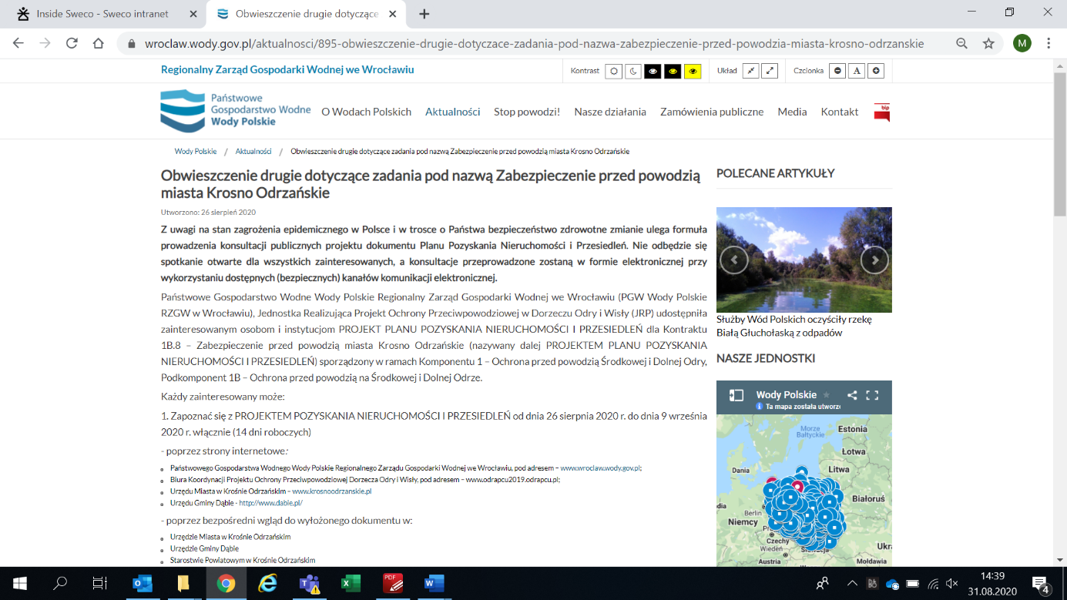
Fig. 1 Announcement on the PGW WP RZGW website in Wrocław (part 1)
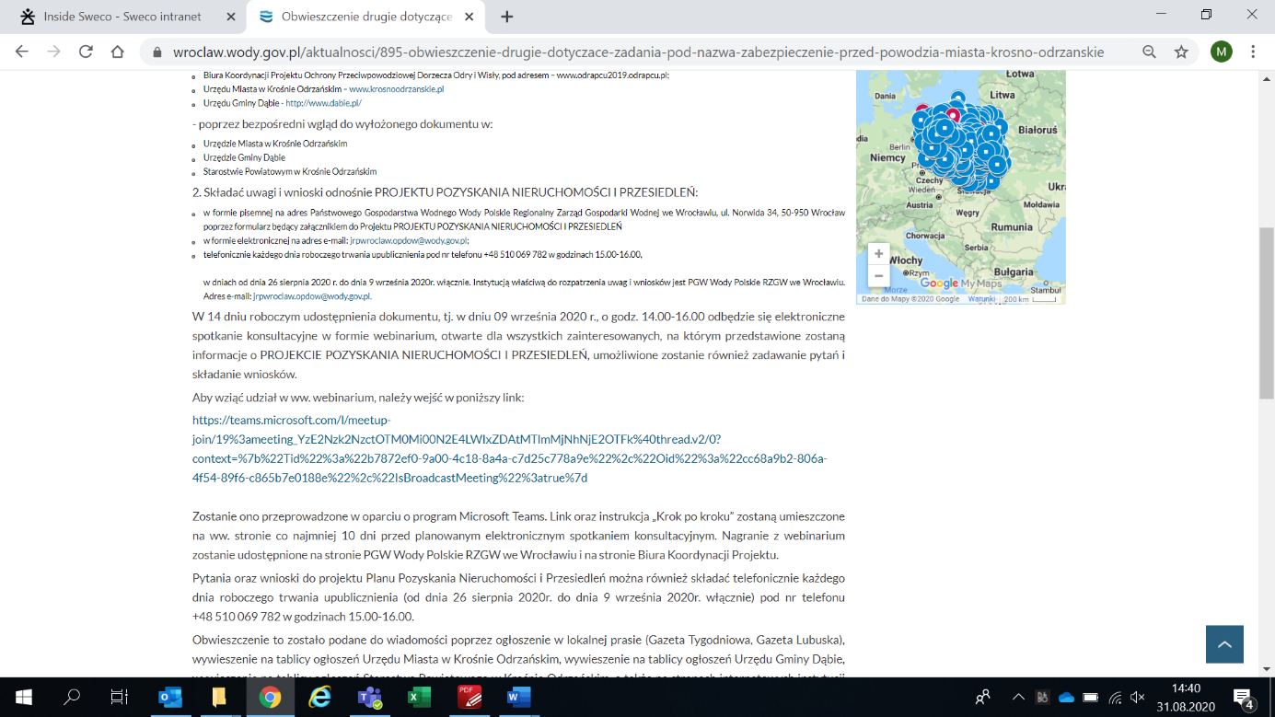
Fig. 2 Announcement on the PGW WP RZGW website in Wrocław (part 2)
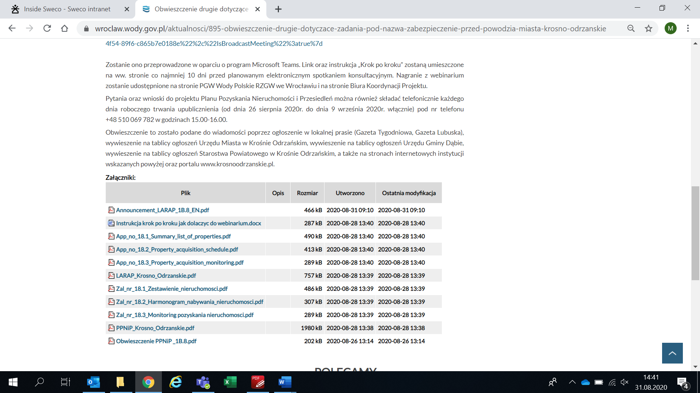
Fig. 3 Announcement on the PGW WP RZGW website in Wrocław (part 3)
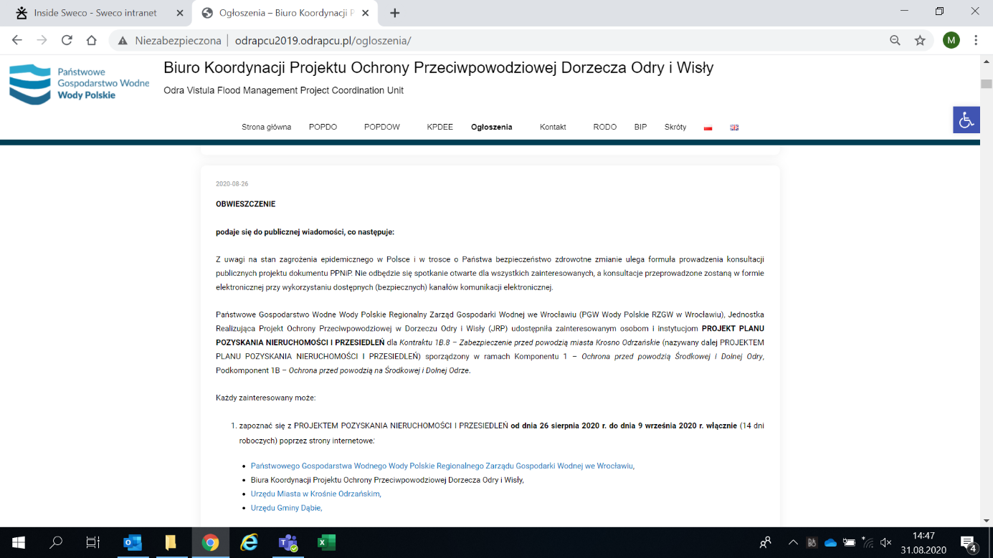
Fig. 4 Content of the draft document on the website of the OVFMP PCU (part 1)
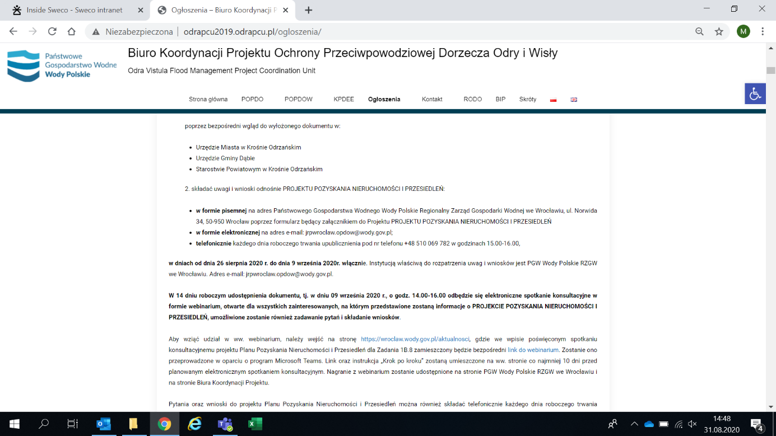
Fig. 5 Content of the draft document on the website of the OVFMP PCU (part 2)
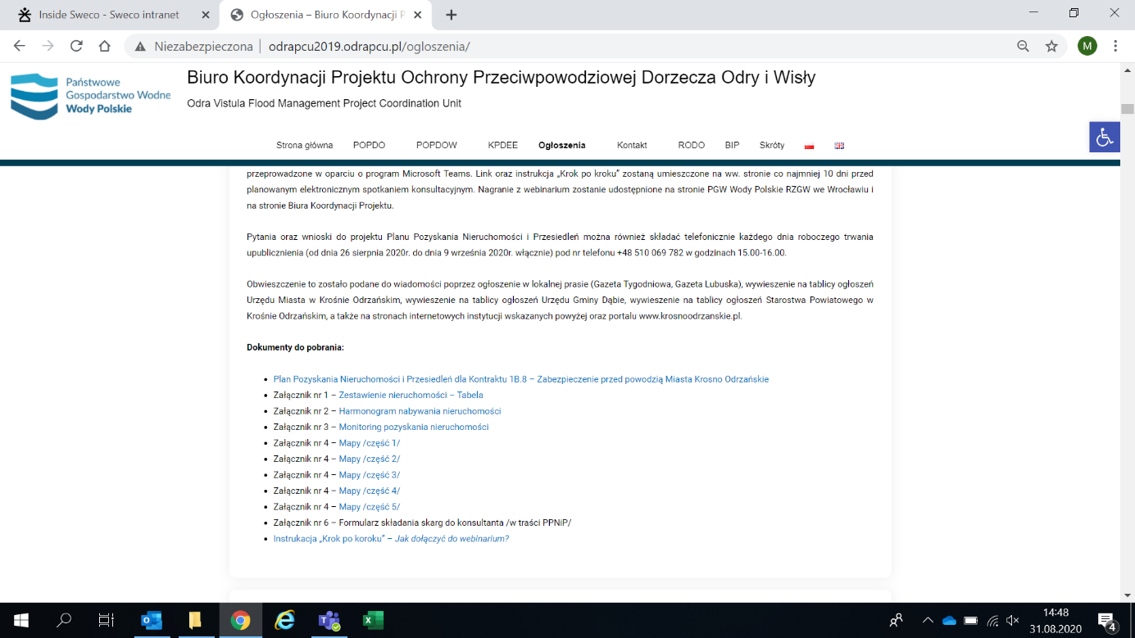
Fig. 6 Content of the draft document on the website of the OVFMP PCU (part 3)

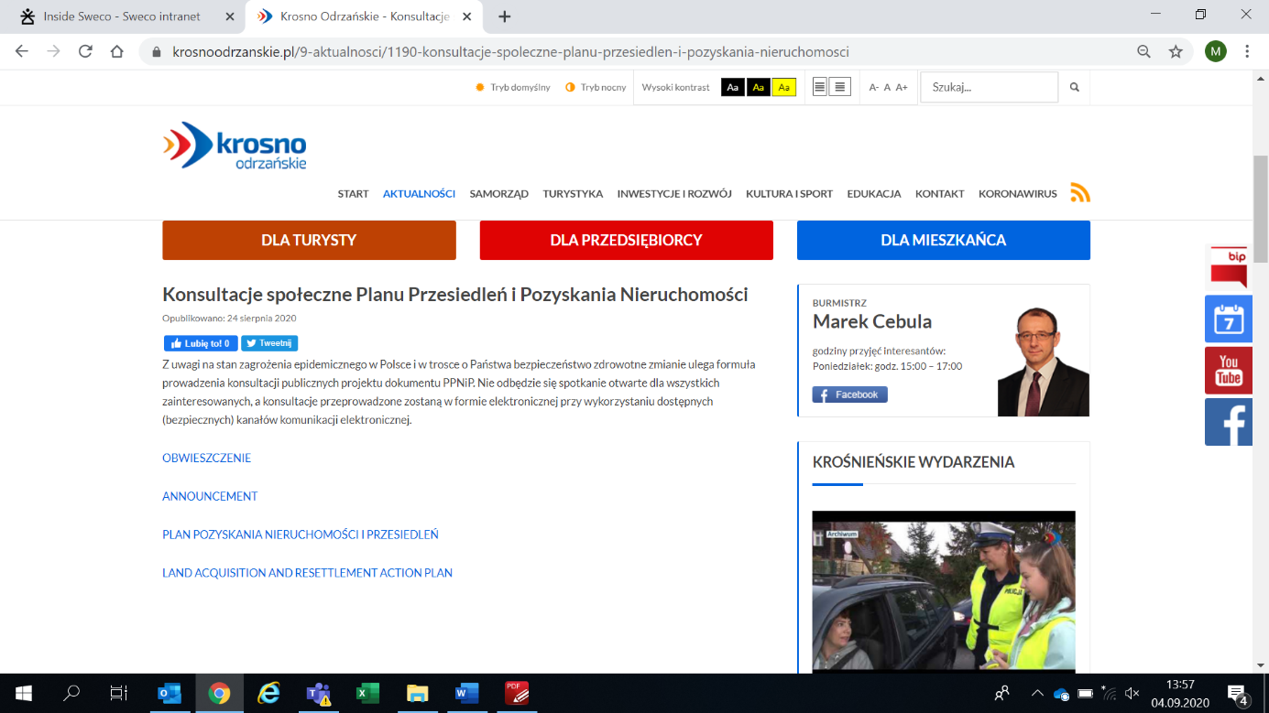
Fig. 7 Announcement on the website of the City Hall in Krosno Odrzańskie

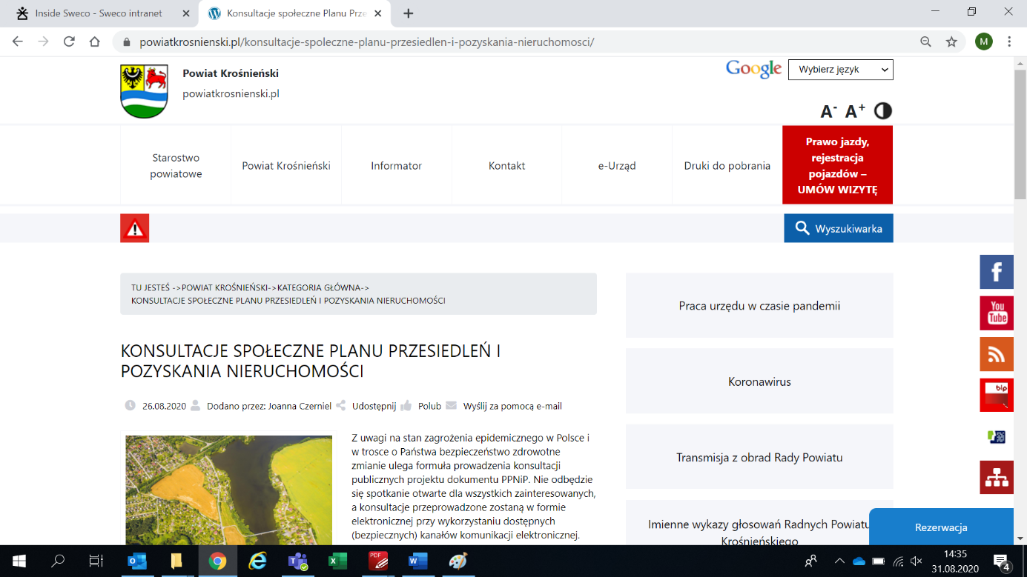
Fig. 8 Announcement on the website of the District Starosty in Krosno Odrzańskie (part 1)
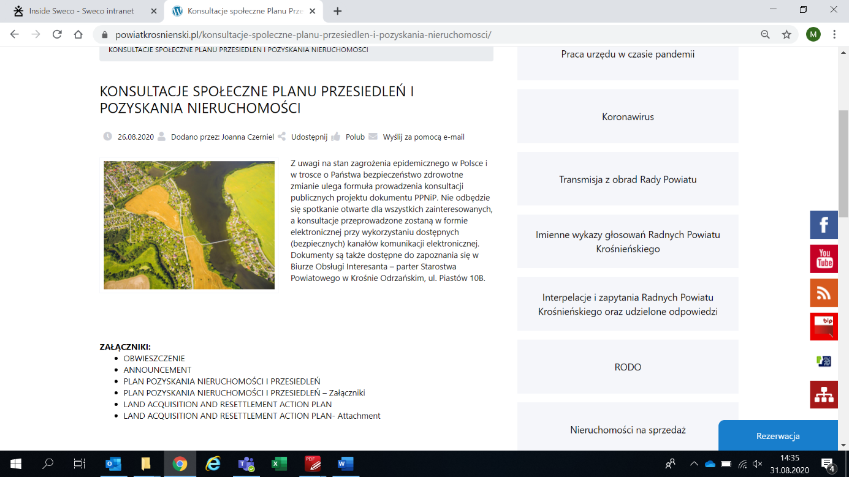
Fig. 9 Announcement on the website of the District Starosty in Krosno Odrzańskie (part 2)
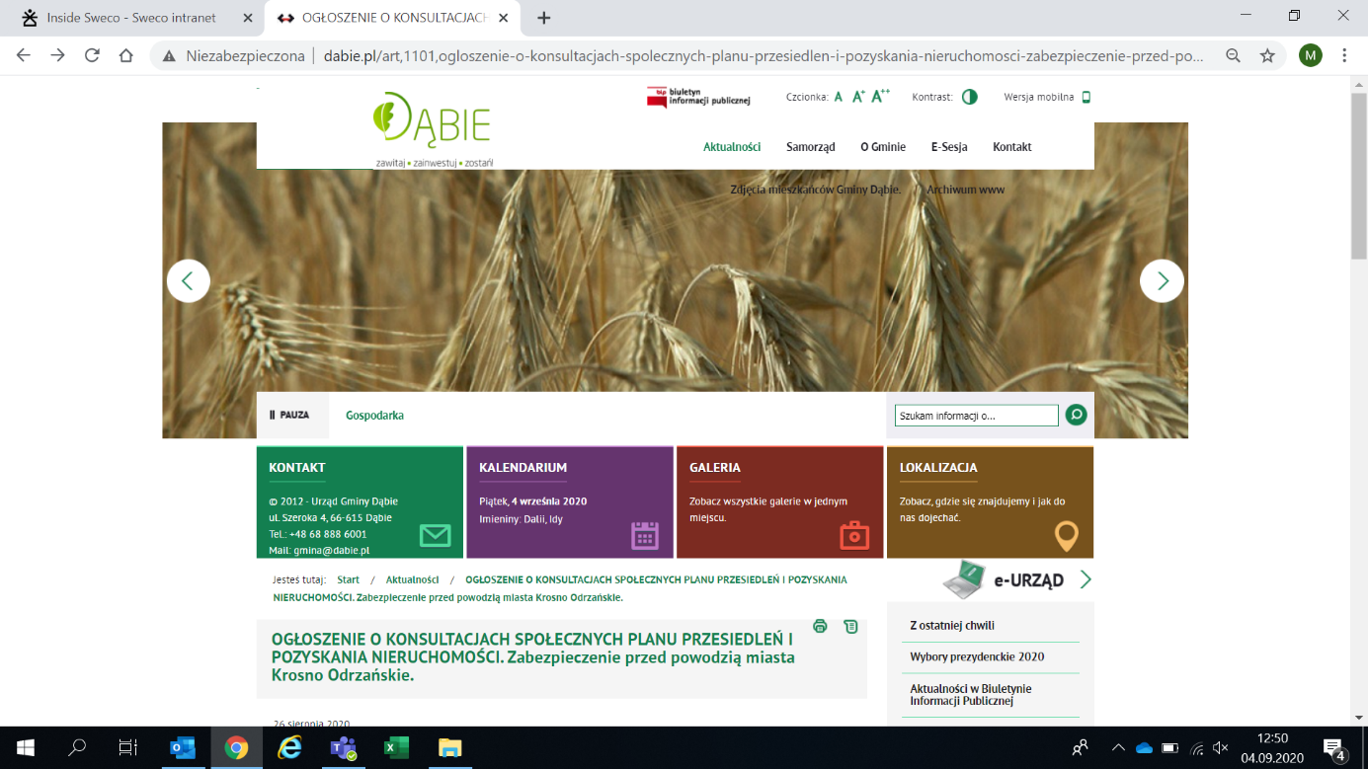
Fig. 10 Announcement on the website of the Dąbie Commune Office (part 1)
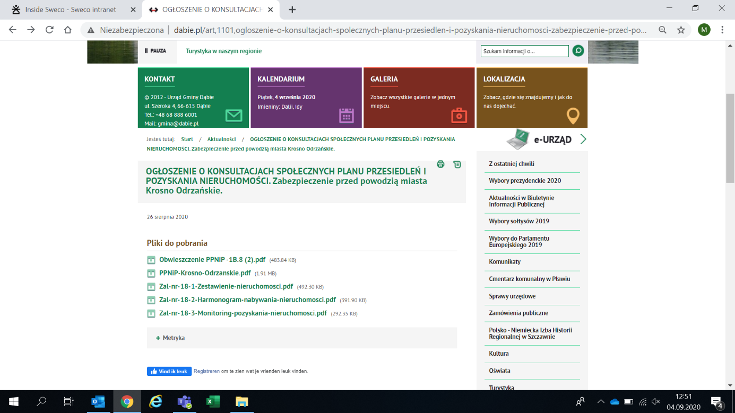
Fig. 11 Announcement on the website of the Dąbie Commune Office (part 2)
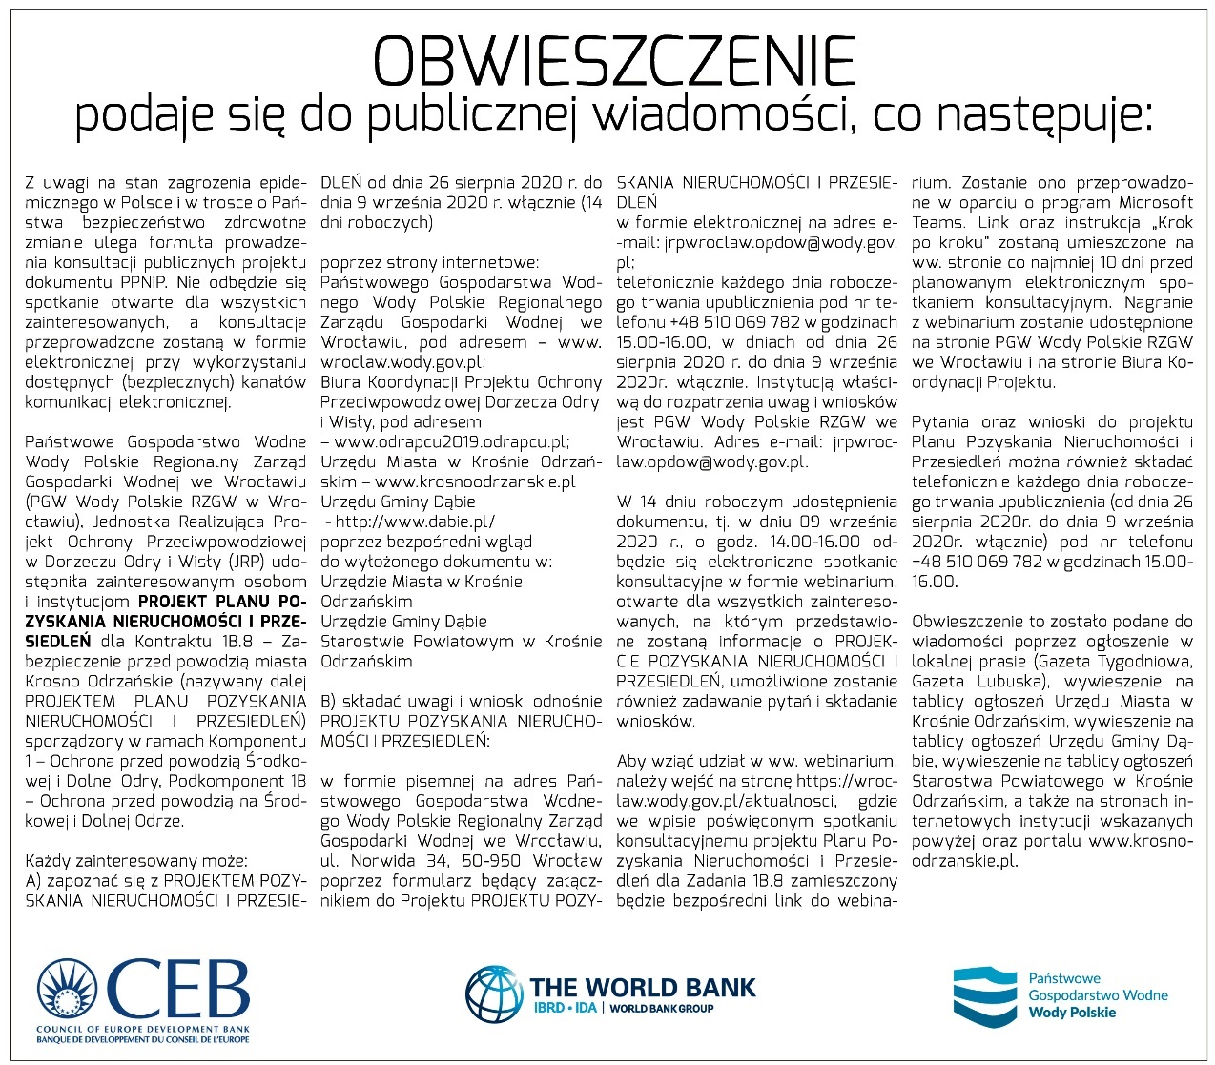
Fig. 12 Announcement in Gazeta Tygodniowa of August 27, 2020.
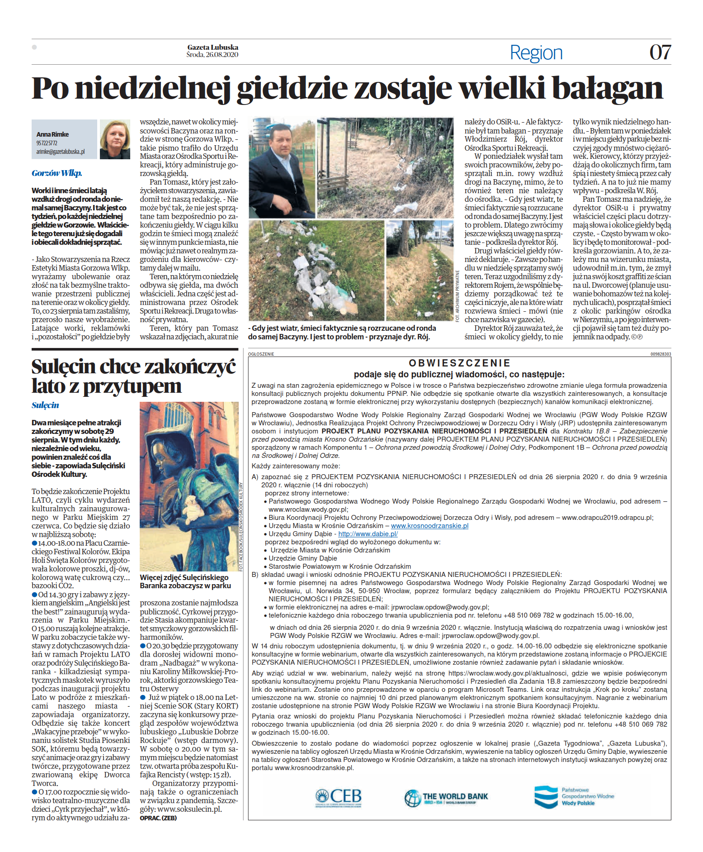
Fig. 13 Announcement in Gazeta Lubuska of August 26, 2020.

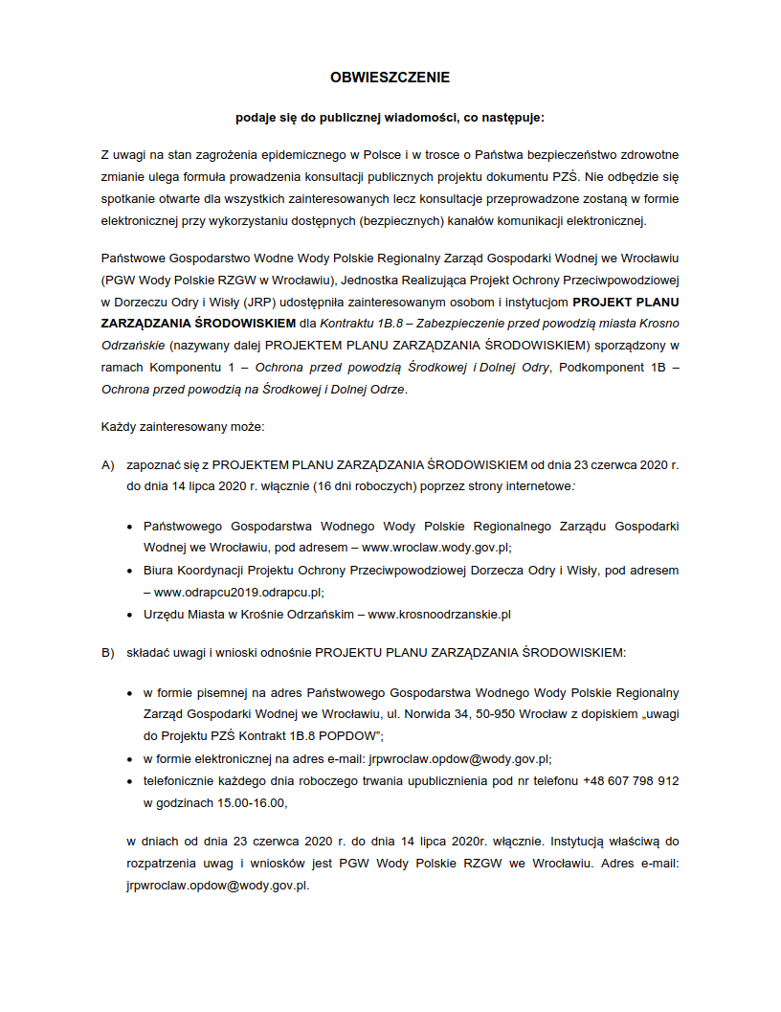
Fig. 14 Announcements posted on the notice boards of offices (part 1)

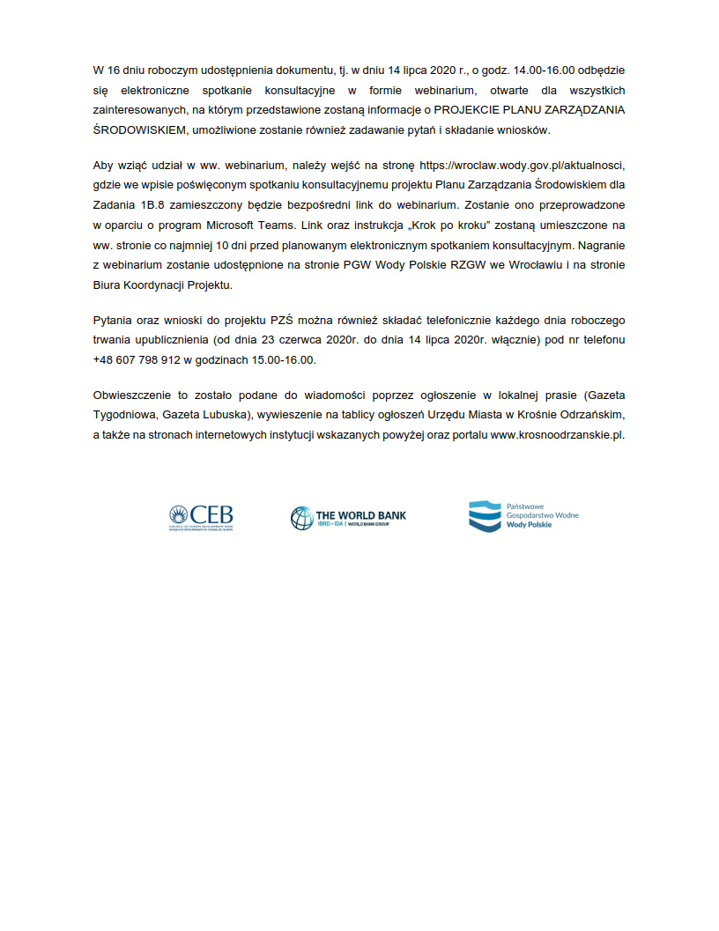
Fig. 15 Announcements posted on the notice boards of offices (part 2)

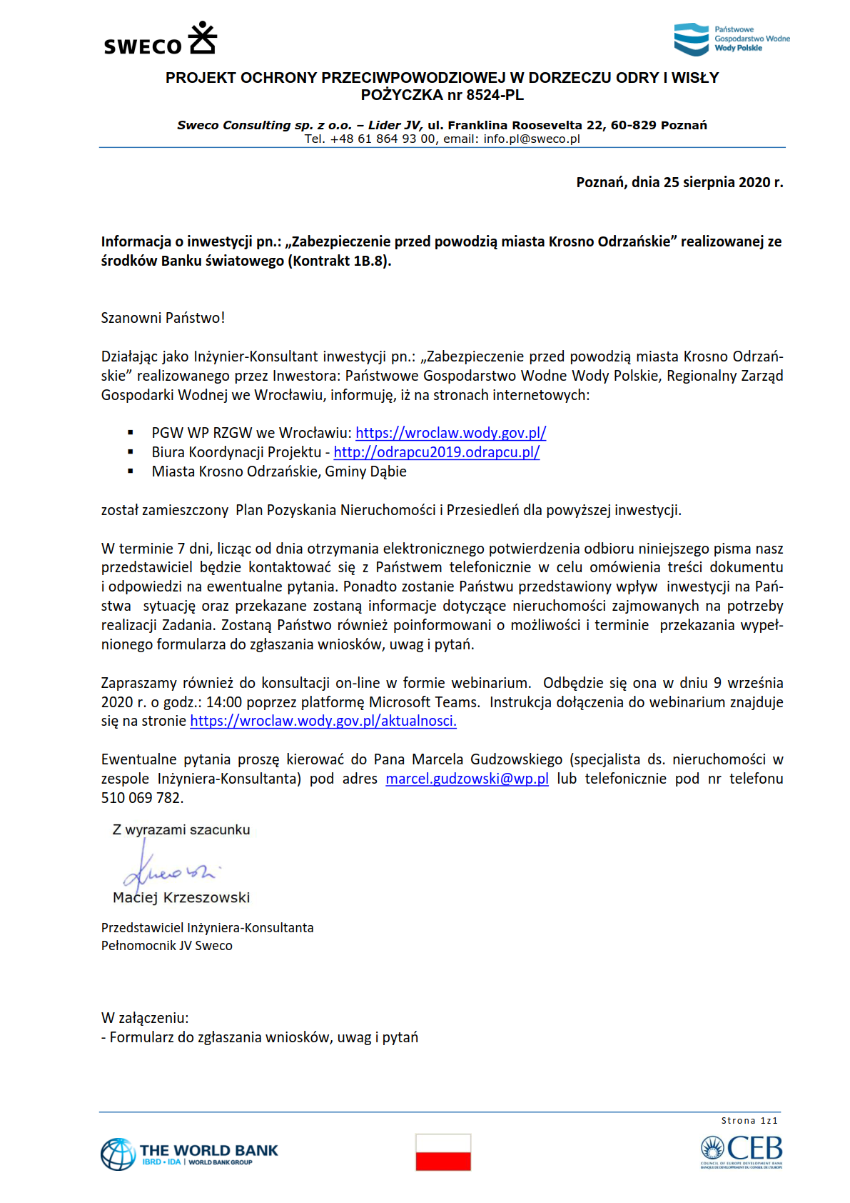
Fig. 16 Notification sent to the Project Affected Persons (PAPs)

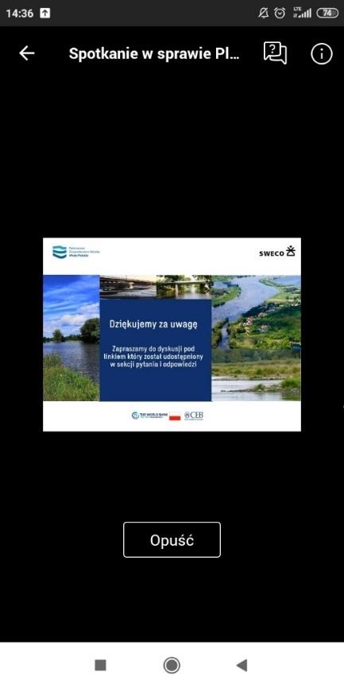
Fig. 17 End of presentation, invitation to discussion (mobile device view)
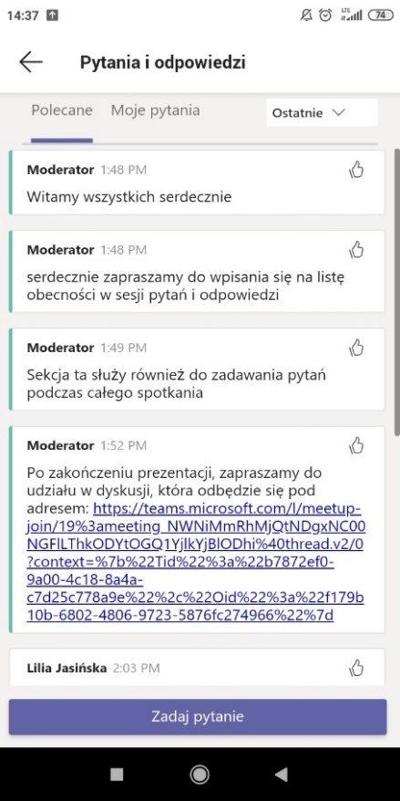
Fig. 18 Chat preview (part 1, mobile device view)
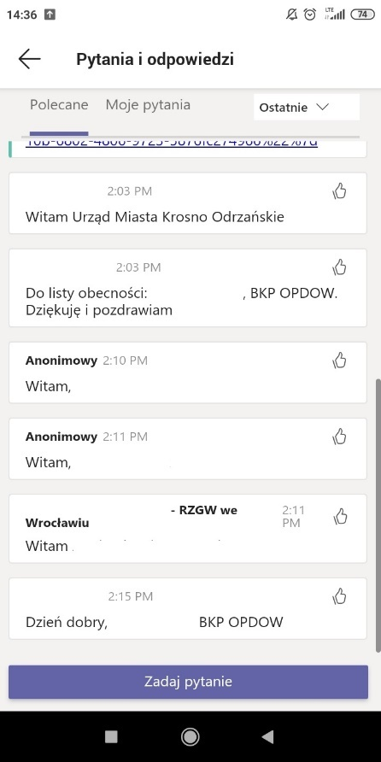

Fig. 19 Chat preview (part 2, mobile device view)
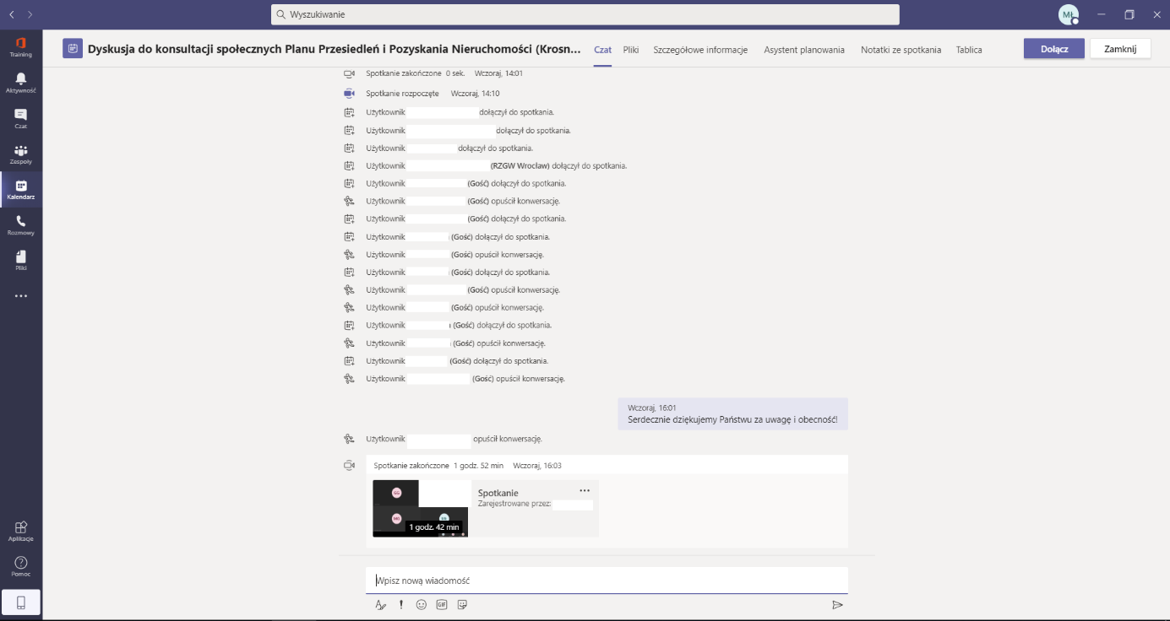
Fig. 20 Closing the meeting

Information on the course of telephone consultations

In the period from September 7 to September 18, 2020, a procedure of direct telephone conversations with PAPs was carried out, during which the impact of the investment on their situation was indicated and information regarding properties occupied for the purposes of the Task was provided. Information on possible other forms of contact was also be made available, and additional questions and comments were collected, together with an indication of the possibility of submitting the form for applications, comments and inquiries within the time limit set for correspondence consultations. The consultations were conducted by telephone due to the ongoing state of epidemic in the Republic of Poland. Reaching 10 out of 43 PAPs failed, either due to the lack of a telephone number to some, or not answering the call by others, despite repeated attempts at different times of the day. No written complaint, motion or comment regarding the LARAP draft was received from these PAPs. The Consultant will make further attempts to contact those PAPs, who could not be reached.

The vast majority of PAPs did not have any questions about the LARAP or the Task. 6 persons among the PAPs reported the need for a visit by a representative of the Investor or the Designer, who would make it clear on site what works are to be performed and precisely in what areas. Persons reporting the need to meet with the Designer own utility buildings, sheds and garages located on the plots subject to occupation under the Task, and they express concerns if the works performed will not damage these structures. One of the PAPs, with whom the conversation lasted nearly half an hour, insisted on a site inspection with the participation of a person who had proper knowledge on the technical aspects of the task and stated that they still felt aggrieved by the investment. They also expressed hope for assistance in constructing a new utility building. During conversations with the above-mentioned PAP a pledge was given to organize meetings in October 2020, with the participation of a person who has knowledge on the technical aspects of the Project. The person who stated that they still felt aggrieved, indicated that the feeling would pass if such a meeting was organized and if they obtained assistance in reconstructing the utility building.

Some of the PAPs, who had not yet received compensation for expropriation, wished to know when it would take place. Therefore, they were informed about the estimated date of issuing the decision by the Lubuskie Voivode and of the compensation payment. In addition, PAPs were informed about the expected time of the planned works execution.

One of the PAPs requested to be sent a map showing the location of the investment, which has already been done. In turn, three of the PAPs reported an interest in purchasing the remaining parts of the properties. Two of these PAPs live abroad.

In conclusion, the telephone consultations proceeded smoothly and none of the PAPs raised any objections to the LARAP draft or lodged any complaint with the Consultant.

Appendices:
- List of persons to whom information about the publication of LARAP was sent / is not published due to the provisions on personal data /

